1950s Consumer Culture Advertising Assignment

You will create an ad for one of the many markets that were popular in the 1950s. Following WWII, the American economy was thriving. The average American saw a 25% increase in income which led to a booming domestic market. In the midst of Cold War anxiety, the new middle class desired comforts of religion, home, and family, along with new products they could enjoy.

Your job is to create an advertising poster for a product being sold in the 1950s and 1960s. Make sure that your ad includes certain aspects. Consider the following:
- Your target audience- who would be most likely to buy your product?
- The motivations of your target audience- why would they want to buy your product?
- The cost of your product- you may need to research this online!
- The “origin” of your product/idea- include something in your advertisement that shows where your product came from (For example: Fast food restaurants were created due to highways; TVs were inspired by radios; etc.)
- Visually appealing- you may want to research 1950s ads on the internet to get an idea of how you might organize your ad in a way that is aesthetically appealing.

Choose one of the following topics:
Television
Automobile
Fast Food
Levitt home
Shopping mall
Rock n’ Roll Concert
Billy Graham sermon
“Teenpic” (movies targeted at teens)

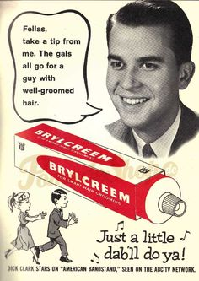

- Domestic prosperity affected everyone
- International Bank and IMF
  - Private loans for reconstruction of war-torn countries
  - Assistance to 3rd world countries
  - Stabilization of currency
- Defense spending
  - Business-government partnership from world wars
  - Permanent mobilization (science industry became entwined with government)
  - Sputnik- Space Race
  - Eisenhower funneled money to colleges for research
  - Limited power to corporations
    - While collar army
    - The Lonely Crowd- independents vs. managerial class
    - Machines replaced workers as production increased
- 25% raise in income for Americans
  - Bottom of society still struggled
- Consumerism
  - Domestic consumer market increased
- GI Bill
  - Veterans in college and trade schools
  - Homeownership
- Collective Bargaining
  - Defeated United Auto Workers Union
  - But made a deal
  - Treaty of Detroit
- Houses, Cars and Children
- CBS and NBC offered regular programming
  - White anglo saxon world of suburban families
- Religion
  - Church membership jumped
  - Evangelical protestants (televangelists)
  - Billy Graham
    - Used TV and advertising
  - Moderate bringing catholics, protestants and jews together

