United States History
Section II

Question 1 (Document Based Question)
Suggested reading period: 15 minutes
Suggested writing period: 45 minutes
Directions: The following question is based on the accompanying Documents 1-7. The documents have been edited for the purpose of this exercise. This question is designed to test your ability to apply several historical thinking skills simultaneously, including historical argumentation, use of relevant historical evidence, contextualization, and synthesis. Your response should be based on your analysis of the documents and your knowledge of the topic.
Write a well-integrated essay that does the following:
- States an appropriate thesis and directly addresses all parts of the question.

- Supports the thesis or an appropriate argument with evidence from all or all but one of the documents AND your knowledge of United States history beyond/outside the documents.

- Analyzes a majority of the documents in terms of such features as their intended audience, purpose, point of view, format, argument, limitations, and/or social context as appropriate to the argument.

- Places the argument in the context of broader regional, national, or global process.

Question 1. Although New England and the Chesapeake region were both settled largely by people of English origin, by 1700 the regions had evolved into two distinct societies. Describe and evaluate the conditions which created these differences.

Document 1
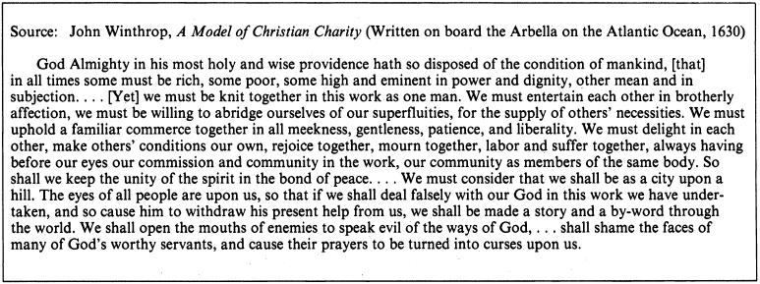

Document 2
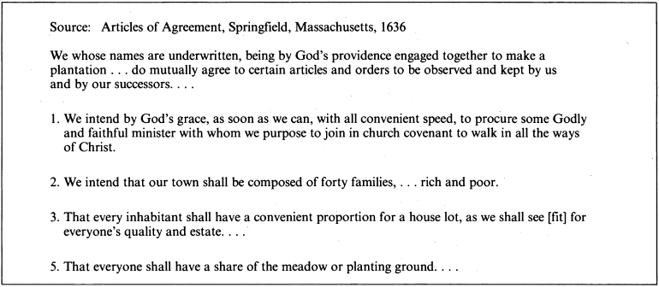

Document 3
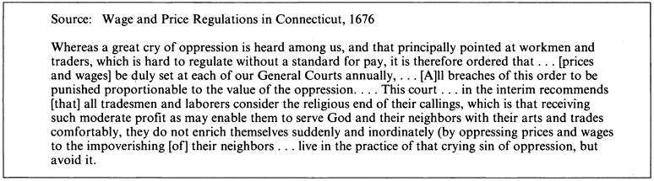

Document 4
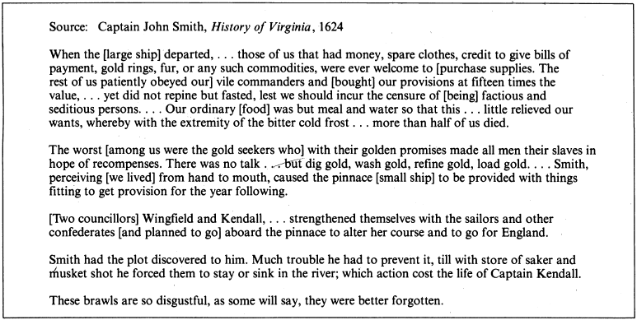

Document 5

Document 6
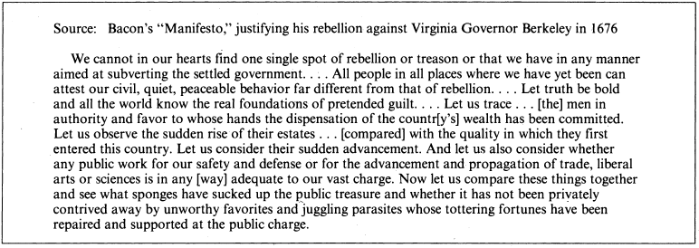

Document 7
Source: Report of Governor William Berkeley of Virginia to the Crown, 1671.
Question: What number of planters, servants, and slaves; and how many parishes are there in your plantation?

Answer: We suppose, and I am very sure we do not much miscount, that there is in Virginia above forty thousand persons, men, women, and children, and of which there are two thousand black slaves, six thousand Christian servants [indentured] for a short time. The rest are born in the country or have come in to settle and seat, in bettering their condition in a growing country.

Question: What number of English, Scots, or Irish have for these seven years last past come yearly to plant and inhabit within your government; as also what blacks or slaves have been brought in within the said time?

Answer: Yearly, we suppose there comes in, of servants, about fifteen hundred, of which most are English, few Scotch, and fewer Irish, and not above two or three ships of Negroes in seven years.

