NAME: ___________________________PER. ___ Genocide: Darfur Sudan
Sources:  Spend 10-15 minutes on each resource reading, exploring, and taking notes. | Main Idea:  What is the main idea of the source? | Details:  Record 2-3 details from the source. | Reaction/Solution: What do you think about this issue/conflict? What’s a possible solution?

Genocide in Darfur
Darian Tucker, Sonoma Valley High School | Mar 22, 2010

http://www.schooltube.com/video/c13145941e331b7b16ae/Genocide-in-Darfur
“Darfur Genocide” Article

Map of Sudan, Africa

Darfur Genocide
What?
The “Darfur Genocide” refers to the current mass slaughter and rape of Darfuri men, women and children in Western Sudan. The killings began in 2003 and continue still today, as the first genocide in the 21st century.
The genocide is being carried out by a group of government-armed and funded Arab militias known as the Janjaweed (which loosely translates to ‘devils on horseback’). The Janjaweed systematically destroy Darfurians by burning villages, looting economic resources, polluting water sources, and murdering, raping, and torturing civilians. As of today, over 480,000 people have been killed, and over 2.8 million people are displaced refugees.
Where?
Sudan is the largest country in Africa. Located in Northeastern Africa, it borders the Red Sea and falls between Egypt, Chad, Uganda, as well as six other countries. The capitol, Khartoum, is in the Northeastern part of the country. Darfur is a region in Western Sudan that encompasses an area roughly the size of Spain. The population of Darfur is estimated at 6,000,000 people. The conflict in Darfur has also increased tensions in neighboring Chad and the Central African Republic as hundreds of thousands of refugees stream over the two countries’ borders to escape violence.
When?
Following independence from Britain in 1956, Sudan became involved in two civil wars for most of the remainder of the 20th century. These conflicts were rooted in northern economic, political, and social domination of largely non-Muslim, non-Arab southern Sudanese. Competition for scarce resources played a large role. As nomads began to compete for grazing land, traditional reconciliation measures were no longer able to settle disputes, causing the region to become increasingly militarized. The complexities of desertification, famines, and the civil war raging between North and South Sudan contributed to a rise in regional tensions during the 1980s. Similarly, as oil was discovered in Western Sudan, the Sudanese government and international contributors became increasingly interested in the land in Darfur.
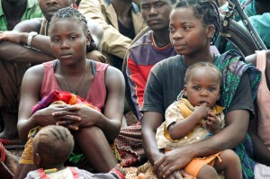

How?
Attacks on Darfuri villages commonly begin with Sudanese Air Force bombings. Air campaigns are often followed by Janjaweed militia raids. All remaining village men, women, and children are either murdered or forced to flee. Looting, burning food stocks, enslaving and raping women and children, and stealing livestock are common. Dead bodies are tossed in wells to contaminate water supplies and entire villages are burned to the ground.
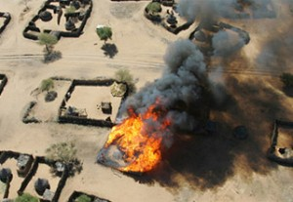
Burning Village

World Response
The on-going conflict in Darfur, Sudan was declared “genocide” by United States Secretary of State Colin Powell on September 9, 2004 in testimony before the Senate Foreign Relations Committee. On February 18, 2006, President George W. Bush called for the number of international troops in Darfur to be doubled.
On September 17, 2006, British Prime Minister Tony Blair wrote an open letter to the members of the European Union calling for a unified response to the crisis. In supporting the United Nations Security Council Resolution in 2007 to authorize the deployment of up to 26,000 peacekeepers to try to stop the violence in Darfur, British Prime Minister Gordon Brown said in a speech before the General Assembly of the United Nations, the Darfur crisis was “the greatest humanitarian disaster the world faces today.” The British government also endorsed the International Criminal Court’s ruling regarding Sudanese president Omar al-Bashir and has urged the Sudanese government to co-operate.
Early in 2008, the UN issued a hybrid United Nations-African Union mission (UNAMID) to maintain peace in Darfur. UNAMID, with a projected strength of 26,000 troops, was authorized to use force to protect civilians. Despite this mandate, however, only 9,000 were sent, and they lacked the necessary equipment to carry out their mission.

Genocide in Darfur
Darfur is in the western part of Sudan, bordering on Libya, Chad, and the Central African Republic.
Darfur is a region in Sudan the size of France. It is home to about 6 million people from nearly 100 tribes. Some nomads. Some farmers. All Muslims. In 1989, General Omar Bashir took control of Sudan by military coup, which then allowed The National Islamic Front government to inflame regional tensions. In a struggle for political control of the area, weapons poured into Darfur. Conflicts increased between African farmers and many nomadic Arab tribes.
In 2003, two Darfuri rebel movements- the Sudan Liberation Army (SLA) and the Justice and Equality Movement (JEM)- took up arms against the Sudanese government, complaining about the low quality of life the area and the failure to protect sedentary people (farmers) from attacks by nomads. The government of Sudan responded by unleashing Arab militias known as Janjaweed, or “devils on horseback”. Sudanese forces and Janjaweed militia attacked hundreds of villages throughout Darfur. Over 400 villages were completely destroyed and millions of civilians were forced to flee their homes.
In the ongoing genocide, African farmers and others in Darfur are being systematically displaced and murdered at the hands of the Janjaweed. The genocide in Darfur has claimed 400,000 lives and displaced over 2,500,000 people. More than one hundred people continue to die each day; five thousand die every month. The Sudanese government disputes these estimates and denies any connection with the Janjaweed.
The Sudanese government appears unwilling to address the human rights crisis in the region and has not taken the necessary steps to restrict the activities of the Janjaweed. In June 2005, the International Criminal Court (ICC) took the first step in ending impunity in Darfur by launching investigations into human rights violations in Darfur. However, the government of Sudan refused to cooperate with the investigations.
On March 4, 2009 Sudanese President Omar al Bashir, became the first sitting president to be indicted by ICC for directing a campaign of mass killing, rape, and pillage against civilians in Darfur. The arrest warrant for Bashir follows arrest warrants issued by the ICC for former Sudanese Minister of State for the Interior Ahmad Harun and Janjaweed militia leader Ali Kushayb. The government of Sudan has not surrendered either suspect to the ICC.
Darfuris today continue to suffer and the innumerable problems facing Sudan cannot be resolved until peace is secured in Darfur. According to UN estimates, 2.7 million Darfuris remain in internally displaced persons camps and over 4.7 million Darfuris rely on humanitarian aid. Resolving the Darfur conflict is critical not just for the people of Darfur, but also for the future of Sudan and the stability of the entire region.

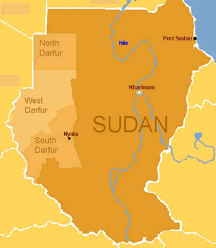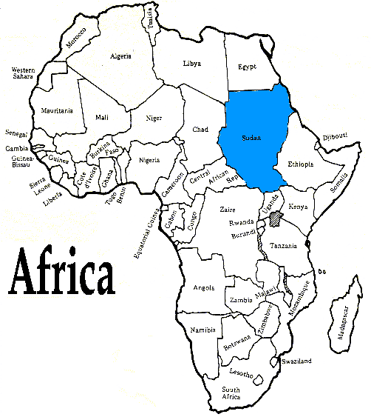

Sources:  Spend 10-15 minutes on each resource reading, exploring, and taking notes. | Main Idea:  What is the main idea of the source? | Details:  Record 2-3 details from the source. | Reaction/Solution: What do you think about this issue/conflict? What’s a possible solution?
The New York Times: Upfront
“Armed & Underage” article

“Somalia: Child Solders”

https://www.youtube.com/watch?v=XxC5XbR0oGI

“Child Soldier”
15 year old Madeleine came to the UN to testify about the horrors of life at the hands of Thomas Lubanga as a Child Soldier.
https://www.youtube.com/watch?v=_6IMjnwztTo
“Warfare Waged by the Young” Map
Child Soldiers
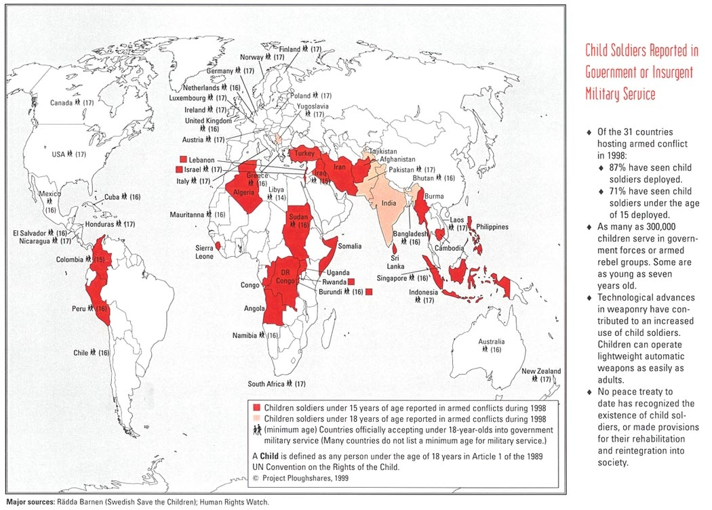
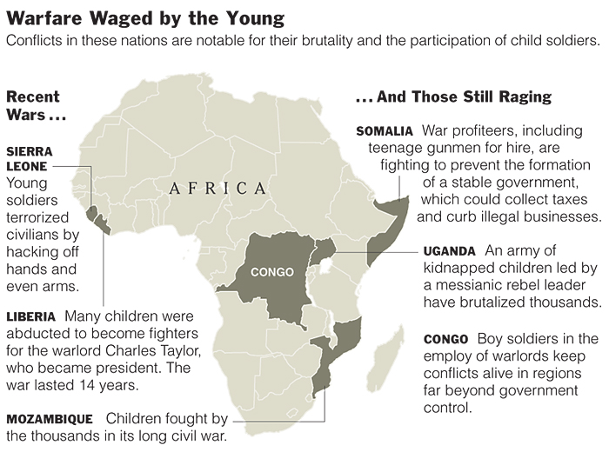
Sources:  Spend 10-15 minutes on each resource reading, exploring, and taking notes. | Main Idea:  What is the main idea of the source? | Details:  Record 2-3 details from the source. | Reaction/Solution: What do you think about this issue/conflict? What’s a possible solution?
“Jay Z: Water for Life”

Watch the 3 videos
http://www.mtv.com/videos/news/120283/together-we-can-do-this.jhtml#id=1545981
Safe Water Map
Safe Water
Blood Diamonds (Conflict Diamonds)
Sources:  Spend 10-15 minutes on each resource reading, exploring, and taking notes. | Main Idea:  What is the main idea of the source? | Details:  Record 2-3 details from the source. | Reaction/Solution: What do you think about this issue/conflict? What’s a possible solution?
National Geographic “Diamonds of War: Africa’s Blood Diamonds”

Watch the first 15 minutes
http://www.youtube.com/watch?v=aaqQjIzIbiY

“Countries with Blood Diamond Sales” and “Africa’s Precious Stones” Maps

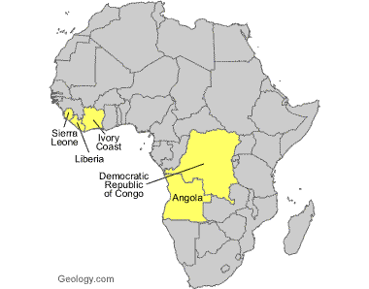
Countries with Blood Diamonds Sales
