Defining and Debating America's Founding Ideals
On a June day in 1776, Thomas Jefferson set to work in a rented room in Philadelphia. His task was to draft a document that would explain to the world why Great Britain's 13 American colonies were declaring themselves to be "free and independent states." The Second Continental Congress had appointed a five-man committee to draft this declaration of independence. At 33, Jefferson was one of the committee's youngest and least experienced members, but his training in law and political philosophy had prepared him for the task. He picked up his pen and began to write words that would change the world.
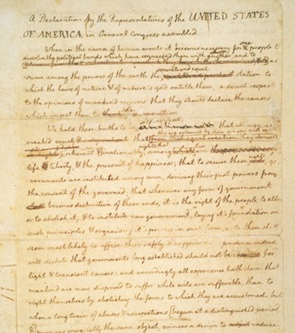
Had he been working at home, Jefferson might have turned to his large library for inspiration. Instead, he relied on what was in his head to make the declaration "an expression of the American mind." He began,
We hold these truths to be self-evident, that all men are created equal, that they are endowed by their Creator with certain unalienable Rights, that among these are Life, Liberty and the pursuit of Happiness.—That to secure these rights, Governments are instituted among Men, deriving their just powers from the consent of the governed.
—Thomas Jefferson, Declaration of Independence, 1776
In these two sentences, Jefferson set forth a vision of a new nation based on ideals. An ideal is a principle or standard of perfection that we are always trying to achieve. In the years leading up to the Declaration, the ideals that Jefferson mentioned had been written about and discussed by many colonists. Since that time, Americans have sometimes fought for and sometimes ignored these ideals. Yet, throughout the years, Jefferson's words have continued to provide a vision of what it means to be an American. In this chapter, you will read about our nation's founding ideals, how they were defined in 1776, and how they are still being debated today.

Section 2 - The First Founding Ideal: Equality
"We hold these truths to be self-evident, that all men are created equal."
When Jefferson wrote these words, this "truth" was anything but self-evident, or obvious. Throughout history, almost all societies had been divided into unequal groups, castes, or social classes. Depending on the place and time, the divisions were described in different terms—patricians and plebeians, lords and serfs, nobles and commoners, masters and slaves. But wherever one looked, some people had far more wealth and power than others. Equality, or the ideal situation in which all people are treated the same way and valued equally, was the exception, not the rule.
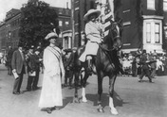
In 1848, a group of women used the Declaration of Independence as a model for their own Declaration of Sentiments on women’s rights. They declared that “all men and women are created equal.” Achieving equality, however, has been a tremendous struggle. This photograph shows a woman, some 60 years later, still marching for the right to vote.
Defining Equality in 1776 For many Americans of Jefferson's time, the ideal of equality was based on the Christian belief that all people are equal in God's eyes. The colonists saw themselves as rooting this ideal on American soil. They shunned Europe's social system, with its many ranks of nobility, and prided themselves on having "no rank above that of freeman."
This view of equality, however, ignored the ranks below "freeman." In 1776, there was no equality for the half million slaves who labored in the colonies. Nor was there equality for women, who were viewed as inferior to men in terms of their ability to participate in society.
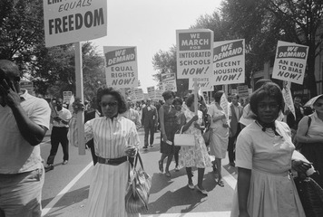
For much of our history, African Americans were treated as less than equal to whites. No one knew that better than the participants of this civil rights march in Washington, D.C., in 1963. Their signs reminded the nation that each person in our society should be treated with equal respect.

Debating Equality Today Over time, Americans have made great progress in expanding equality. Slavery was abolished in 1865. In 1920, a constitutional amendment guaranteed all American women the right to vote. Many laws today ensure equal treatment of all citizens, regardless of age, gender, physical ability, national background, and race.
Yet some people—both past and present—have argued that achieving equal rights does not necessarily mean achieving equality. Americans will not achieve equality, they argue, until we address differences in wealth, education, and power. This "equality of condition" extends to all aspects of life, including living standards, job opportunities, and medical care.
Is equality of condition an achievable goal? If so, how might it best be achieved? These and other questions about equality are likely to be hotly debated for years to come.

Section 3 - The Second Founding Ideal: Rights
"They are endowed by their Creator with certain unalienable Rights."
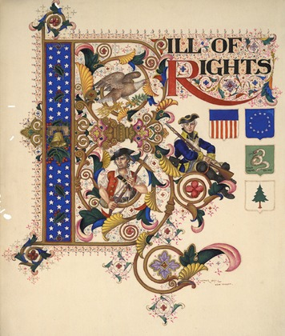
This celebration of the Bill of Rights was painted by Polish American artist Arthur Szyk in 1949. It includes a number of Revolutionary War-era symbols, such as flags, Minutemen, and America’s national bird, the bald eagle. Szyk wanted his work to promote human rights. “Art is not my aim,” he maintained, “it is my means.”
The idea that people have certain rights would have seemed self-evident to most Americans in Jefferson's day. Rights are powers or privileges granted to people either by an agreement among themselves or by law. Living in British colonies, Americans believed they were entitled to the "rights of Englishmen." These rights, such as the right to a trial by jury or to be taxed only with their consent, had been established slowly over hundreds of years. The colonists believed, with some justice, that having these rights set them apart from other peoples in the world.
Defining Rights in 1776 Jefferson, however, was not thinking about specific legal or political rights when he wrote of "unalienable rights." He had in mind rights so basic and so essential to being human that no government should take them away. Such rights were not, in his view, limited to the privileges won by the English people. They were rights belonging to all humankind.
This universal definition of rights was strongly influenced by the English philosopher John Locke. Writing a century earlier, Locke had argued that all people earned certain natural rights simply by being born. Locke identified these natural rights as the rights to life, liberty, and property. Locke further argued that the main purpose of governments was to preserve these rights. When a government failed in this duty, citizens had the right to overthrow it.
Debating Rights Today The debate over what rights our government should preserve began more than two centuries ago, with the writing of the U.S. Constitution and the Bill of Rights, and continues to this day. The Constitution (and its amendments) specifies many basic rights, including the right to vote, to speak freely, to choose one's faith, and to receive fair treatment and equal justice under the law. However, some people argue that the government should also protect certain economic and social rights, such as the right to health care or to a clean environment.
Should our definition of rights be expanded to include new privileges? Or are there limits to the number of rights a government can protect? Either way, who should decide which rights are right for today?

Section 4 - The Third Founding Ideal: Liberty
"That among these [rights] are Life, Liberty and the pursuit of Happiness."
By the time Jefferson was writing the Declaration, the colonists had been at war with Britain for more than a year—a war waged in the name of liberty, or freedom. Every colony had its liberty trees, its liberty poles, and its Sons and Daughters of Liberty (groups organizing against the British). Flags proclaimed "Liberty or Death." A recently arrived British immigrant to Maryland said of the colonists, "They are all liberty mad."
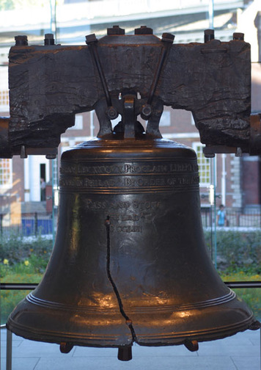
Every year, millions visit the Liberty Bell in Philadelphia’s Independence National Historic Park. The huge bell was commissioned by the Pennsylvania Assembly in 1753. Its every peal was meant to proclaim “liberty throughout all the land.” Badly cracked and battered, the bell is now silent. But it remains a beloved symbol of freedom.
Defining Liberty in 1776 Liberty meant different things to different colonists. For many, liberty meant political freedom, or the right to take part in public affairs. It also meant civil liberty, or protection from the power of government to interfere in one's life. Other colonists saw liberty as moral and religious freedom. Liberty was all of this and more.
However colonists defined liberty, most agreed on one point: the opposite of liberty was slavery. "Liberty or slavery is now the question," declared a colonist, arguing for independence in 1776. Such talk raised a troubling question. If so many Americans were so mad about liberty, what should this mean for the one fifth of the colonial population who labored as slaves? On the thorny issue of slavery in a land of liberty, there was no consensus.
Debating Liberty Today If asked to define liberty today, most Americans would probably say it is the freedom to make choices about who we are, what we believe, and how we live. They would probably also agree that liberty is not absolute. For people to have complete freedom, there must be no restrictions on how they think, speak, or act. They must be aware of what their choices are and have the power to decide among those choices. In all societies, there are limits to liberty. We are not, for example, free to ignore laws or to recklessly endanger others.
Just how liberty should be limited is a matter of debate. For example, most of us support freedom of speech, especially when it applies to speech we agree with. But what about speech that we don't agree with or that hurts others, such as hate speech? Should people be at liberty to say anything they please, no matter how hurtful it is to others? Or should liberty be limited at times to serve a greater good? If so, who should decide how, why, and under what circumstances liberty should be limited?

Section 5 - The Fourth Founding Ideal: Opportunity
"That among these [rights] are Life, Liberty and the pursuit of Happiness."
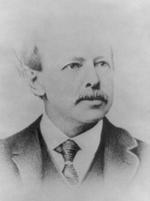
Horatio Alger, author of Strive and Succeed, wrote more than 100 “dime novels” in the late 1800s. Many of these inexpensive books were about opportunity.
Something curious happened to John Locke's definition of natural rights in Jefferson's hands. Locke had included property as the third and last right in his list. But Jefferson changed property to "the pursuit of Happiness." The noted American historian Page Smith wrote of this decision,
The change was significant and very American . . . The kings and potentates, the powers and principalities of this world [would not] have thought of including "happiness" among the rights of a people . . . except for a select and fortunate few. The great mass of people were doomed to labor by the sweat of their brows, tirelessly and ceaselessly, simply in order to survive . . . It was an inspiration on Jefferson's part to replace [property] with "pursuit of happiness" . . . It embedded in the opening sentences of the declaration that comparatively new . . . idea that a life of weary toil . . . was not the only possible destiny of "the people."
—Page Smith, A New Age Now Begins, 1976
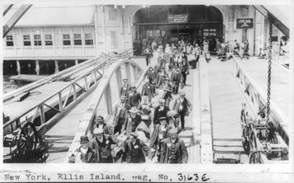
Many foreigners come to America looking for the opportunity to achieve the American dream. The American dream is the concept that poor could become successful through hard work, courage, and concern for others.
The destiny that Jefferson imagined was one of endless opportunity, or the chance for people to pursue their hopes and dreams.
Defining Opportunity in 1776 The idea that America was a land of opportunity was as old as the colonies themselves. Very soon after colonist John Smith first set foot in Jamestown in 1607, he proclaimed that here "every man may be master and owner of his owne labour and land." Though Jamestown did not live up to that promise, opportunity was the great lure that drew colonists across the Atlantic to pursue new lives in a new land.
Debating Opportunity Today More than two centuries after the Declaration of Independence was penned, the ideal of opportunity still draws newcomers to our shores. For most, economic opportunity is the big draw. Here they hope to find work at a decent wage. For others, opportunity means the chance to reunite families, get an education, or live in peace.
For all Americans, the ideal of opportunity raises important questions. Has the United States offered equal opportunity to all of its people? Or have some enjoyed more opportunity to pursue their dreams than have others? Is it enough to "level the playing field" so that everyone has the same chance to succeed in life? Or should special efforts be made to expand opportunities for the least fortunate among us?

Section 6 - The Fifth Founding Ideal: Democracy
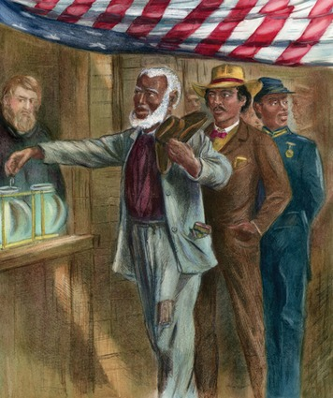
The right to vote is so basic to a democracy that most Americans today think little about it. For much of our history, however, that right was denied to women and most African Americans. Their “consent” was not considered important to those who governed.
"That to secure these rights, Governments are instituted among Men, deriving their just powers from the consent of the governed."
In these few words, Jefferson described the basis of a democracy—a system of government founded on the simple principle that the power to rule comes from the consent of the governed. Power is not inherited by family members, as in a monarchy. Nor is it seized and exercised by force, as in a dictatorship. In a democracy, the people have the power to choose their leaders and shape the laws that govern them.
Defining Democracy in 1776 The colonists were familiar with the workings of democracy. For many generations, the people had run their local governments. In town meetings or colonial assemblies, colonists had learned to work together to solve common problems. They knew democracy worked on a small scale. But two questions remained. First, could democracy be made to work in a country spread over more than a thousand miles? In 1776, many people were not sure that it could.
The second question was this: Who should speak for "the governed"? In colonial times, only white, adult, property-owning men were allowed to vote or hold office. This narrow definition of voters did not sit well with many Americans, even then. "How can a Man be said to [be] free and independent," protested citizens of Massachusetts in 1778, "when he has not a voice allowed him" to vote? As for women, their voices were not yet heard at all.
Debating Democracy Today The debate over who should speak for the governed was long and heated. It took women more than a century of tenacious struggle to gain voting rights. For many minority groups, democracy was denied for even longer. Today, the right to vote is universal for all American citizens over the age of 18.
Having gained the right to vote, however, many people today do not use it. Their lack of participation raises challenging questions. Why do so many Americans choose not to make their voices heard? Can democracy survive if large numbers of citizens decide not to participate in public affairs?

Section 7 - In Pursuit of America's Ideals
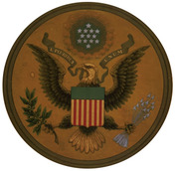
The front of the Great Seal features a bald eagle and a shield with 13 red and white stripes, representing the original 13 states. The scroll in the eagle’s beak contains our national motto, E Pluribus Unum, which means “Out of Many, One.” The motto refers to the creation of one nation out of 13 states.
"Ideals are like stars," observed Carl Schurz, a German American politician in the late 1800s. "You will not succeed in touching them with your hands, but like the seafaring man on the ocean desert of waters, you choose them as your guides, and, following them, you reach your destiny." In this book, the ideals found in the Declaration of Independence will serve as your guiding stars. You will come upon these ideals again and again—sometimes as points of pride, sometimes as prods to progress, and sometimes as sources of sorrow.
Living up to these ideals has never been a simple thing. Ideals represent the very highest standards, and human beings are far too complex to achieve such perfection. No one illustrates that complexity more clearly than Jefferson. Although Jefferson believed passionately in the Declaration's ideals, he was a slaveholder. Equality and liberty stopped at the borders of his Virginia plantation. Jefferson's pursuit of happiness depended on depriving the people who labored for him as slaves the right to pursue happiness of their own.
Soon after the Continental Congress approved the Declaration of Independence, it appointed a committee to design an official seal for the United States. The final design appears on the back of the one-dollar bill. One side shows an American eagle holding symbols of peace and war, with the eagle facing toward peace. The other shows an unfinished pyramid, symbolizing strength and endurance. Perhaps another reason for the unfinished pyramid was to show that a nation built on ideals is a work in progress. As long as our founding ideals endure, the United States will always be striving to meet them.

