#1

http://www.youtube.com/watch?v=WXwg_G8_Enc&feature=player_embedded#!

Cesar Chavez from The Fight in the Fields

#2

Paula Crisostomo, a high school leader
Interview by Jesus Treviño, February 15, 1993.
“Our schools…on the Eastside were in such poor condition as compared to other schools. We had taken this [trip] to…Paley High. And just the physical appearance was appalling to all of us. And I know for myself, never having ventured very far from my own neighborhood…just traveling out and seeing how other people lived and how other kids went to school…And there was the building of the new high school, Wilson [in East Los Angeles], which was taking an awfully long time…And again schools in the Valley and West LA, brand new schools, were being put up right away with swimming pools.”

#3
Corky Gonzales, "What Political Road for the Chicano Militant?" speech, 1969.
Background information: While some Mexican Americans sought to improve their standard of living by fighting for greater economic justice under the leadership of Cesar Chavez (1927–93) (founder of the United Farm Workers of America), Corky Gonzales and other Mexican Americans sought political self-determination for the Chicano people.
[ . . . ]
We [Mexican-Americans] have to understand that liberation comes from self-determination, and to start to use the tools of nationalism to win over our barrio brothers, to win over the brothers who are still believing that machismo means getting a gun and going to kill a Communist in Vietnam because they've been jived about the fact that they will be accepted as long as they go get themselves killed for the gringo captain; who still think that welfare is giving them something and don't understand that the one who is administering the welfare is the one that's on welfare, because, about 90 percent of the welfare goes into administration; and who still do not understand that the war on poverty is against the poor, to keep them from reacting.
[ . . . ]

#4

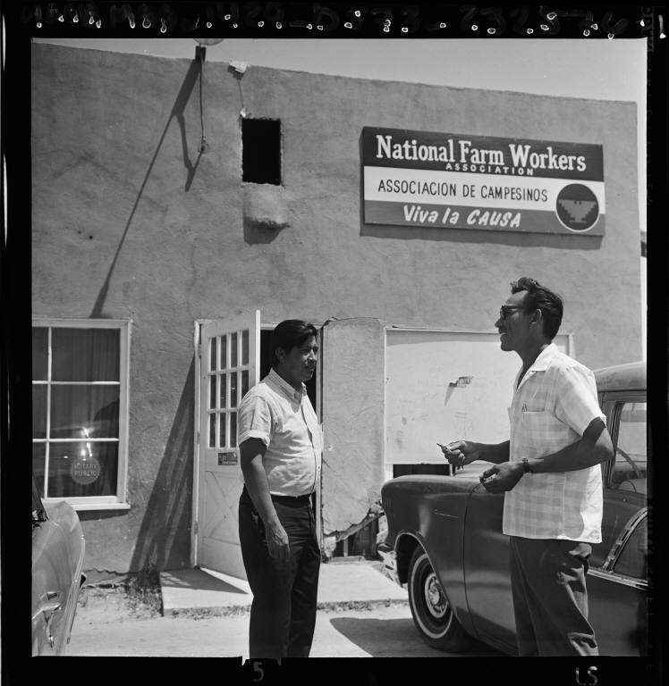
Cesar Chavez at National Farm Workers Association headquarters

#5
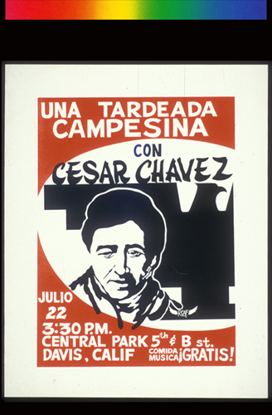

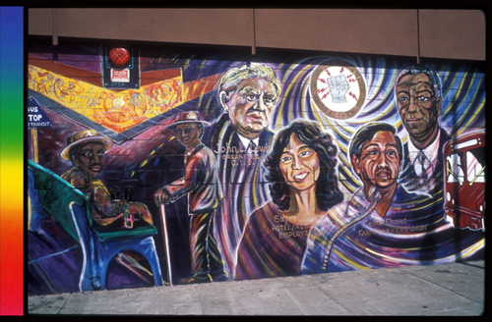
Labor in San Diego

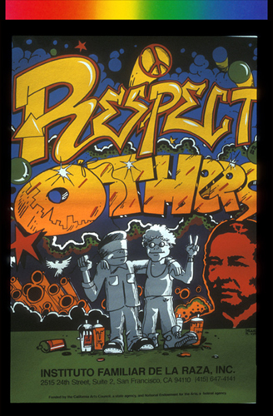
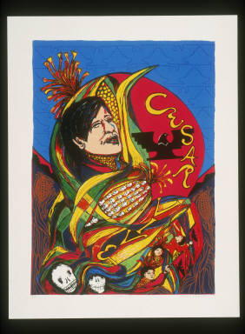

#6
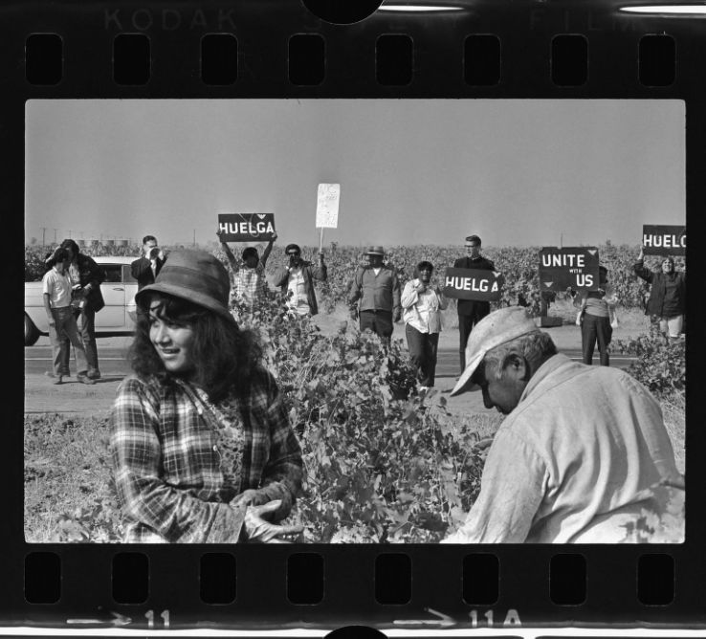
United Farm Worker's strike in Delano (Calif.)
Strike Call--Pickets gather at edge of grape field at Delano to urge workers, foreground, to join strike, but these two ignored the call. Among the pickets, who later were arrested, is the Rev. Roger Ridgway of Hayward. Word "Huelga" is Spanish for strike.

#7
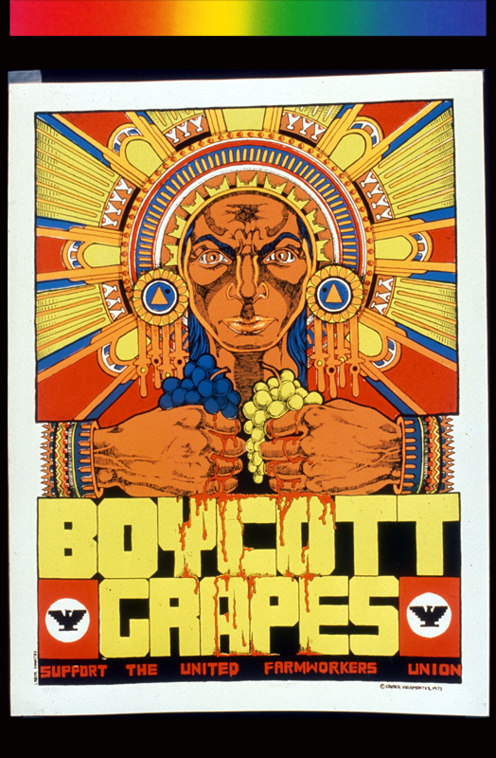
Boycott Grapes: Support the United Farmworkers Union
#8

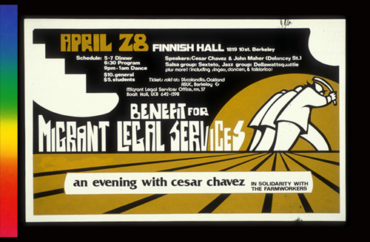
Benefit For Migrant Legal Services, Announcement poster for

#9
Chicano Rights Timeline

1962 - December 14 - The National Farm Workers Association was founded by Cesar Chavez.
1964 – January 8 – President Lyndon Johnson declares “War on Poverty”
- Civil Rights Acts were established.
1965– September 1965 – Agricultural Workers Organizing Committee
(AWOC) Filipina field hands joined workers Grape Boycott.
– Acuna starts teaching first Mexican American history class in Los
Angles, California.
1967 – The Mexican American Youth Organization (MAYO) was formed.
- Two Yakima College Students are inspired by the Grape Boycott and go to California to meet Cesar Chavez.
1968 – March 3 – A primarily Chicano school, Abraham Lincoln High School protested school policies and teachers.
- May 20 – BSU members sit-in University of Washington
- May 27 – Grand jury indicts conspiracy for disrupting peace in school walk out.
1969 – February 16 - University of Washington’s Grape Boycott halts 16
grape companies.
1971 – The FBI’s Counter Intelligence Program infiltrates Chicano Organization.
1972-Ramona Acosta Banuelos becomes the first Hispanic treasurer of the United States.
1973 - January 23 – Chicano students occupy a building and present a list of demands about classes specifically for ethnic studies to Yakima Valley College.
1974 – May 2 – 40 students lead by the University of Washington’s MEChA, demanding more Chicano’s to fill administrative positions, and equal rights for graduating Chicano students.
1975 – The Voting Rights Act of 1965 is extended to “Hispanic Americans”
- Boycott of Grapes was successful and finally was brought to an end.
1976 – Chicano student charges law school with discrimination.
1986 - November 6 – Congress enacts The Immigration Reform and Control Act, making it able for illegal immigrants to become legal by applying for an application who had been in the United States illegally since January 1, 1982.
1988 - Regan appoints the first Hispanic Secretary of Education Lauro F. Cavazoa.

#10

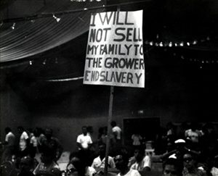
Protest from the Chicano Movement.

