The Civil Rights Revolution: "Like a Mighty Stream"

How did civil rights activists advance the ideals of liberty, equality, and opportunity for African Americans?

Section 1- The Courts Begin to Dismantle Segregation
In 1951, getting to school every day was hard for Linda Brown, a seven-year-old in Topeka, Kansas. First she had to walk a mile, passing through a railroad yard on her way to the bus stop. Then she had to take a long bus ride to school. All of this made no sense to Linda because there was a good school only seven blocks from her house. But the schools in Topeka were segregated. The school near Linda was for whites only, and Linda was black. Her father, Oliver Brown, decided to do something about that. With the help of the court system, Brown and other civil rights activists began to dismantle segregation.
Early Court Decisions Make Big Strides In the 1930s and 1940s, the Supreme Court began to strike down Jim Crow laws. In 1935, the Court ordered the University of Maryland to admit a black student. Later it declared white primaries unconstitutional and barred segregation on interstate transport. These were important steps in breaking down segregation.
In 1948, the Supreme Court tackled the issue of segregated housing. In Shelley v. Kraemer, the Court ruled that states could not enforce restrictive covenants. As a result, many city neighborhoods became desegregated. Over the next few years, for example, thousands of black families in Chicago moved into areas that had previously been restricted to whites.
In 1950, the Court handed down strong rulings against discrimination in education. In two cases, the Court declared that segregation in graduate schools and law schools was unconstitutional. It began to look as if all “separate but equal” education was on the way out.
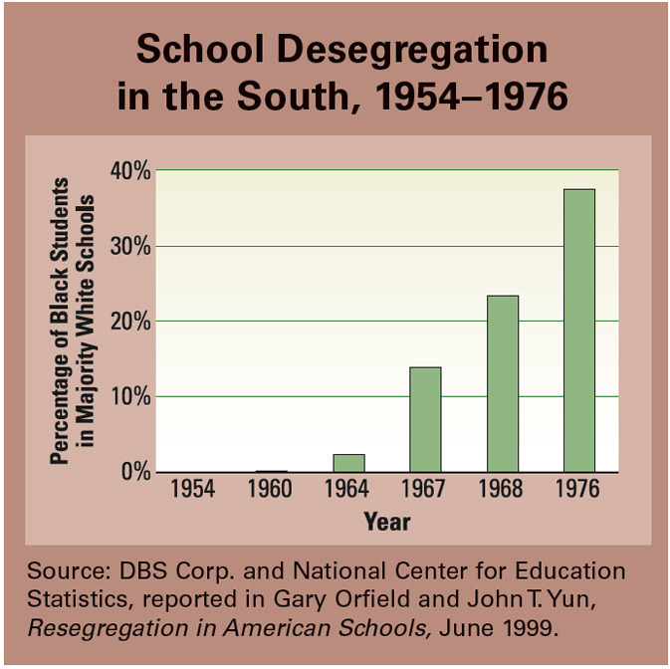
A Landmark Ruling: Brown v. Board of Education Meanwhile in Topeka, Oliver Brown, Linda’s father, had contacted the NAACP, which in turn gathered 12 other parents to join in efforts to desegregate the city’s schools. First the parents tried to enroll their children in white schools, but all were denied admission. So in 1951 the NAACP sued the Topeka school district in court. A local court found “no willful discrimination.” The NAACP appealed the case, and it went all the way to the Supreme Court.
Brown vs Board of Education was actually a set of cases from Kansas, South Carolina, Virginia, Delaware, and Washington, D.C., that had moved up through the court system at the same time. The Court decided to combine the cases because the plaintiffs were all looking for the same legal remedy. The Brown case was a class-action lawsuit, a lawsuit filed by people on behalf of themselves and a larger group who might benefit.

In the first 10 years after the Brown ruling, slow progress was made in school desegregation. After 1964, however, the pace of desegregation quickened.
The NAACP’s lead attorney, Thurgood Marshall, argued the case. He supplied evidence showing how segregation harms African American children. The most famous piece of evidence was the “doll test.” In the test, 16 black children had been shown a white doll and a brown doll. Ten of the children chose the white doll as the “nice” doll. The children were also asked to identify the doll that looked “bad.” Eleven children selected the black doll. According to the psychologist who conducted the test, “the Negro child accepts as early as six, seven or eight the negative stereotypes about his own group.”
The Brown case stayed in the Supreme Court for a year and a half. During this time, a new chief justice, Earl Warren, was appointed to the Court. Warren was a firm opponent of segregation. Believing that a unanimous decision in the Brown case would carry more weight than a divided one, he worked hard to convince all the judges to rule in favor of the plaintiffs. Finally, in May 1954, he succeeded. On May 17, he announced the Supreme Court ruling in Brown v. Board of Education:
We come then to the question presented: Does segregation of children in public schools solely on the basis of race, even though the physical facilities and other “tangible” factors may be equal, deprive the children of the minority group of equal educational opportunities? We believe that it does . . . We conclude that in the field of public education the doctrine of “separate but equal” has no place. Separate educational facilities are inherently unequal. Therefore, we hold that the plaintiffs and others similarly situated for whom the actions have been brought are, by reason of the segregation complained of, deprived of the equal protection of the laws guaranteed by the Fourteenth Amendment.
—Brown v. Board of Education, 1954

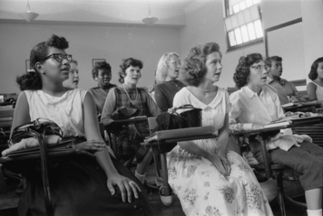
This photo shows an integrated classroom in Washington D.C., 1957. Black and white students sit side by side in the classroom.

The Brown decision dismantled the legal basis for segregation in schools and other public places. It was one of the most important judicial decisions in the nation’s history. It was also one of many key rulings on civil rights made by the Court under Earl Warren, who served as chief justice from 1953 to 1969. In fact, the Warren Court became known for its activism on civil rights and free speech.
All Deliberate Speed? Much of the South Resists Change A year after the Brown decision, the Supreme Court issued a second ruling, known as Brown II. This ruling instructed the states to begin desegregation “with all deliberate speed.” The phrase was chosen carefully. The justices wanted desegregation to go forward as quickly as possible, but they also recognized that many obstacles stood in the way. They wanted to allow states some flexibility in desegregating their schools in accordance with Brown.
In some border states, desegregation took place without incident. But in parts of the South, there was greater resistance. For example, in 1955 a white citizens’ council in Mississippi published a handbook called Black Monday, referring to the day the Supreme Court handed down the Brown decision. The handbook called for an end to the NAACP and public schools. It also advocated a separate state for African Americans.
Despite such opposition, the Brown decision inspired hopes that African Americans could achieve equal rights in American society. It served as a catalyst for the civil rights movement of the 1950s and 1960s, a time when many individuals and groups dedicated themselves to promoting equality, opportunity, and rights.

Section 2- Overview of Civil Rights movement following Brown v. Board.
Four decades later, Cardell Gay still remembered the day—May 3, 1963—when hundreds of young people marched through the streets of Birmingham, Alabama, to protest segregation. “The police were there with their dogs and their hoses,” he recalled. “And . . . although they had instructed us to stop, we would not stop. We continued to move closer to them. What they did, they let it fly.”
What the police “let fly” was water from a high-pressure fire hose. “It knocked us on the ground,” Gay said. “The hoses were so strong . . . [the water] . . . would knock us all over the place, send you tumbling.” The force of the blast even rolled children down the street.

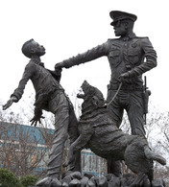
Hundreds of child marchers were arrested in a Birmingham park in May 1963. Today that park features monuments honoring those children and their fight against segregation.

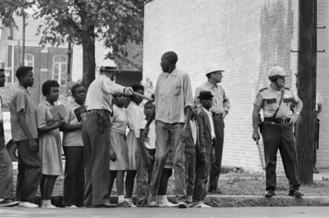
It was the second day of marches by young people in Birmingham that spring. Gay was 16 at the time. His high school teachers had influenced his decision to march. “In class, they’d say, ‘Don’t leave campus or you’ll be expelled,’” Gay explained years later. “But in private, they’d say, ‘Go on. I can’t do it, I’d lose my job. But do it up. Keep it up.’”
More than a thousand young people, some as young as five, marched on May 2, the first day of the protest. Hundreds were arrested for marching without a permit. The following day, an even larger force of young blacks turned out to march. Police Chief Bull Connor ordered them to be dispersed with fire hoses. As the youngsters fled, policemen chased them down with clubs and dogs.

Children arrested during Birmingham civil rights marches
Connor ordered them to be dispersed with fire hoses. As the youngsters fled, policemen chased them down with clubs and dogs.
The Birmingham protests showed that African Americans were not going to back down in their struggle for civil rights. They would persist until they reached their goal. “I’ll keep marching till I get freedom,” one 12-year-old protester declared.
In this chapter, you will learn about key events in the early years of the civil rights movement. The years from 1955 to 1965 witnessed efforts to desegregate buses, schools, lunch counters, and other public places. During these years, civil rights activists also worked to secure voting rights for African Americans.

Section 3- A Boycott in Montgomery Inspires a Movement
Although the 1954 Supreme Court ruling in Brown v. Board of Education outlawed segregation in public schools, segregation continued in much of the South. Law and custom still required blacks and whites to use separate facilities, like drinking fountains and waiting rooms, and to sit separately in restaurants and on buses. In 1955, however, a boycott in Montgomery, Alabama, began to shake up the Jim Crow South.
Protesting Unfair Bus Laws
In the 1950s, public buses in Montgomery were segregated, as they were throughout the South. African Americans had to sit at the back of the bus. If the bus was full, they were required to give up their seats to white riders. Furthermore, blacks could never share a row with whites.

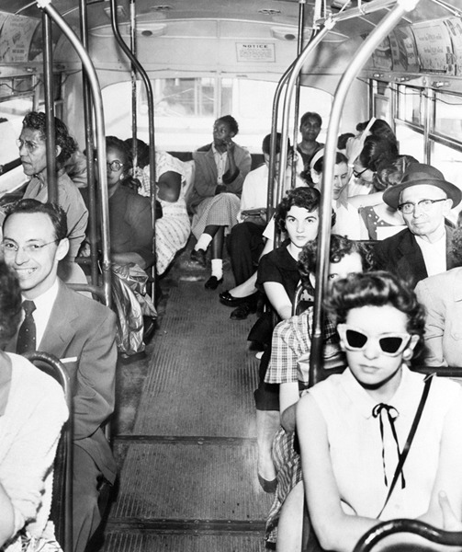Public buses were rigidly segregated in the South. If a bus was full, black passengers had to make way for whites. In 1955, however, activists in Montgomery, Alabama, organized a successful bus boycott and achieved integration on city buses.
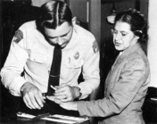
Leaders of the Montgomery chapter of the NAACP had been looking for a test case to fight segregation. Parks, who was well-spoken and had a solid reputation in the community, seemed perfect. E. D. Nixon, a local activist, asked Parks if the NAACP could build a case around her arrest, and Parks agreed.
The following evening, a group of African American ministers met to plan a strategy. They decided to hold a one-day bus boycott on December 5. Black ministers announced the boycott at Sunday services, and activists distributed leaflets asking African Americans to take part.

That was about to change. On December 1, 1955, Rosa Parks, a 43-year-old African American woman, refused to give up her seat on a bus to a white passenger. Parks, a seamstress, had been active in the Alabama chapter of the National Association for the Advancement of Colored People. Years later, Parks described her motives for remaining in her seat: “This is what I wanted to know: when and how would we ever determine our rights as human beings?”
Rosa Parks was arrested for refusing to give up her seat on a bus to a white man. When told by the driver that he was going to call the police, she calmly replied, “You may go on and do so.” Her action served as a catalyst for the Montgomery Bus Boycott.

On December 5, a sign at a Montgomery bus stop read, “People, don’t ride the bus today. Don’t ride it, for freedom.” On that day, 90 percent of African Americans who usually rode the bus honored the boycott.
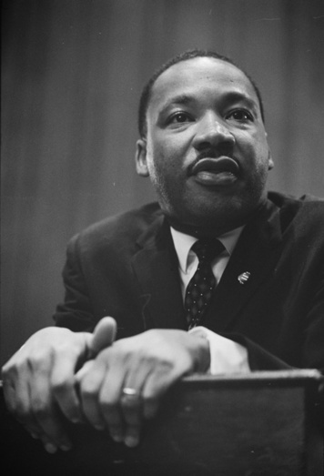
A Young Minister Becomes a Leader
The one-day boycott was so successful that the organizers, who called themselves the Montgomery Improvement Association (MIA), decided to extend it. To lead the Montgomery Bus Boycott, the MIA chose a 26-year-old minister, Martin Luther King Jr.
King was pastor of the Dexter Avenue Baptist Church. Originally from Atlanta, King had come to Montgomery after completing a Ph.D. in theology at Boston University. He had been in town two years when the boycott began. King explained the purpose of the action in a speech to a mass meeting at Holt Street Baptist Church on the evening of December 5:
My friends, I want it to be known that we’re going to work with grim and bold determination to gain justice on the buses in this city. And we are not wrong, we are not wrong in what we are doing. If we are wrong, the Supreme Court of this nation is wrong. If we are wrong, the Constitution of the United States is wrong. If we are wrong, God Almighty is wrong . . . If we are wrong, justice is a lie. And we are determined here in Montgomery to work and fight until justice runs down like water and righteousness like a mighty stream.
To make the boycott work, African Americans in Montgomery organized an elaborate carpool system to get around town. Several thousand people used the carpools daily. Others walked, rode bicycles, took taxis, or hitchhiked.

Reverend Martin Luther King Jr. quickly established himself as a leader in the struggle for civil rights. King’s use of nonviolent protest—which he learned from studying the great Indian leader Mahatma Gandhi—helped shape the civil rights movement. Here he is answering questions during a press conference.

Many of Montgomery’s white leaders did everything they could to stop the boycott and preserve segregation. Some business owners fired black protesters from their jobs. Other people took more drastic action. Some radical segregationists, including members of the Ku Klux Klan, attacked protesters and even set off bombs at the houses of boycott leaders. They also firebombed several churches that served the black community.
In November 1956, the Supreme Court upheld an Alabama court’s ruling that segregation on buses was unconstitutional. About a month later, on December 20, the protesters voted to end the boycott, which had lasted 381 days. As a result of the Montgomery Bus Boycott, Martin Luther King Jr. earned a national reputation as a civil rights leader.
African American Churches Support the Movement
After the boycott, King worked with other ministers and civil rights leaders to form the Southern Christian Leadership Conference (SCLC) in 1957. With King as its president, the SCLC would play a major role in the civil rights movement.
The SCLC pledged to use nonviolent resistance to redeem “the soul of America.” Nonviolent resistance is peaceful protest or noncooperation with authorities that is designed to achieve social or political goals. In a public statement on January 11, 1957, the SCLC explained the strategy:
Nonviolence is not a symbol of weakness or cowardice, but as Jesus demonstrated, nonviolent resistance transforms weakness into strength and breeds courage in the face of danger. We urge . . . [African Americans], no matter how great the provocation, to dedicate themselves to this motto: “Not one hair of one head of one white person shall be harmed.”
—SCLC, “A Statement to the South and Nation,” January 11, 1957
Supporters of the SCLC vowed that they would not resort to violence to achieve their ends but would remain peaceful and steadfast in their pursuit of justice. This would prove to be a powerful tactic in the struggle for civil rights.

Section 4 - School Desegregation
After the Brown ruling, some districts and states in the South desegregated their schools quickly. Others, however, resisted the Supreme Court decision. Governors of several southern states staunchly maintained their opposition to integration. The governors of Arkansas and Mississippi, for example, aggressively intervened in an effort to prevent blacks from attending all-white schools. The battle to integrate public schools proved to be long and difficult.
Nine Teenagers Integrate Central High School
In 1957, a federal judge ordered public schools in Little Rock, Arkansas, to begin desegregation. The Little Rock school superintendent, Virgil Blossom, hoped to postpone the change as long as possible. He set up a plan to integrate just one school, Central High School. Two thousand white students attended Central. In September 1957, nine black students were scheduled to join them. They would later be known as the Little Rock Nine.

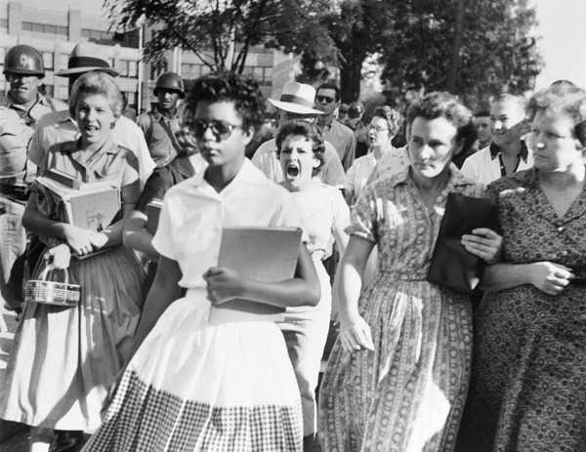
In 1957, nine black students, including Elizabeth Eckford (shown here), challenged segregation by enrolling at Central High School in Little Rock, Arkansas. The governor and a mob of angry citizens tried to stop them, but the federal government backed them up. Eventually all southern states integrated their public schools.

long as possible. He set up a plan to integrate just one school, Central High School. Two thousand white students attended Central. In September 1957, nine black students were scheduled to join them. They would later be known as the Little Rock Nine.
Citing public opposition to integration in Arkansas, Governor Orval Faubus declared that he would not support desegregation in Little Rock. Faubus called out the Arkansas National Guard. On September 4, 1957, the day the nine students were to begin classes, the troops appeared at Central High as a show of force and to prevent the students from entering the building. One of the students, Elizabeth Eckford, recalled being surrounded by an angry white crowd outside the school:
They moved closer and closer . . . I tried to see a friendly face somewhere in the crowd—someone who maybe would help. I looked into the face of an old woman and it seemed a kind face, but when I looked again, she spat on me.
—Elizabeth Eckford, in an interview with NAACP official Daisy Bates
Another white woman later emerged from the crowd and helped to shield Eckford from harm. But Eckford and her fellow black students were kept out of school that day and for days afterward.
Finally, on September 23, the Little Rock Nine returned to Central High. Once again, an angry white mob surrounded the school. This time, though, the mayor of Little Rock sought help from President Eisenhower. Although Eisenhower did not believe that integration should be accomplished by force, he could not allow defiance of federal authority. The president issued Executive Order 10730, sending in federal troops to maintain order and enforce the integration of the school. Eisenhower also put the Arkansas National Guard under federal control. The students rode to school in a convoy led by army jeeps with guns mounted on their hoods. They also had military bodyguards to protect them—at least for part of the school year.
Despite this protection, the black students were subjected to insults and acts of violence from white students. As one of the nine, Minnijean Brown, said at the time, “They throw rocks, they spill ink on your clothes . . . they bother you every minute.” Melba Pattillo was another one of the students. Acid was thrown in her eyes, and only the quick action of her bodyguard saved her eyesight. The students and their families also received death threats.
Eight of the nine African American students finished out the year at Central High. The following year, however, Governor Faubus closed all the Little Rock schools rather than allow another year of integration. It was not until September 1959 that integration continued in Little Rock.
James Meredith Enrolls at the University of Mississippi
Public universities were also required to integrate. In 1961, James Meredith, an African American veteran of the Korean War, applied for admission as a transfer student to the University of Mississippi, commonly known as Ole Miss. The university had traditionally been all white, and Meredith knew he would be taking a stand to integrate it.
When his application was rejected, Meredith turned to the NAACP to help him take his case through the courts. At first, a district court ruled against him. On appeal, however, a higher court ruled that the university had to admit Meredith. Refusing him admission, the court said, amounted to the state of Mississippi maintaining segregation.

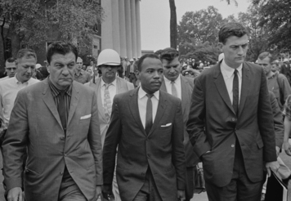
James Meredith required protection from U.S. Marshals in order to attend classes at Ole Miss. He was the first African American to attend Ole Miss. He later wrote that the country’s future “rests on . . . whether or not the Negro citizen is to be allowed to receive an education in his own state.”

Mississippi governor Ross Barnett vowed that no black student would attend Ole Miss while he was in office. On September 20, Barnett, acting as university registrar, personally refused to enroll Meredith.
But President John F. Kennedy, also known as JFK, and Attorney General Robert Kennedy were determined to uphold the law as Brown had defined it. Although JFK was concerned about losing Democratic support in the South, he was sympathetic to the civil rights movement. In a nationally broadcast speech, he declared, “Americans are free to disagree with the law but not to disobey it.”
On Sunday, September 30, 1962, James Meredith secretly arrived on campus. When the news got out that night, a riot erupted. Angry white students burned cars and destroyed property. Before the night was over, two men had been shot and killed.
President Kennedy sent armed federal marshals to protect Meredith so he could attend classes. Meredith survived verbal taunts and threats against his life and the lives of his parents. But he had always known what was at stake. Just days before entering Ole Miss, he had written, “The price of progress is indeed high, but the price of holding back is much higher.” Meredith graduated from Ole Miss in the summer of 1963.

Section 5 - Sit-Ins and Freedom Rides
The campaign to integrate public facilities in the South continued through the 1960s. During this time, a growing student movement influenced the direction of the civil rights struggle. Student protesters challenged segregation in various ways. They sat down in “whites-only” public places and refused to move, thereby causing the business to lose customers. This tactic is known as a sit-in. They also boycotted businesses that maintained segregation. And they rode interstate buses that many whites in the South tried to keep segregated.
Sitting Firm to Challenge Segregated Facilities
On February 1, 1960, four African American students from North Carolina’s Agricultural and Technical College sat down at a lunch counter in the Woolworth’s drugstore in Greensboro. They ordered food, but the waitress refused to serve them, saying that only white customers could eat at Woolworth’s.

The four students stayed at the counter until the store closed. One of the four, Franklin McCain, explained later that the group did not like being denied “dignity and respect.” They decided to return the next day, and about 20 other people joined them. They sat at the counter all day, but were not served.
During the 1960s, sit-ins like this one captured nationwide attention for the civil rights movement. As news of the Greensboro action spread, protesters began sit-ins in towns and cities across the South.

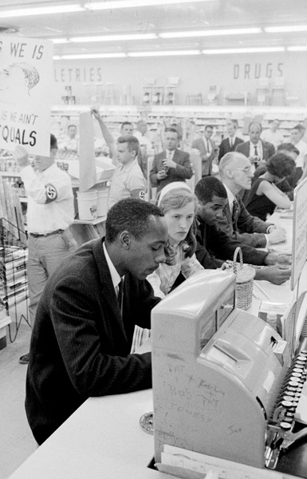
Across the South, protesters held sit-ins to integrate lunch counters. The demonstrators remained nonviolent, even when local residents taunted them.

The Greensboro protests continued for months. In April, the city’s blacks organized a boycott of Woolworth’s and another local store with a segregated lunch counter. Eventually the local businesses gave in. On July 25, 1960, the first African American ate at the Woolworth’s lunch counter in Greensboro.
Black students also mounted a large sit-in campaign in Nashville, Tennessee. As in Greensboro, Nashville’s African American community followed up with a boycott of downtown businesses. And once again, local business owners and public officials gave in. On May 10, 1960, Nashville became the first major city in the South to begin integrating its public facilities.
Students Organize to Make a Difference
The sit-ins and boycotts began to transform the segregated South and change the civil rights movement. College students took the lead in the sit-ins, and many became activists in the movement.
In April 1960, Ella Baker, a leader with the SCLC, called a meeting of student civil rights activists in Raleigh, North Carolina. Although Baker herself was 55 years old and no longer a student, she believed it was important for students to organize and run their own organization.
Under Baker’s guidance, the students formed the Student Nonviolent Coordinating Committee (SNCC), pronounced “snick.” SNCC’s Statement of Purpose, written in May 1960, affirmed the new organization’s commitment to justice, peace, and nonviolence:
We affirm the philosophical or religious ideal of nonviolence as the foundation of our purpose . . . Through nonviolence, courage displaces fear; love transforms hate. Acceptance dissipates prejudice; hope ends despair. Peace dominates war; faith reconciles doubt. Mutual regard cancels enmity. Justice for all overthrows injustice.
SNCC trained students in civil disobedience, counseling them to deliberately break laws they considered unjust. SNCC leaders emphasized that protesters must not use violence, even if they were physically attacked. One SNCC training document explained, “You may choose to face physical assault without protecting yourself, hands at the sides, unclenched; or you may choose to protect yourself, making plain you do not intend to hit back.”
SNCC members planned and participated in direct action throughout the South. Direct action refers to political acts, including protests of all types, designed to have an immediate impact. SNCC members played a major role in various campaigns of nonviolent direct action over the next several years.
Freedom Riders Face Violence One direct action targeted the interstate bus system in the South. In 1960, the Supreme Court ruled that segregation in interstate transport was illegal. In the spring of 1961, the civil rights group Congress of Racial Equality (CORE) organized Freedom Rides to test whether southern states were complying with the ruling.
On May 4, 1961, seven blacks and six whites boarded two buses in Washington, D.C., and headed south. When the first bus reached Anniston, Alabama, on May 14, a white mob attacked the Freedom Riders.
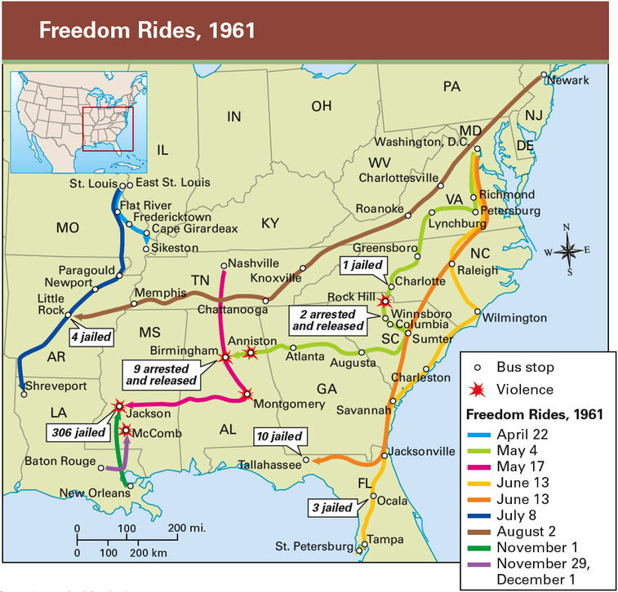

south. When the first bus reached Anniston, Alabama, on May 14, a white mob attacked the Freedom Riders. The mob followed the bus as it left town, threw a firebomb through the window, and then beat the passengers as they fled the bus. Passengers on the second bus were also beaten when they arrived in Alabama.
CORE abandoned the Freedom Rides, but SNCC continued them. Finally, Attorney General Robert Kennedy sent federal marshals to ensure safe passage for the riders to Jackson, Mississippi. When the Freedom Riders arrived, however, Jackson officials arrested them. They suffered physical abuse while in jail, but most became even more committed to ending segregation.
In late 1962, the Interstate Commerce Commission issued clear rules stating that buses and bus terminals involved in interstate travel must be integrated. CORE’s leader, James Farmer, proclaimed victory for the Freedom Rides.
Section 6- A Campaign in Birmingham
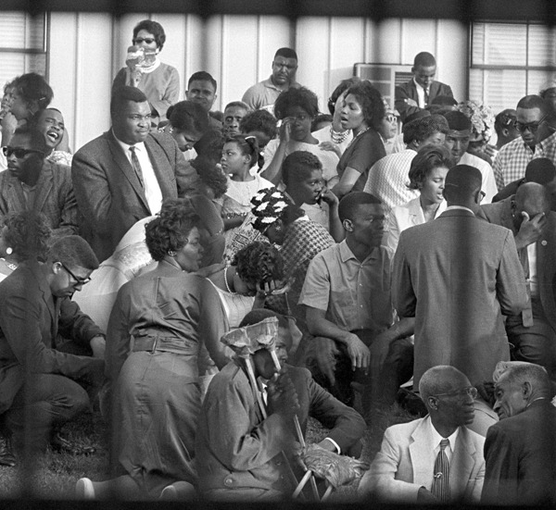
In the early 1960s, Birmingham, Alabama, was a steel-mill town with a long history of bigotry. Martin Luther King Jr. called it the most segregated city in the country. As a result, the SCLC decided to focus its attention there in 1963.
Taking Aim at the Nation’s Most Segregated City
Black residents of Birmingham experienced segregation in nearly every aspect of public life. Virtually no public facility in Birmingham allowed blacks and whites to mix.
Furthermore, Birmingham had a history of racist violence. Between 1956 and 1963, there were 18 unsolved bombings in black neighborhoods. The violence not only targeted African Americans. In 1960, the New York Times reported attempts to explode dynamite at two Jewish synagogues as well.
The SCLC stepped directly into this violent climate in the spring of 1963. King and the SCLC joined forces with local Birmingham activists, led by Reverend Fred L. Shuttlesworth. Together they carefully planned a series of nonviolent actions against segregation.

Hundreds of people were arrested and jailed during mass demonstrations in Birmingham in 1963. This photograph of protesters at the jail was taken through the bars of a paddy wagon. Martin Luther King Jr. was one of those arrested. It was at this time that he wrote his famous “Letter from a Birmingham Jail.” In it he said, “Injustice anywhere is a threat to justice everywhere . . . Whatever affects one directly, affects all indirectly.”

Birmingham activists, led by Reverend Fred L. Shuttlesworth. Together they carefully planned a series of nonviolent actions against segregation.

King Advocates Nonviolence in “Letter from a Birmingham Jail”
The protests began on April 3 with lunch-counter sit-ins followed by street demonstrations. Thirty protesters were arrested for marching at Birmingham City Hall without a permit. As leader of the Birmingham campaign, King decided the protests and arrests must continue. With little money to post bail, King realized that he would most likely go to jail and stay there for a while.
On April 12, King and 50 others demonstrated and were quickly arrested. While King was in jail, many members of Birmingham’s white clergy took out an ad in the local newspaper, criticizing King’s tactics: “We recognize the natural impatience of people who feel that their hopes are slow in being realized,” the ad said. “But we are convinced that these demonstrations are unwise and untimely.” Instead, the clergy urged African Americans to abide by the law and to negotiate with whites to achieve integration.
King disagreed. While he waited in jail, he wrote a response to the ad. In “Letter from a Birmingham Jail,” King explained why African Americans were using civil disobedience and other forms of direct action to protest segregation. “The answer lies in the fact that there are two types of laws: just and unjust,” he wrote. “One has not only a legal but a moral responsibility to obey just laws. Conversely, one has a moral responsibility to disobey unjust laws.” Concerning the charge that protesters were being “impatient,” King wrote,
We know through painful experience that freedom is never voluntarily given by the oppressor; it must be demanded by the oppressed. Frankly, I have yet to engage in a direct-action campaign that was “well-timed” in the view of those who have not suffered unduly from the disease of segregation. For years now I have heard the word “Wait!” It rings in the ear of every Negro with piercing familiarity. This “Wait!” has almost always meant “Never.” We must come to see . . . that “justice too long delayed is justice denied.”
—Martin Luther King Jr., “Letter from a Birmingham Jail,” April 16, 1963

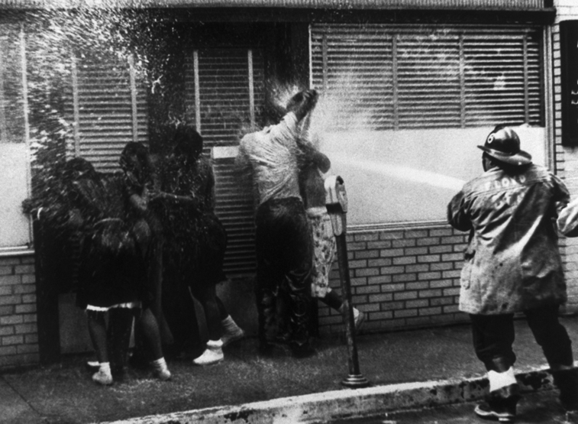
The Nation Watches in Horror
By late April, Birmingham’s black leaders realized their protests were running out of steam. Few members of the black community were willing to carry out more direct action at the risk of going to jail. So the SCLC decided to turn to children. Although the decision was controversial, King argued that the children who took part in the demonstrations would develop “a sense of their own stake in freedom and justice.”

On May 2, 1963, more than 1,000 African American youths marched from Birmingham’s Sixteenth Street Baptist Church into the city center. The city’s public safety commissioner, Bull Connor, had most of them arrested.
On May 3, more students gathered at the church, preparing to march again. This time, Connor ordered the police to barricade them in. When some students tried to leave, the police used attack dogs and high-pressure fire hoses on them.

News photographers captured scenes of peaceful protesters being knocked down by blasts of water or attacked by snarling dogs. The images in newspapers and on television shocked Americans, many of whom had never imagined that southerners would go to such brutal lengths to maintain segregation.

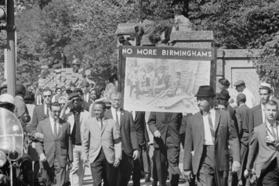
In honor of the four African American girls killed in the bombing, CORE held a march in Washington D.C. The march brought more attention to the hostile atmosphere in Birmingham.

The protests and the national attention they attracted marked a turning point. At the urging of local business leaders, the city stepped back from confrontation, and on May 10 civil rights leaders announced a historic accord in Birmingham. Their agreement with the city called for a number of changes, including the desegregation of public facilities within 90 days. King called the deal “the most magnificent victory for justice we’ve seen in the Deep South.”
A racist backlash soon followed, however. The Ku Klux Klan held a rally, and bombs later went off at a motel where black leaders had been staying. In response, President Kennedy sent federal troops to a nearby military base, promising to deploy them if necessary to keep the peace.
Birmingham remained calm for several months after that, but then another violent attack occurred. On September 15, during Sunday services, a bomb exploded at the Sixteenth Street Baptist Church, killing four African American girls. Reverend King later spoke at their funeral, calling them “the martyred heroines of a holy crusade for freedom and human dignity.”

Section 7 - Achieving Landmark Civil Rights Legislation
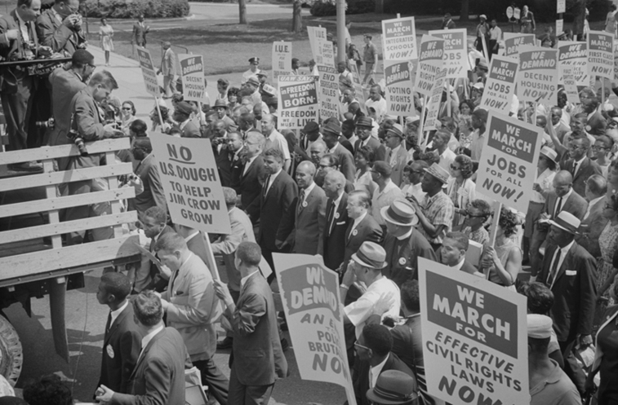
Despite the success of the Birmingham campaign, the city did not change overnight, nor did the events there bring immediate equality for African Americans. But the campaign did have important effects. It increased support for the civil rights movement around the country. More Americans came to identify with the movement’s emphasis on rights, freedom, equality, and opportunity.
Following the spring protests in Birmingham, civil rights activists took their concerns to Washington, D.C. There they demonstrated for “jobs and freedom” and urged the passage of civil rights legislation.

On August 28th 1963, some 250,000 people marched in Washington D.C. People marched for civil rights, employment, decent housing, and voting rights.

Thousands March on Washington for Jobs and Freedom
The 1963 March on Washington was a long time coming. A. Philip Randolph, the head of the Brotherhood of Sleeping Car Porters, had proposed the march in 1941. His goal was to protest unequal treatment of African Americans in the war industries. He called off that rally, however, in deference to President Roosevelt’s call for unity in the war effort.
In 1963, however, the time was ripe for the long-delayed march, which was organized by leaders of the country’s major civil rights organizations. On August 28, more than 250,000 people marched in Washington. It was the largest political gathering ever held in the United States. The quarter of a million protesters included about 60,000 whites as well as union members, clergy, students, entertainers, and celebrities such as Rosa Parks and Jackie Robinson.
That day, marchers listened to African American performers, like opera great Marian Anderson, who sang “He’s Got the Whole World in His Hands.” They also held hands and joined in as folksinger Joan Baez sang “We Shall Overcome.”
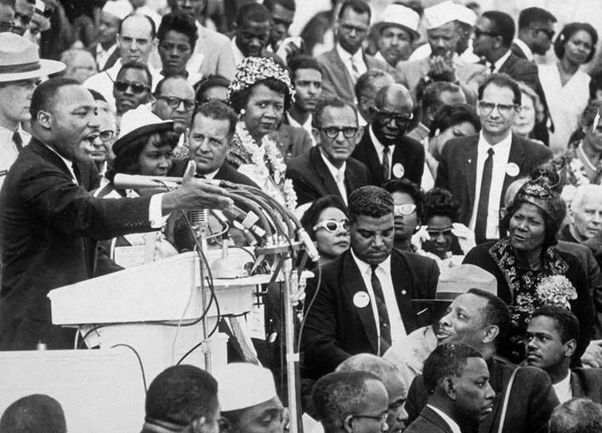
King Inspires the Nation with His Dream
The most notable event of the day was Martin Luther King Jr.’s “I have a dream” speech, delivered from the Lincoln Memorial. In ringing tones, King spoke of his dream for a better America:
I have a dream that one day this nation will rise up and live out the true meaning of its creed: “We hold these truths to be self-evident; that all men are created equal . . .” When we allow freedom to ring, when we let it ring from every village and every hamlet, from every state and every city, we will be able to speed up that day when all God’s children, black men and white men, Jews and Gentiles, Protestants and Catholics, will be able to join hands and sing in the words of the old Negro spiritual, “Free at last! Free at last! Thank God Almighty, we are free at last!”
—Martin Luther King Jr., “I have a dream” speech, August 28, 1963

In his “I have a dream” speech, Martin Luther King Jr. declared, “When the architects of our republic wrote the magnificent words of the Constitution and the Declaration of Independence, they were signing a promissory note . . . that all men . . . would be guaranteed the unalienable rights of life, liberty, and the pursuit of happiness.”

be able to join hands and sing in the words of the old Negro spiritual, “Free at last! Free at last! Thank God Almighty, we are free at last!”
—Martin Luther King Jr., “I have a dream” speech, August 28, 1963
At the time of the march, a civil rights bill cautiously supported by President Kennedy was making its way through Congress. After Kennedy’s assassination in November, President Lyndon B. Johnson continued to push for the bill. It stalled in the Senate, however, when senators opposed to the bill filibustered, speaking at great length to prevent legislative action. Nevertheless, the bill finally passed and was signed into law on July 2, 1964. The landmark Civil Rights Act of 1964 banned discrimination on the basis of race, sex, religion, or national origin—the most important civil rights law passed since Reconstruction.

Section 7 - Regaining Voting Rights
In January 1964, the Twenty-fourth Amendment to the Constitution was ratified. It stated that no U.S. citizen could be denied the right to vote “by reason of failure to pay any poll tax or other tax.” Some southern states had used poll taxes to prevent blacks from voting. The Twenty-fourth Amendment was a key victory in the African American struggle for voting rights. But there was more to be done to ensure that black citizens could actually vote.
Registering African American Voters in a Freedom Summer
In the spring of 1964, CORE and SNCC organized Freedom Summer, a campaign to register black voters in Mississippi. At the time, Mississippi was

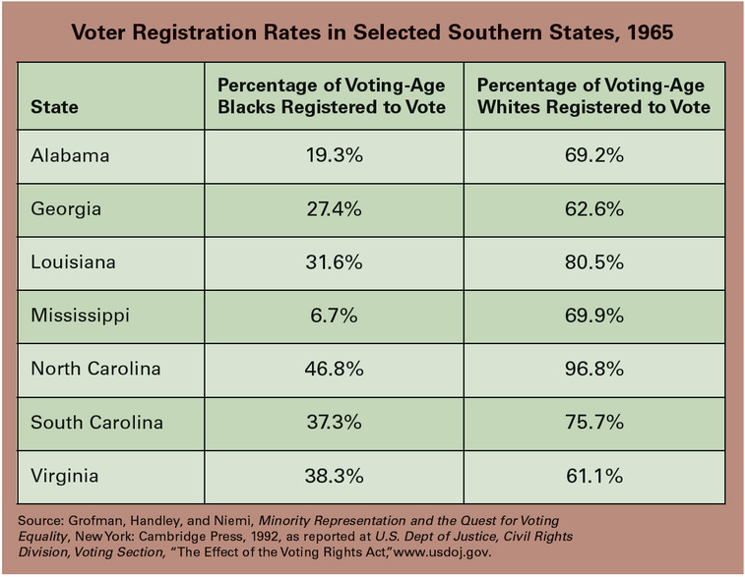
one of the most segregated states in the country, and voting rights for blacks were severely restricted. Although they made up nearly half of the state’s population, only a few African Americans were registered to vote, due in large part to restrictions imposed by state and local officials.
More than 900 people volunteered for Freedom Summer. Most were white college students from the North. They were given training in voter registration and were told to expect violent opposition to their efforts.
That prediction promptly came true. On June 21, three student activists disappeared in Neshoba County, Mississippi, after visiting the site of a burned black church. One of the activists, James Chaney, was black. The other two, Andrew Goodman and Michael Schwerner, were white. Six weeks later, the FBI discovered their bodies. They had been murdered.
Other violent acts marred Freedom Summer. There were numerous beatings, shootings, and bombings. At least three other activists suffered violent deaths. Most of these crimes went unpunished.
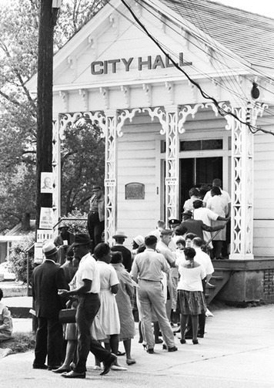
Marching for the Right to Vote
Undeterred by the violence of Freedom Summer, activists continued their registration campaign. Early the following year, the SCLC began to register black voters in Selma, Alabama. In Dallas County, where Selma is located, only 320 of more than 15,000 eligible black voters were registered to vote at the time. For weeks, civil rights protesters held daily marches at the Dallas County Courthouse. By February, more than 3,000 had been arrested, charged with crimes such as “unlawful assembly.” At that point, the SCLC called for a march from Selma to the state capital at Montgomery. The marchers planned to present the governor with a list of grievances.
On March 7, 1965, the protesters began their walk. Decades later, civil rights activist John Lewis recalled,
As we crossed the Pettus Bridge, we saw a line of lawmen. “We should kneel and pray,” I said . . . but we didn’t have time. “Troopers,” barked an officer, “advance!” They came at us like a human wave, a blur of blue uniforms, billy clubs, bullwhips and tear gas; one had a piece of rubber hose wrapped in barbed wire.
Once again, televised images of the violence that day outraged many Americans. The civil rights movement continued to gain support around the country.

African Americans lined up to vote for the first time throughout the South after passage of the Voting Rights Act of 1965. The number of registered black voters grew dramatically in the late 1960s.

In August, Congress passed the Voting Rights Act of 1965. The act outlawed literacy tests and other tactics used to deny African Americans the right to vote. The act also called for the federal government to supervise voter registration in areas where less than half of voting-age citizens were registered to vote. Federal intervention would ensure that eligible voters were not turned away.
Efforts to secure voting rights proved quite successful. In 1964, less than 7 percent of Mississippi’s eligible black voters were registered to vote. By 1968, that number had risen to 59 percent. In Alabama, the numbers rose from about 20 percent to 57 percent during the same four-year period. Overall, the number of African American voters in the South increased from 1 million to 3.1 million between 1964 and 1968. The civil rights movement had made great strides in the years since the Montgomery Bus Boycott.
Summary
Between 1955 and 1965, many key events took place in the civil rights movement. African Americans made great progress in their struggle for rights and equality.
Montgomery Bus Boycott In 1955, blacks in Montgomery, Alabama, began a lengthy boycott of the city’s segregated bus system. As a result, Montgomery’s buses were integrated.
SCLC and SNCC These two groups helped organize nonviolent civil rights actions. The Southern Christian Leadership Conference was led by Martin Luther King Jr. It played a major role in the Birmingham campaign and other events. The Student Nonviolent Coordinating Committee organized sit-ins and engaged in other forms of civil disobedience.
Freedom Rides In 1961, black and white Freedom Riders rode buses through the South. They were testing southern compliance with laws outlawing segregation in interstate transport. The riders were subjected to violence and eventually received federal protection.
March on Washington A quarter of a million people marched in Washington, D.C., in August 1963 to demand jobs and freedom. The highlight of this event was Martin Luther King Jr.’s “I have a dream” speech.
Freedom Summer In the summer of 1964, activists led voter registration drives in the South for African Americans.
Landmark legislation The Civil Rights Act of 1964 banned discrimination on the basis of race, sex, religion, or national origin. The Voting Rights Act of 1965 outlawed literacy tests, enabling many African Americans to vote.

