Title: ____________________________________________________________ Name: __________________________________________

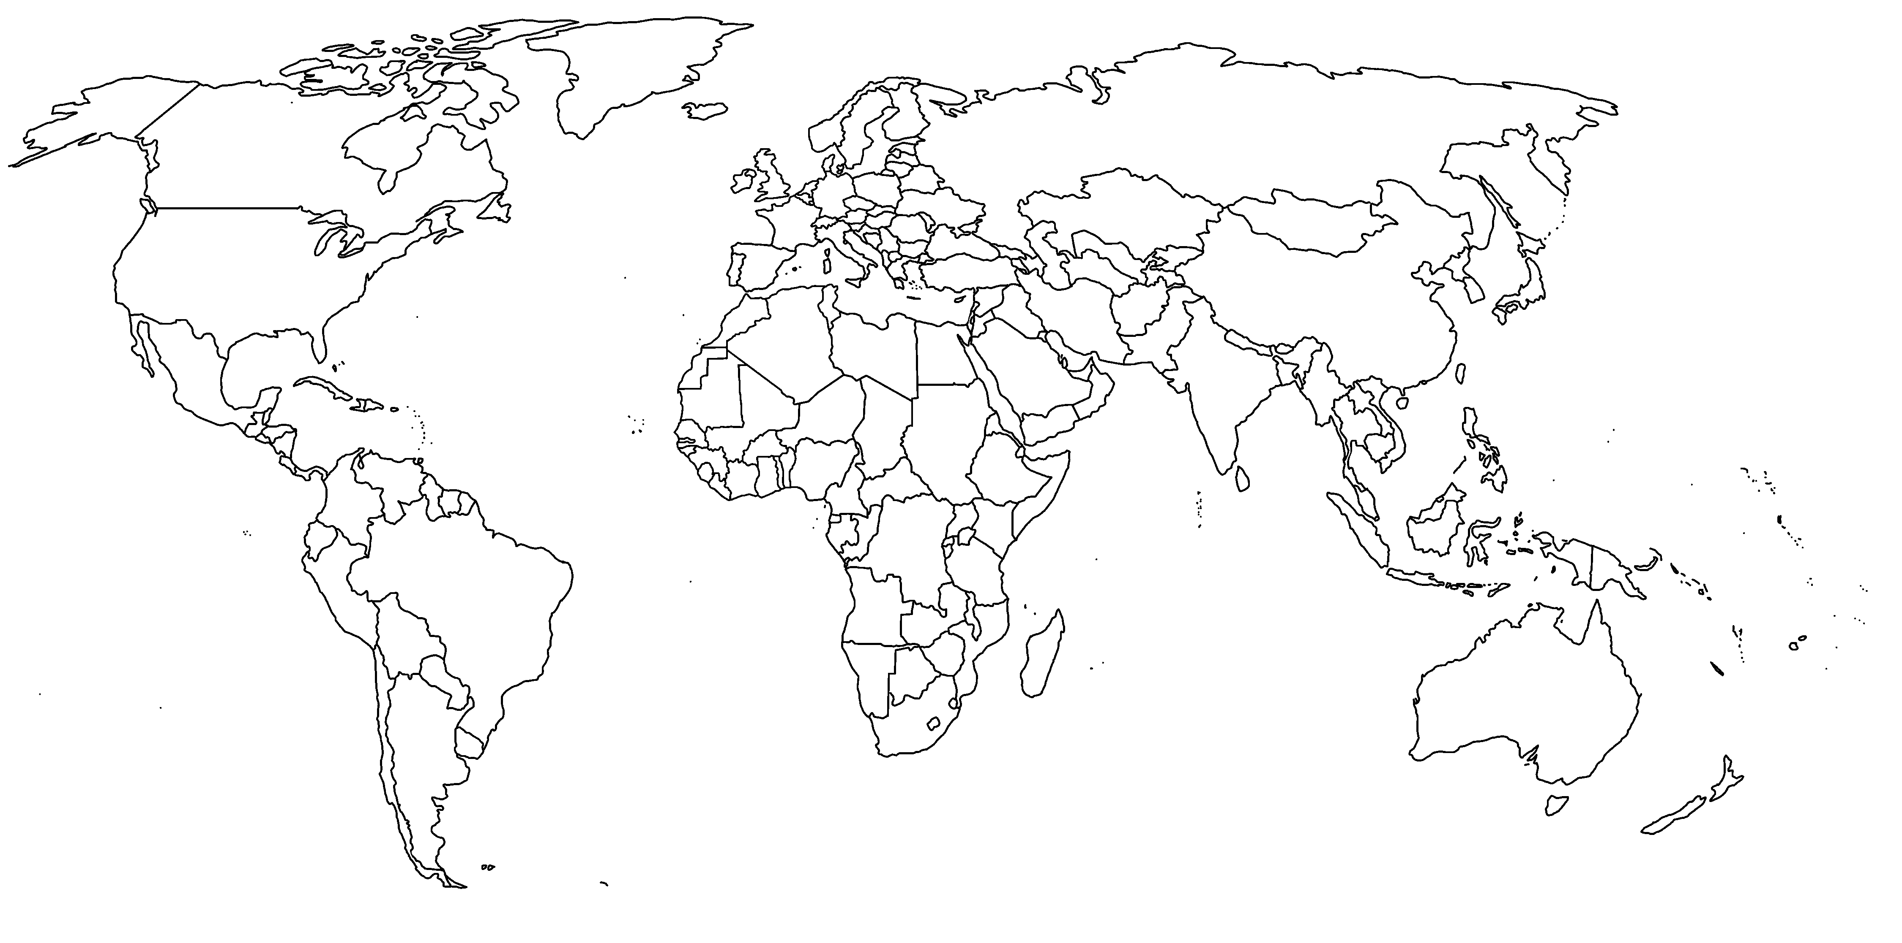

Key

