America’s Dependency on Oil: DBQ (Document based questions)
Question: How does oil socially, politically, and economically drive U.S. Foreign Policy?
Document A:
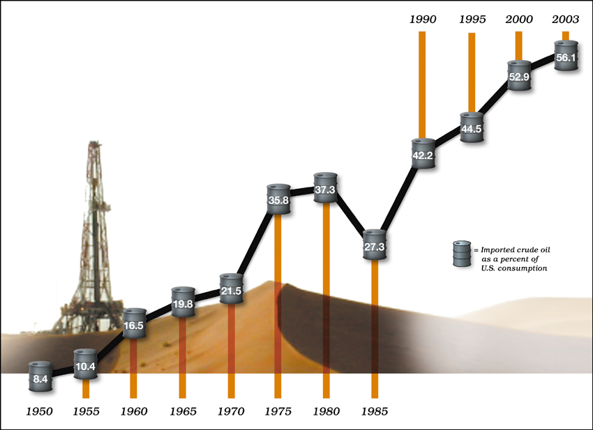
America's growing dependence on foreign oil represents an interrelated combination of factors that together create economic, political, and security problems of the highest order. Oil supply is increasingly determined by a small number of nations that wield a near monopoly over world production. An insatiable demand, driven in part by the robust growth of Asian economies, makes American industry and consumers even more vulnerable to the recent shock of higher oil prices. Whether America can remove this vulnerability will depend on substantially reducing the volume of oil imported and consumed, an ambitious goal tied directly to making available affordable and practical petroleum substitutes.
—David L. Greene, Engineering Science and Technology Division, ORNL.
A1. What is meant by “driven in part by the robust growth of Asian economies”?
A2. What is the trend in the graph?

Document B:
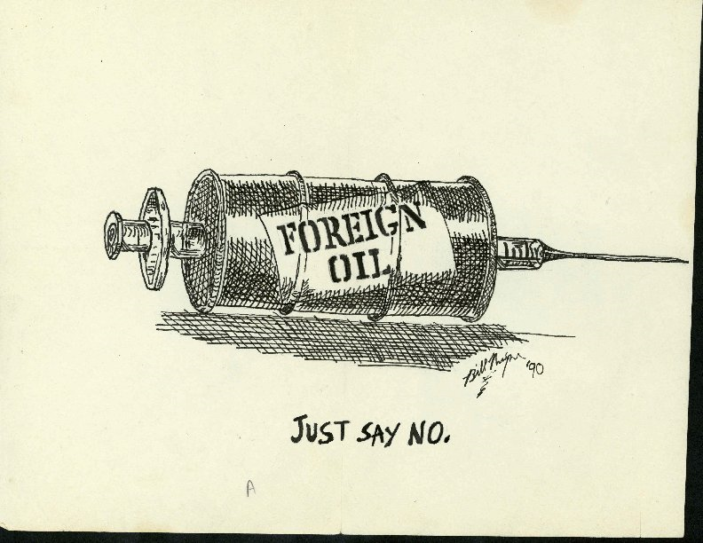
B1. How and why is America “addicted” to foreign oil supplies?

Document C:
“I am saddened that it is politically inconvenient to acknowledge what everyone knows: the Iraq war is largely about oil,”
Allan Greenspan, former Chairman of the Federal Reserve
C1: How might the dependency on oil determine which nations the U.S. supports during war or crisis?

C2: Evaluate the reliability of the source for Document C.

Document D:
"Today we are so dependent on oil, and oil is so embedded in our daily doings, that we hardly stop to comprehend its pervasive significance. It is oil that makes possible where we live, how we live, how we commute to work, how we travel....Oil (and natural gas) are the essential components in the fertilizer on which world agriculture depends; oil makes it possible to transport food to the totally non-self-sufficient mega-cities of the world. Oil also provides the plastics and chemicals that are the bricks and mortar of contemporary civilization, a civilization that would collapse if the world's oil wells suddenly went dry." (Daniel Yergin, The Prize: The Epic Quest for Oil, Money & Power)
D1: What are some of the things that people are dependent on oil for?

D2: In April of 2011, the World’s population hit 7 billion. How will that impact our consumption of oil?
Document E:
In 2008 the United States imported oil from 10 countries currently on the State Department’s Travel Warning List, which lists countries that have “long-term, protracted conditions that make a country dangerous or unstable.” These nations include Algeria, Chad, Colombia, the Democratic Republic of the Congo, Iraq, Mauritania, Nigeria, Pakistan, Saudi Arabia, and Syria. Our reliance on oil from these countries could have serious implications for our national security, economy, and environment.
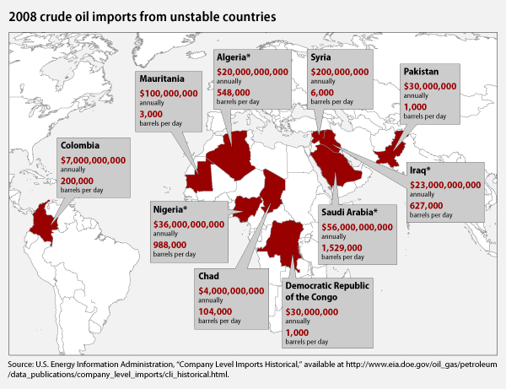
E1: List three reasons why relying on the purchase of oil from “unstable nations” might be a bad business practice.

Document F:

Clean energy can help bring the economy back to life. The United States has an opportunity right now to reduce its dependence on foreign oil by adopting clean-energy and global warming pollution reduction policies that would spur economic recovery and long-term sustainable growth. With a struggling economy and record unemployment, we need that money invested here to enhance our economic competitiveness. Instead of sending money abroad for oil, investing in clean-energy technology innovation would boost growth and create jobs. (Rebecca Lofton, Center for American Progress: Oil Dependency is a Dangerous Habit, January 12, 2010)
F1: How might the U.S. economically reduce its dependency on foreign oil?

F2: How would adopting clean energy methods help our economy?

Document G:
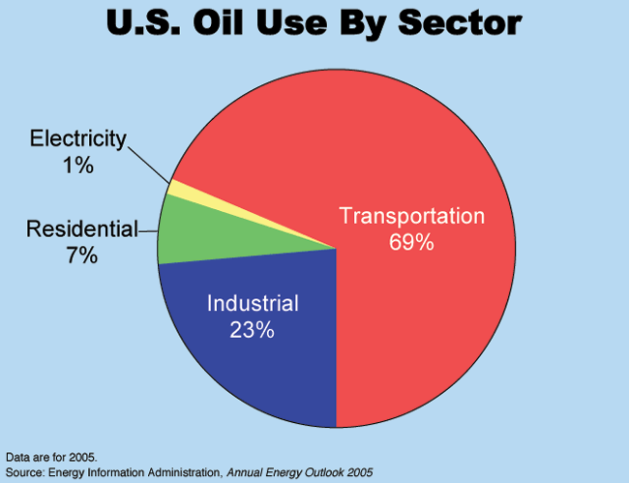
G1: According to the chart, what is the number one reason for US dependency on oil?
G2: Why is the answer to G1 higher than most other developed nations?

Document H:
Afghan war costs now outpace Iraq's. The monthly cost of the war in Afghanistan driven by troop increases and fighting on difficult terrain, has topped Iraq costs for the first time since 2003 and shows no sign of letting up. Pentagon spending in February, the most recent month available, was $6.7 billion in Afghanistan compared with $5.5 billion in Iraq. As recently as fiscal year 2008, Iraq was three times as expensive; in 2009, it was twice as costly.
(Richard Wolf, Afghan war costs now outpace Iraq's, USA Today)
H1: How does oil drive US foreign policy (dealing with other nations)?

Document I:
The U.S. has 3% of the world's population but consumes 25% of the world's oil supply. That's 20 million barrels daily (one barrel=42 gallons), of which 44% is refined into gasoline for motor vehicles. (Michael Klare, www.thenation.com, 9/6/05)
I1: How are the American people responsible for a dependency on foreign oil reserves?

Document J: A List of Products Made from Oil

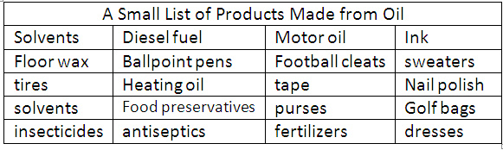

J1: How can we help decrease the use and production of these product in order to conserve oil?
Document K:
“Because we are now running out of gas and oil, we must prepare quickly for a third change, to strict conservation and to the use of ... permanent renewable energy sources, like solar power.” (Former U.S. President Jimmy Carter)
K1: How might your life change during this “third change”?

