DBQ: The Great Depression and the New Deal

Historical Context: The federal government responded quite differently to the prosperity of the 1920s and the Great Depression that followed. Roosevelt's New Deal was not only a decisive plan to combat the Depression, but it also marked a new direction in the role of government in managing the economy—a role that is still being debated today.

Document Based Question: Discuss the response of the United States government to the Great Depression. How and why is the government response during the Depression considered a turning point in the federal government’s role in managing the economy?

Document #1

"… we must have tax reform. The method of raising tax revenue ought not to impede the transaction of business; it ought to encourage it. I am opposed to extremely high taxes, … because they are bad for the country, and because they are wrong. We cannot finance the country through any system of injustice, even if we attempt to inflict it on the rich. … The wise and judicious course to follow in taxation and economic legislation is not to destroy those already who have secured success, but to create conditions under which everyone will have a better chance to be successful."

—Calvin Coolidge, Inaugural Address, March 4, 1925

Document #2
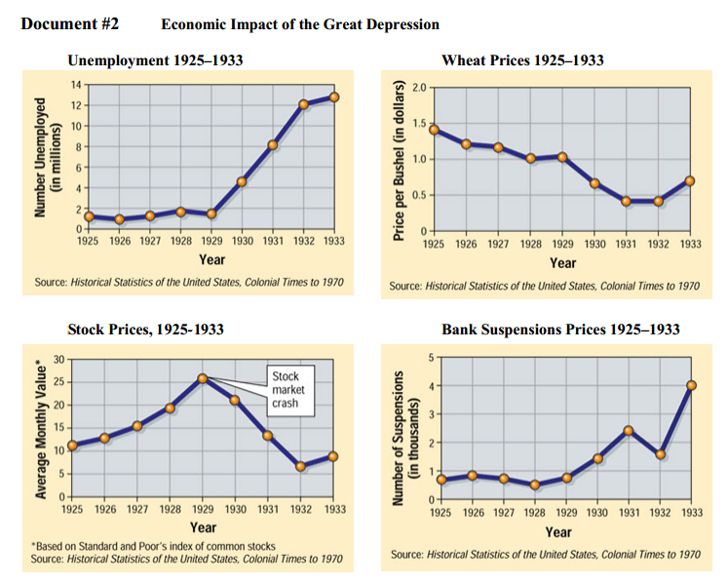
Document #3

“. . . I am convinced that where Federal action is essential . . . it should limit its responsibilities to supplement the States and local communities, and that it should not assume the major role or the entire responsibility . . . To do otherwise threatens the whole foundations of local government, which is the very basis of selfgovernment. That is to strengthen in the Nation a sense and an organization of self-help and cooperation to solve as many problems as possible outside of government. Due to lack of caution in business . . .. We are projected into temporary unemployment, losses, and hardships. In a nation rich in resources, many people were faced with hunger and cold through no fault of their own. Our national resources are not only material supplies and material wealth but a spiritual and moral wealth in kindliness, in compassion, in a sense of obligation of neighbor to neighbor and a realization of responsibility by industry, by business, and the community for its social security and its social welfare. The evidence of our ability to solve great problems outside of government action and the degree of moral strength with which we emerge from this period will be determined by whether the individuals and the local communities continue to meet their responsibilities. Throughout this depression I have insisted upon organization of these forces through industry, through local government and through charity, that they should meet this crisis by their own initiative, by the assumption of their own responsibilities. The Federal Government has sought to . . . avoid the opiates of government charity.”

- Herbert Hoover, Radio Address, Feb 12, 1932

Document #4

"I have recounted to you in other speeches, and it is a matter of general information, that for at least two years after the crash, the only efforts by the [Hoover] administration to cope with the distress of unemployment were to deny its existence."

—Franklin D. Roosevelt, 1932

Document #5

"So, first of all, let me assert my firm belief that the only thing we have to fear is fear itself—nameless, unreasoning, unjustified terror which paralyzes needed efforts to convert retreat into advance. In every dark hour of our national life a leadership of frankness and vigor has met with that understanding and support of the people themselves which is essential to victory. I am convinced that you will again give that support to leadership in these critical days. In such a spirit on my part and on yours we face our common difficulties. They concern, thank God, only material things. Values have shrunken to fantastic levels; taxes have risen; our ability to pay has fallen; government of all kinds is faced by serious curtailment of income; the means of exchange are frozen in the currents of trade; the withered leaves of industrial enterprise lie on every side; farmers find no markets for their produce; the savings of many years in thousands of families are gone. More important, a host of unemployed citizens face the grim problem of existence, and an equally great number toil with little return. Only a foolish optimist can deny the dark realities of the moment."

—Franklin D. Roosevelt, First Inaugural Address, March 4, 1933

Document #6

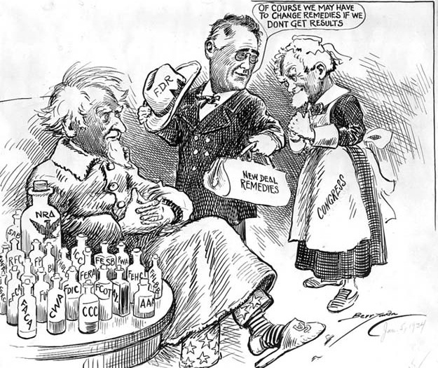

Document #7

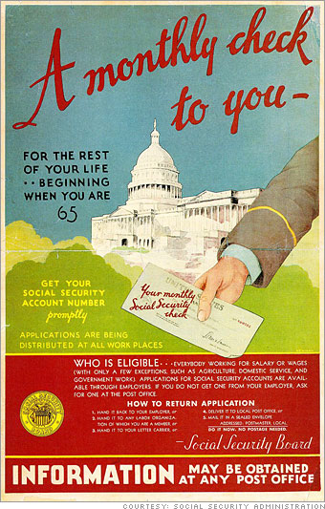

Document Analysis Questions:

Document #1. According to this quote, how did Calvin Coolidge feel about the role of government in managing business?

________________________________________________________________________________________________________________________________________________________________________________________________________________________________________________________________________________________________________________________________________________________________________

Document #2: Based on the charts above, what effect did the stock market crash of 1929 have on the overall economy of the United States?

________________________________________________________________________________________________________________________________________________________________________________________________________________________________________________________________________________________________________________________________________________________________________

Document #3: Based on Hoover’s Radio Address above, what was his view of the role of government in dealing with the economic crisis of the Depression?

________________________________________________________________________________________________________________________________________________________________________________________________________________________________________________________________________________________________________________________________________________________________________

Document #4: Based on this quote that Roosevelt made during the 1932 presidential campaign, how did Roosevelt evaluate the efforts made by the Hoover administration to resolve the nation's economic problems?

________________________________________________________________________________________________________________________________________________________________________________________________________________________________________________________________________________________________________________________________________________________________________

Document #5: In this excerpt from FDR's first inaugural speech, how did he attempt to win the support of the American people for his leadership during the economic crisis of the Great Depression?

________________________________________________________________________________________________________________________________________________________________________________________________________________________________________________________________________________________________________________________________________________________________________

Document #6: According to this political cartoon, how did some people view the New Deal and government intervention into the economic crisis?

________________________________________________________________________________________________________________________________________________________________________________________________________________________________________________________________________________________________________________________________________________________________________

Document #7: Who is the Social Security program designed for and how is it funded? How did this help shape the new “welfare state?”

________________________________________________________________________________________________________________________________________________________________________________________________________________________________________________________________________________________________________________________________________________________________________

