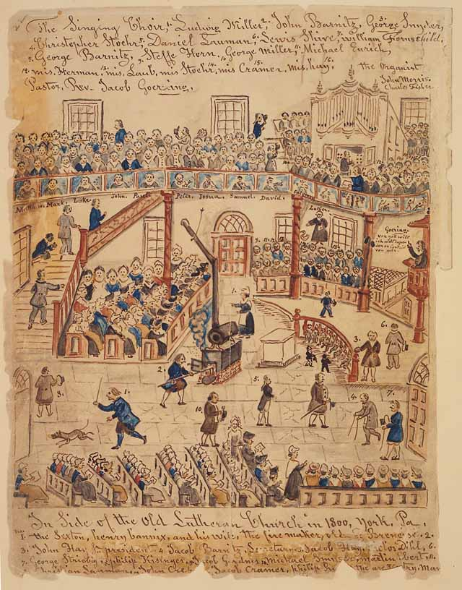

In Side of the Old Lutheran Church in 1800, inYork, Pa. Watercolor with pen and ink by Lewis Miller, c. 1800. The Historical Society of York County, Pennsylvania (56)

Lutheran Church Services
This view of the interior of a Lutheran Church by Pennsylvania folk artist Lewis Miller (1796-1882) reveals features--wall paintings of great figures of the modern and early church--which would have been absent from English Protestant churches of the time. Notice the homey interruptions to worship in early America such as the sexton chasing a dog out of the sanctuary and a member stoking a stove.

Excerpt from John Locke’s Two Treatises of Government 1690
To understand political power, we must consider the condition in which nature puts all men. It is a state of perfect freedom to do as they wish and dispose of themselves and their possessions as they think fit, within the bounds of the laws of nature. They need not ask permission or the consent of any other man.
The state of nature is also a state of equality. No one has more power or authority than another. Since all human beings have the same advantages and the use of the same skills, they should be equal to each other. The state of nature has a law of nature to govern it. Reason is the law. It teaches that all men are equal and independent, and that no one ought to harm another in his life, liberty, or possessions. All men are made by one all-powerful and wise Maker. They are all servants of one Master who sent them into the world to do His business. He has put men naturally into a state of independence, and they remain in it until they choose to become members of a political society.

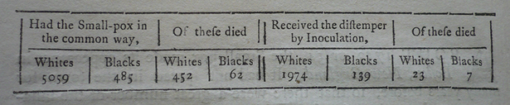
Above: From "Mortality from smallpox and variolation." Chart. In Benjamin Franklin, by Benjamin Franklin and William Heberden. London, England: W. Strahan, 1759.

