Name__________________________________

Under A Cloud Of Austerity, Real Smoke Clouds Greece As Well
by Joanna Kakissis
January 22, 2013 3:35 AM
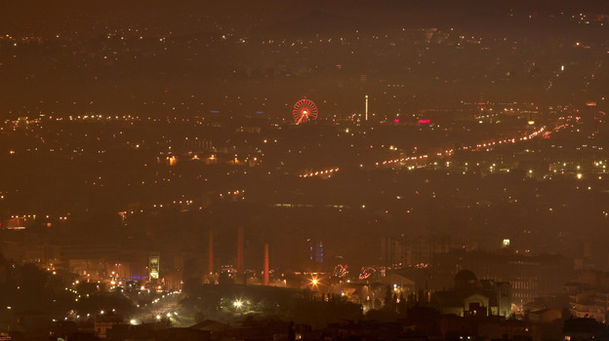
A haze of smoke hangs over Athens early Jan. 3. The hazy conditions result from residents' switch to wooden stoves and fireplaces for heating, as many households can no longer afford to buy heating oil.
In this winter of austerity and Depression-era unemployment, a fog of woodsmoke hangs over the Greek capital on cold nights.
It's coming from the tens of thousands of fireplaces and wood-burning stoves Athenians are using to heat their homes. Most can no longer afford heating oil, the price of which has risen 40 percent since last year. The government also cut a fuel subsidy for low-income families earlier this month.
Some Greeks buy cheap firewood; others used their discarded Christmas trees as kindling. The most desperate are burning old furniture and raiding protected forests. Someone even hacked away the remains of a 3,000-year-old olive tree where Plato is said to have taught.
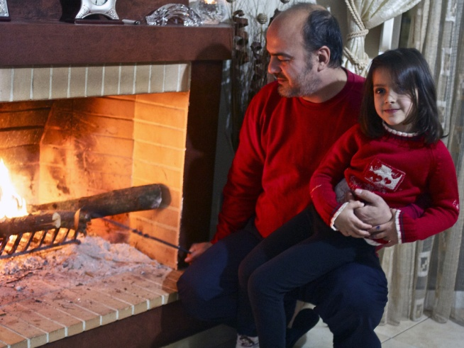
Sotiris Sotiriou, 41, and his daughter Sophia, 5, check out the olive-wood kindling in the fireplace that heats their family's home.
In the working-class suburb of Aegaleo, west of Athens, 41-year-old Sotiris Sotiriou and his two young daughters, Magda and Sophia, are bundled up in thick sweaters. They add wood from olive-tree saplings in the flames of their living-room fireplace. The saplings grow on a small family plot outside Athens.
"Last year, the fireplace was just decorative," says Sotiriou, who also owns a home improvement shop. "This year, it's how we heat our home."
Like many Greeks, Sotiriou and his wife, Haroula Lappa, cannot afford to buy heating oil. Sotiriou has no business at his home-improvement store, since the Greek construction industry has all but halted.
Nearly all of Lappa's salary as a court clerk goes to their $930 monthly home mortgage payment. After groceries and tax bills, there's nothing left for the heating oil, she says.
She goes outside for a walk and smells the scent of woodsmoke from other fireplaces.
Two weeks ago, she also smelled something else: burning paint.
"Someone must have been burning a door with the windows still set in," she says. "When the girls and I were walking home, it was hard to breathe. We used our coats as masks."
Greeks may actually be burning old furniture to stay warm, says Stephanos Sambatakakis of the Hellenic Center for Disease Control and Prevention.
Scientists are studying the particles in the noxious fumes, which could soon leave people suffering from inflamed eyes, respiratory problems, headaches and nausea, he says. Long-term effects could include lung inflammation and, "in extreme cases, lung cancer," he says.
Environmentalist Grigoris Gourdomichalis is worried about another scourge — deforestation. Twice a day, he and his colleagues climb into a jeep and patrol a protected forest on a hill west of Athens. Illegal logging is rampant here.
He says it's not just the poor cutting down saplings to use as fuel to stay warm. Poachers also sell the wood for profit.
"Before World War II, this forest had so many trees," Gourdomichalis says. "But the Germans and Italians took the heating oil and coal during the war, and Greeks were forced to chop down all the trees for firewood so they could cook and keep themselves warm. The forest has since recovered, so we can't let it be destroyed again."
He says the patrols have stopped some of the deforestation. But then he and a colleague spot another threat to the forest: Someone has destroyed a giant water tank used to fight summer forest fires. Gourdomichalis says the tank's steel frame was cut to be sold as scrap metal.
"People are destroying everything in a desperate effort to survive, or they're using the crisis to make a profit," he says, shaking his head in despair.
He peers out the jeep's window at the city below. It's getting dark and cold. He sees the first wisps of the smoky fog that will soon hang over his city.
ON A SEPARATE PAPER, WRITE A WELL-DEVELOPED PARAGRAPH (5-7) SENTENCES ABOUT YOUR THOUGHTS ON THIS ISSUE. What should the government do to help? Is it okay that Greek citizens are contributing to deforestation? Do you think something like this could happen in America?

