Hurricanes

Introduction:
You’ve just gotten finished boarding up your house with 2 by 4’s and other materials, and now you are huddling under a mattress with the rest of your family in the bathroom with no windows. The sound of raging wind and water is so loud around you that it is almost deafening. You cling to the mattress praying that the storm won’t take your house, or worse, your life. This may sound like a scene from the Wizard of Oz where Dorothy is swept away by a tornado, however, this is actually a situation one might go through when facing a hurricane. Hurricanes are actually tropical cyclones which are very similar to tornadoes. The main difference is that hurricanes occur in the tropic zones and require warm water and warm, moist air. A hurricane creates winds of at least 74 miles per hour and can produce heavy rain and high waves. Trust me when I tell you that you do not want to be anywhere near a hurricane when it hits.

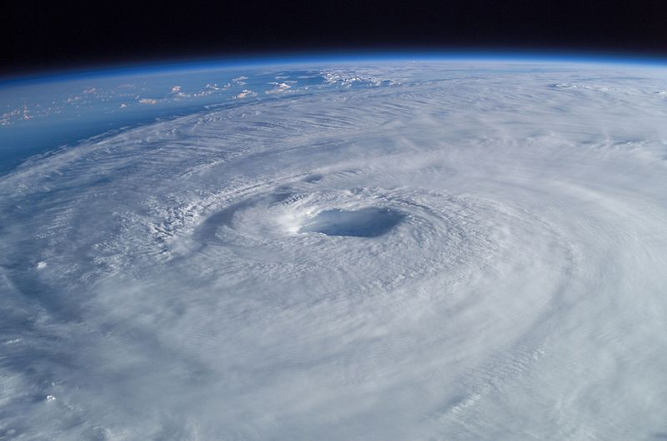

Process:
Hurricanes are the product of a certain combination of heat, air, water, and sunlight. When the conditions are right in tropical waters a hurricane can begin to form. To begin, the ocean temperature must be at least 80 degrees Fahrenheit. The warm water will release warm, moist air into the atmosphere which condenses into clouds and rain. This can lead to the creation of a tropical thunderstorm. Once several tropical thunderstorms come together they become a tropic depression. As the tropic depression increases in size, more warm air collects and the storm will begin to spin counterclockwise due to the Coriolis Effect. Once winds reach 39 miles per hour it becomes known as a tropical storm. If it continues to suck up more warm air and moisture it will eventually become a hurricane or tropical cyclone.

There are three important parts of a hurricane. First, the eye of the hurricane is the center of the storm and can range in size from 20 to 40 miles across. Next, the eye wall is the area of the storm made up of thunderstorms and dark clouds. Lastly, rainbands, which consists of dense, raining clouds, swirl around the eye wall. Predicting the path or pace of a hurricane is extremely difficult. However, the longer it stays over warm water, the longer it can gather size and strength.

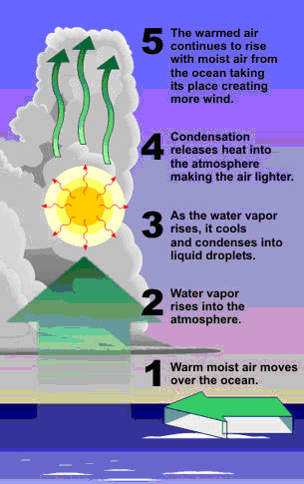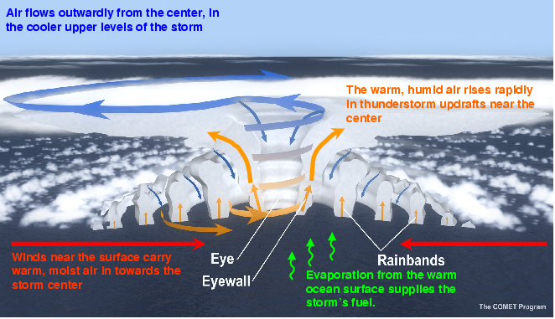

Place:
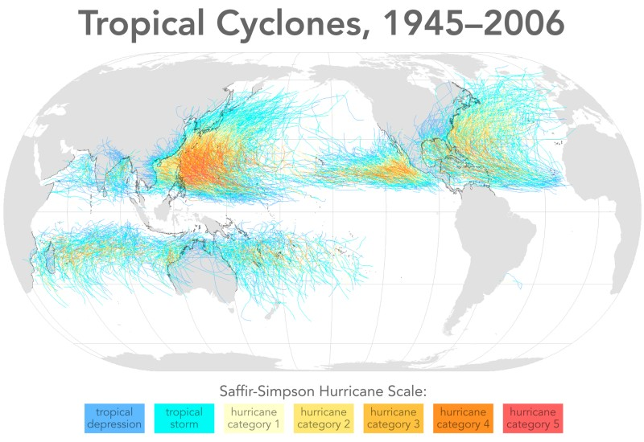

Effects:
There are numerous effects that hurricanes have on people and places. Its most powerful weapons are wind and rain. Wind speeds can gain power up to 200 miles per hour. This is enough speed and power that wind can blow houses, trees, cars and other materials around. The intense rain, on the other hand, can lead to immense flooding and water damage. Moreover, heavy rainfall can even lead to mudslides which can cause epic damage. The deadliest force of all is the storm surge. This is a wall of water that can rise up to 33 feet above sea level and decimate everything in its path. Hurricane Katrina caused the most property damage than any other hurricane in the Atlantic Ocean. Its storm surge caused such bad structural damage that almost the entire city was flooded. In addition to damaged property, loss of life can also be an unfortunate effect of hurricanes. Hurricane Mitch hit Central America in 1998 and killed almost 11,000 people. Many people attempt to prepare themselves and their property for impending hurricanes hoping that the damage will be minimum.
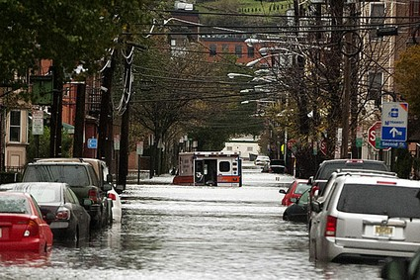

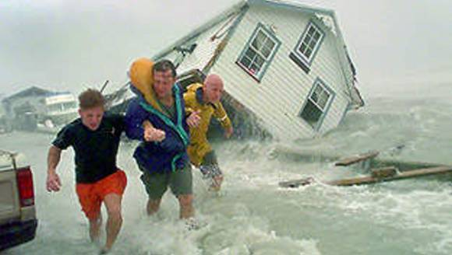

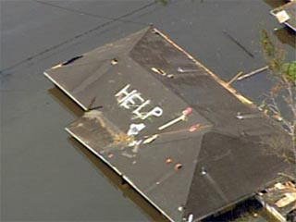

Preparation:
Unfortunately, hurricanes cannot be prevented. Therefore, preparation becomes a crucial part of living with this form of extreme weather. There are several steps that a person or family need to take in order to prepare for the event. First, a hurricane survival kit will need to be procured. The contents of the bag should include water, food, a first aid kit, blankets and clothes, a flashlight with extra batteries, a battery-powered radio, and tools for getting out of your shelter in case there is damage blocking your exit. Depending on the rating of the hurricane, which runs from 1 to 5, families may decide to board up their houses and wait for the storm to pass, or they may decide to evacuate their homes in order to seek shelter in a safer area.

Hurricane Hunters and Meteorologists work together to inform the public about the path and intensity of incoming hurricanes. The tools that they use for their predictions include satellite images and data from flight crews. Once a storm is identified as a hurricane they give it a name and a rating. The rating system is known as the Saffir-Simpson Scale; the system rates a hurricane from 1 to 5 where the larger the number means the greater the danger and intensity of the hurricane. Hurricane Isabel, for example, was given a category 5 rating which allowed people to evacuate their homes. It was the longest lasting category 5 hurricane recorded; it last 30 hours. Based on this rating, people are able to better prepare themselves and their property for the incoming storm.

Recovery:
Most hurricanes lose momentum when they reach large landmasses such as Mexico or the United States. In addition, they can also die out if they hit a patch of cold water. Once the hurricane has ended, the recovery process must begin. Damaged property such as schools, hospitals, roads, bridges, and power lines, must be repaired as soon as possible. Furthermore, people may be in worse condition including homelessness, hunger, injuries, and disease. The first step toward recovery is to rescue the people who are still stranded in flooded areas or trapped in wreckage. Also, relief workers begin administering assistance to those in need by providing food, water, shelter, clothing, and much more. The next step toward recovery is cleaning up the property damage. Floodwaters must be drained, water and sewage lines have to be repaired, roads cleared, electricity restored, and buildings rebuilt. The process takes a large amount of time, money, and aid in order to complete the recovery. For example, recovering from Hurricane Katrina cost 108 billion dollars and the job is still not complete even though the hurricane hit in 2005.

