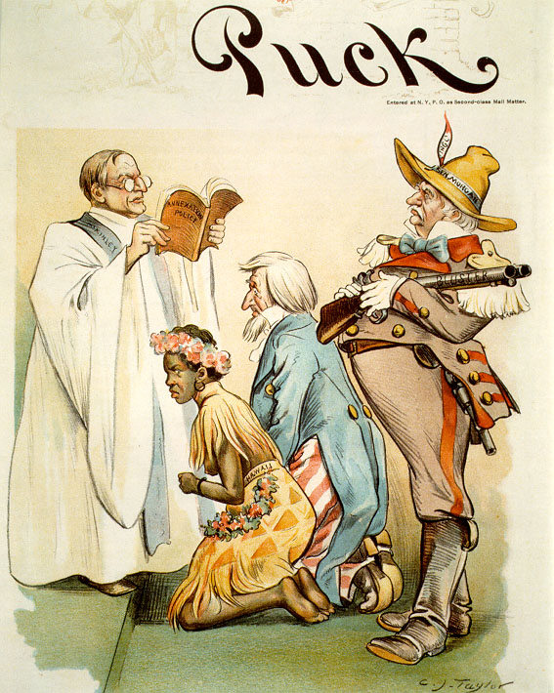

Mark Twain From the New York Herald, October 15, 1900:
I left these shores, at Vancouver, a red-hot imperialist. I wanted the American eagle to go screaming into the Pacific. It seemed tiresome and tame for it to content itself with the Rockies. Why not spread its wings over the Phillippines, I asked myself? And I thought it would be a real good thing to do
I said to myself, here are a people who have suffered for three centuries. We can make them as free as ourselves, give them a government and country of their own, put a miniature of the American constitution afloat in the Pacific, start a brand new republic to take its place among the free nations of the world. It seemed to me a great task to which had addressed ourselves.
But I have thought some more, since then, and I have read carefully the treaty of Paris, and I have seen that we do not intend to free, but to subjugate the people of the Phillippines. We have gone there to conquer, not to redeem. . .
It should, it seems to me, be our pleasure and duty to make those people free, and let them deal with their own domestic questions in their own way. And so I am an anti-imperialist. I am opposed to having the eagle put its talons on any other land.

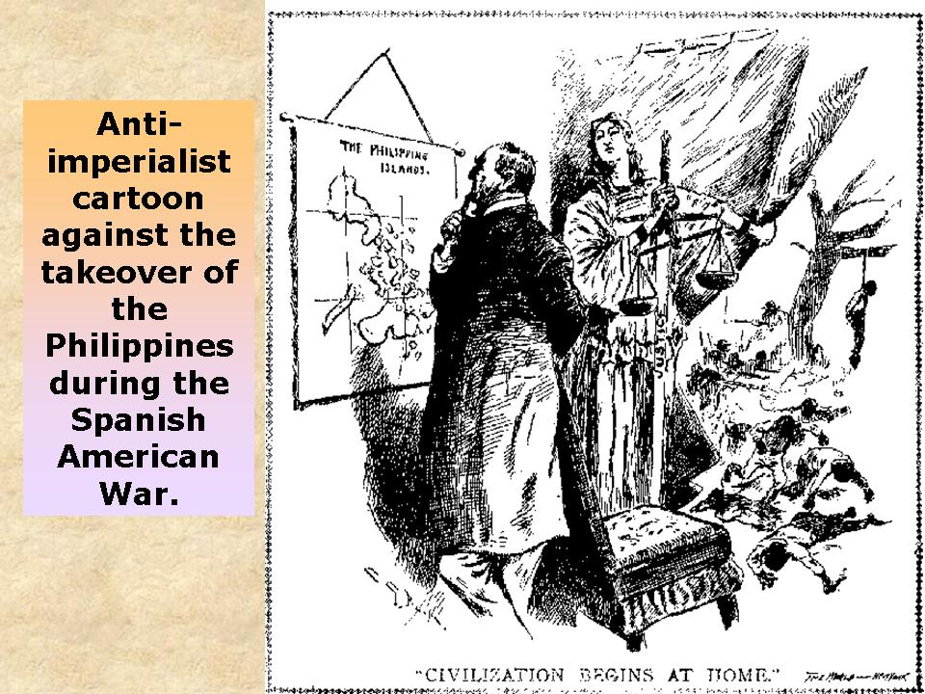

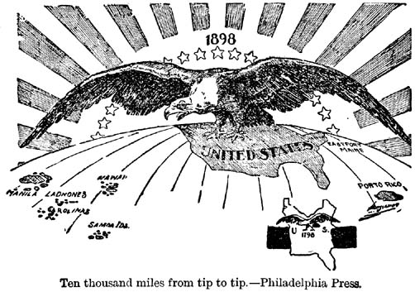

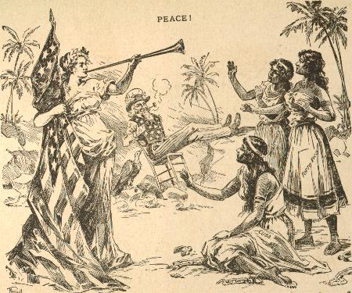
The women’s dresses read “Cuba”, “Puerto Rico” and the “Philippines”

“The White Man’s Burden” Excerpt
--------------------------------------------------------------------------------
Take up the White Man's burden--
The savage wars of peace--
Fill full the mouth of Famine
And bid the sickness cease;
And when your goal is nearest
The end for others sought,
Watch sloth and heathen Folly
Bring all your hopes to nought.
Rudyard Kipling, The White Man's Burden, 1899
--------------------------------------------------------------------------------
This famous poem, written by Britain's imperial poet, was a response to the American takeover of the Phillipines after the Spanish-American War.

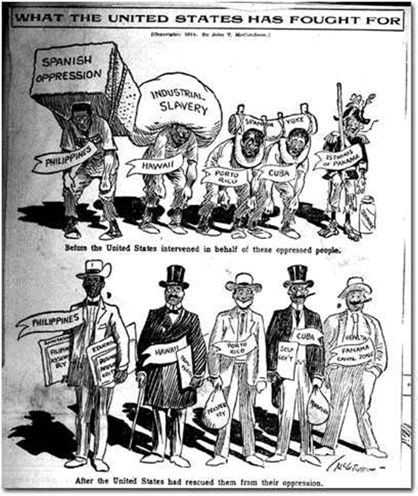

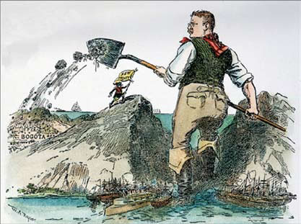

Bogota is the capital of Colombia by W.A. Rogers from the New York Herald, December 1903.

William Jennings Bryan (Democratic presidential candidate in 1896, 1900, and 1908)
Imperialism is the policy of an empire. And an empire is a nation composed of different races, living under varying forms of government. A republic cannot be an empire, for a republic rests upon the theory that the government derive their powers from the consent of the government and colonialism violates this theory. We do not want the Filipinos for citizens. They cannot, without danger to us, share in the government of our nation and moreover, we cannot afford to add another race question to the race questions which we already have. Neither can we hold the Filipinos as subjects even if we could benefit them by so doing. . . . Our experiment in colonialism has been unfortunate. Instead of profit, it has brought loss. Instead of strength, it has brought weakness. Instead of glory, it has brought humiliation.

"Speeches of William Jennings Bryan," Michigan State University Voice Library. Audio version available on the CD-ROM Who Built America?, 1876-1914, by the American Social History Project. For historical commentary and links to many of Bryan's speeches on imperialism, see http://www.boondocksnet.com/ail/bryan.html.

Top of Form

President William McKinley (Republican) 1903 statement to a visiting church delegation
When I next realized that the Philippines had dropped into our laps I confess I did not know what to do with them. . . And one night late it came to me this way. . .1) That we could not give them back to Spain- that would be cowardly and dishonorable; 2) that we could not turn them over to France and Germany-our commercial rivals in the Orient-that would be bad business and discreditable; 3) that we not leave them to themselves-they are unfit for self-government-and they would soon have anarchy and misrule over there worse than Spain's wars; and 4) that there was nothing left for us to do but to take them all, and to educate the Filipinos, and uplift and civilize and Christianize them, and by God's grace do the very best we could by them, as our fellow-men for whom Christ also died.
Text and audio version available on the American Social History Project CD-ROM Who Built America?, 1876-1914.

