Legacy of the New Deal
New Deal policies did not end the Depression. The economy continued to struggle into the 1940s. But the New Deal did help millions of Americans cope with hard times. It also had a lasting impact on American government and society, leaving a legacy that affects all Americans today.
Unalienable Rights: Life, Liberty, and Economic Security One major legacy of the New Deal is the idea that Americans have a right to economic security. Franklin Roosevelt, who began an unprecedented fourth term as president in 1944, explained this idea in his State of the Union address that year:
This Republic had its beginning, and grew to its present strength, under the protection of certain inalienable political rights—among them the right of free speech, free press, free worship, trial by jury, freedom from unreasonable searches and seizures . . . As our Nation has grown in size and stature, however—as our industrial economy expanded—these political rights proved inadequate to assure us equality in the pursuit of happiness. We have come to a clear realization of the fact that true individual freedom cannot exist without economic security and independence.
—Franklin Roosevelt, January 11, 1944

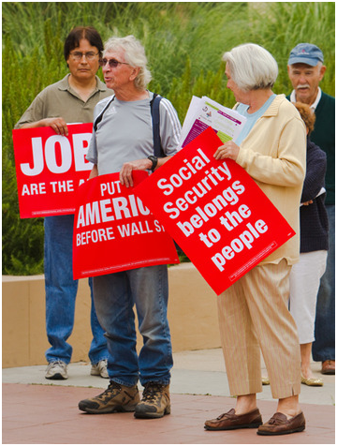
FDR went on to list a number of rights that emerged from the New Deal, including the right to a job, adequate wages, a decent home, medical care, and a good education. Today we take many of these rights for granted. We also accept that the government is responsible for guaranteeing these rights.
Before the New Deal, private charities bore the burden of caring for the needy. But the severity of the Depression changed popular notions of charity. The crisis was so severe that it could be tackled only by using the enormous resources of the federal government. Americans began to accept the idea that many people could not survive without public assistance.
Most New Deal programs offered short-term relief to cope with the immediate effects of the Depression. The Social Security Act did something different, however. This milestone legislation established long-term assistance for those in need. By doing so, it laid the foundation for the modern welfare state. A welfare state is a social system in which the government takes responsibility for the economic well-being of its citizens.
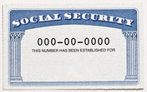
Critics at the time grumbled that government assistance undermined the American principles of self-reliance and individualism. Nevertheless, government assistance continues today in various forms. It now includes a wide array of programs, from health insurance for older Americans to food stamps for the poor and parity price supports for farmers. These are known as entitlement programs, as people who meet eligibility requirements are entitled to receive certain benefits from them. All these programs owe their existence to the New Deal.
A Larger Role for Uncle Sam in People’s Everyday Lives Another notable legacy of the New Deal is the expanded role of government. Traditionally, Americans have distrusted government power. A limited government, the founders said, protects against tyranny. However, to battle the Depression, FDR actively involved the federal government in the economy. He also used it to advance his agenda of social justice. As a result, the government grew. Each federal program required a new agency to administer it, which enlarged the government bureaucracy. The cost was enormous. To meet the expense, FDR reluctantly resorted to deficit spending, or spending more than the government receives in revenues. He financed the deficit by borrowing money.
Conservatives reacted strongly to this growth in the size and power of government. In 1936, one critic wrote that FDR had transformed government “into a highly complex, bungling agency for throttling [strangling] business and bedeviling the private lives of free people. It is no exaggeration to say that he took the government when it was a small racket and made a large racket out of it.” Today, that “large racket” is known as “big government.” Conservatives complain that big government leads to burdensome regulations, higher taxes, and less local control. Liberals, however, defend the expanded role of the federal government as essential to creating a good and just society.
Government today is not just bigger as a result of the New Deal. It also continues to play a more direct role in people’s lives. Americans buy power from government-built dams. They deposit money in bank accounts insured by the FDIC. They are protected from fraud by government agencies such as the SEC. They receive Social Security payments when they retire. These and many more benefits of big government are all legacies of the New Deal.
