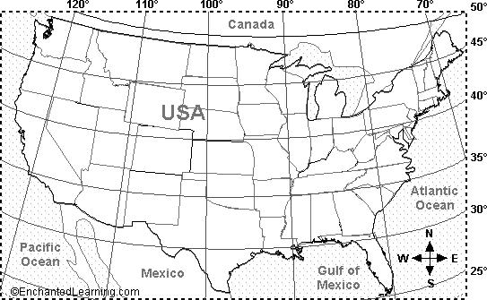
Which states are located on the following coordinates?
1. 30N and 100W
2. 35N and 120W
3. 42N and 75W
4. 47N and 110W
5. 28N and 81W
Use latitude and longitude lines on a map and locate the following and identify the hemispheres that it is in:
- The highest mountain on our continent:
Coordinate ___________ Hemisphere __________________

- The capital cities of three foreign cities (outside of U.S.):
City ___________ Coordinate ______________ Hemispheres __________________
City ___________ Coordinate ______________ Hemispheres __________________
City ___________ Coordinate ______________ Hemispheres __________________

- The national park nearest Aurora:
Park ___________ Coordinate ______________ Hemispheres __________________

- The mouths of three major rivers:
River ___________ Coordinate ______________ Hemispheres __________________
River ___________ Coordinate ______________ Hemispheres __________________
River ___________ Coordinate ______________ Hemispheres __________________

- Three major cities in the United States:
City ___________ Coordinate ______________ Hemispheres __________________
City ___________ Coordinate ______________ Hemispheres __________________
City ___________ Coordinate ______________ Hemispheres __________________

