Geography Unit 1
Activity 4: Map Projections
Directions: Read pages pg. 22-23 in your geography textbook before you begin the activity. After you complete the front of this, draw an image of each kind of map on the back and point to one strength and one weakness of each map.
Type of Map/What it’s Used For | Strengths of This Type of Map | Weaknesses of This Type of Map
Lambert  Projection | At the North Pole and the South Pole the land is NOT distorted. It is accurate in the center. | The land near the equator is distorted.
Mercator Projection

Eckert IV Projection

Goode’s Homolosine Projection

Geography Unit 1

Activity 5, Reasons for the Seasons: Page 20-21
1.
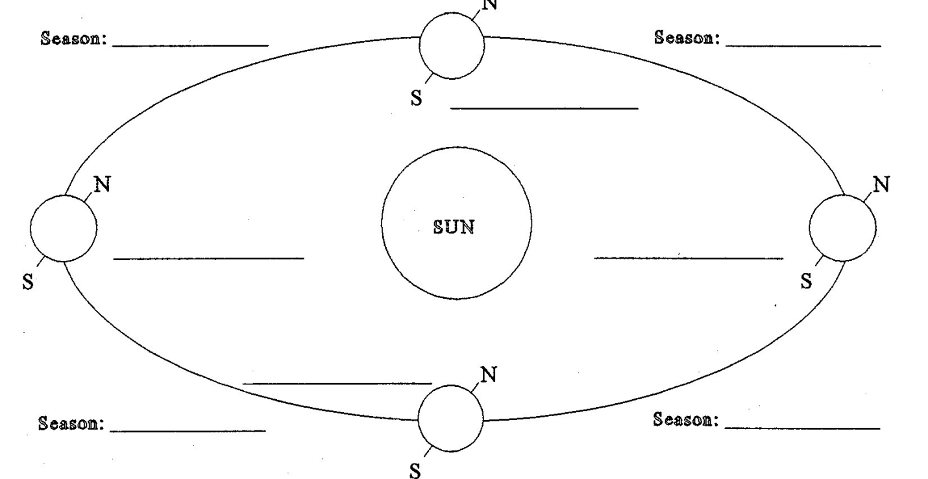
Vocabulary: autumnal equinox, vernal equinox, summer solstice, winter solstice

2. Tilt determines the seasons. At what angle is the Earth tilted at with respect to the Sun? ___ degrees
3. What season does not exist along the Equator? Why?

4. If it is winter in the Southern Hemisphere, then it is __________________ in the Northern Hemisphere.
5. If it is autumn in the Northern Hemisphere, then it is _______________ in the Southern Hemisphere.
6. Critical Thinking: Describe the summer and winter at one of the poles

