Oil, by the Numbers
Where America gets its oil
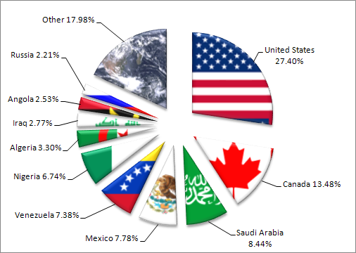
According to the pie chart above, where does the U.S. get most of its oil from?
The U.S. imports more oil from this foreign country than any other?
What 2 Middle East countries account for over 10% of America oil imports?

According to the chart, does the U.S. import more oil from Latin America, Africa, or the Middle East?

Who uses the most oil
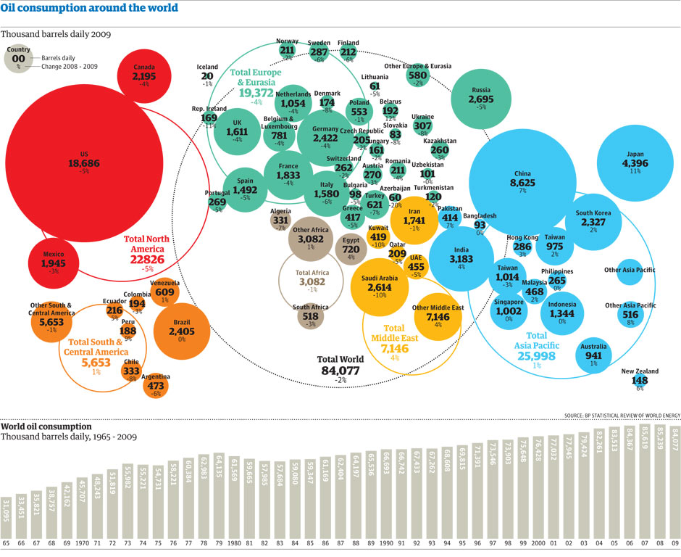
What country consumes more oil on a daily basis than any other? What country is second?

How many barrels of oil does the U.S. consume daily? (Hint: Add 3 zeros to the number shown) And China?

What European country consumes the most? How much?
What South American country consumes the most? How much?
How much oil does the Total World consume on a daily basis?

Who has the most oil
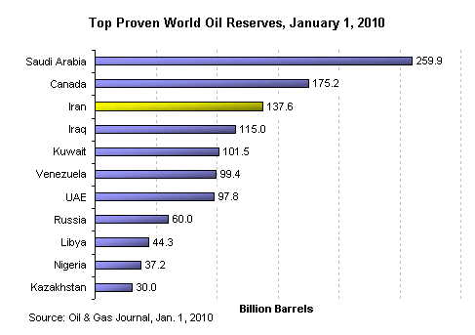

What is an oil reserve?
What country has the largest oil reserve? How much?
What is the total oil reserves of all these countries combined?
How many of these countries are in the Middle East?
How many are members of OPEC?

Unstable countries USA gets its oil from
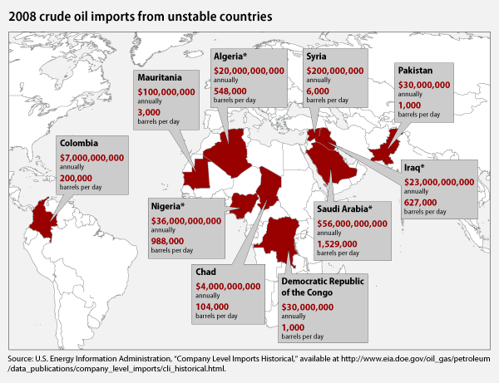
From what country do we import the most and pay the most money to for their oil?
How many barrels a day total come from these countries combined?
Are you surprised that we get oil from some of the countries on this list? Which ones?
What issues can arise from importing oil from unstable countries?

Oil in the USA
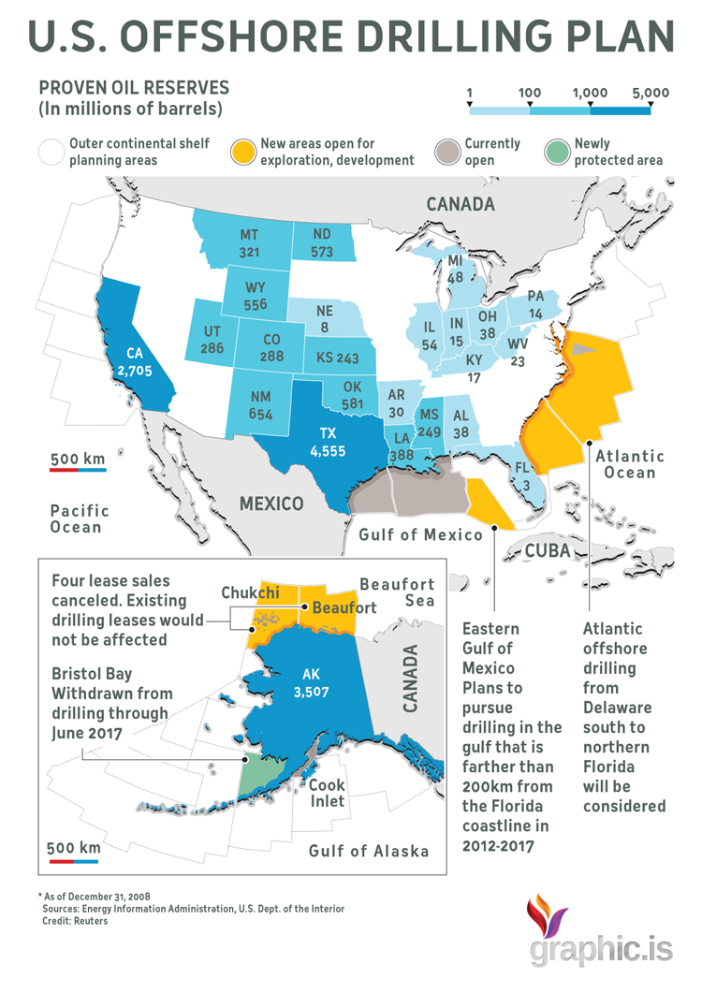
Which U.S. state has the most oil reserves? How much?
How many millions of barrels does Colorado have in Reserve?
The areas in the Atlantic Ocean and Gulf of Mexico can be drilled, should we be drilling for oil in these waters?
What problems can arise from drilling for oil in the Gulf/Ocean? (aka Offshore Drilling)
In Alaska we don’t drill in some areas because it can damage the habit of the wildlife, even though it has been proven that there are large amounts of oil in these areas. What do you think of this?

Political Cartoon
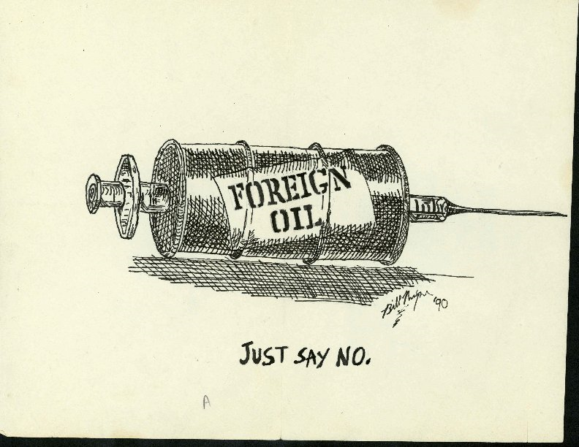
Explain this Political Cartoon.

__________________________________________________________________________________________
__________________________________________________________________________________________
__________________________________________________________________________________________
__________________________________________________________________________________________
__________________________________________________________________________________________
__________________________________________________________________________________________

