Document #1
Arriving at Werowocomoco, their emperor proudly lying upon a bedstead a foot high upon ten or twelve mats . . . with such grave and majestical countenance, as drove me into admiration . . . He kindly welcomed me with good words and great platters of sundry victuals, assuring me his friendship, and my liberty within four days. . . . He asked me the cause of our coming . . . demanded why we went further with our boat. . . . He promised to give me what I wanted to feed us, hatchets and copper we should make him, and none should disturb us. This request I promised to perform. And thus having all the kindness he could devise, sought to content me, he sent me home.

Source: Excerpt adapted from John Smith (1608). A true relation of such occurrences and accidents of note as hath happened in Virginia since the first planting of that colony. In L. G. Gardiner (Ed.). (1907). Narratives of Early Virginia, 1606–1625. New York: Charles Scribner’s Sons, 48, 50.
Online facsimile edition available at www.americanjourneys.org/aj-074

Document #2
At last they brought him to Meronocomoco, where was Powhatan their Emperor. . . . At his entrance before the King, all the people gave a great shout . . . and . . . having feasted him after their best barbarous manner they could, a long consultation was held, but the conclusion was, two great stones were brought before Powhatan: then, as many as could layd hands on him, dragged him to them, and thereon laid his head, and being ready with their clubs, to beate out his braines, Pocahontas, the Kings dearest daughter, when no intreaty could prevaile, got his head in her armes, and laid her owne upon his to save him from death; whereat the Emperour was contented he should live. . . .Two dayes after, Powhatan having disguised himselfe in the most fearefullest manner he could, caused Captaine Smith to be brought forth to a great house in the woods, and there upon a mat by the fire to be left alone . . . then Powhatan more like a devill then a man . . . came unto him and told him now they were friends, and presently he should goe to James towne, to send him two great gunnes, and a gryndstone, for which he would . . . for ever esteeme him as his sonne. . . .

Source: Excerpt adapted from John Smith (1624). General History of Virginia, New England and the Summer Isles. In P. L. Barbour (Ed.). (1986). The Complete Works of Captain John Smith (1580–1631),Vol. 2. Chapel Hill: University of North Carolina Press, 151.
Also available online at http://www.virtualjamestown.org/firsthand.html

Document #3
John Smith’s two completely different versions don’t match up. The later one, A General History of Virginia,
exaggerates a lot of details in A True Relation, and brings up new information Smith never mentioned in the 16 years between the publication of the two.
When Smith describes his captivity (winter of 1607-1608) in A True Relation, he says Powhatan was kind and generous. He says he found no cause to fear for his life. (This proves Smith thought it was wrong to doubt Powhatan’s goodwill.) Plus, Smith never mentioned Pocahontas in A True Relation. Therefore, a thinking
person can’t believe it. A True Relation mentions Pocahontas coming to Jamestown later in 1608. Smith says he gave her gifts in return for her father’s kindness. Wouldn’t he have been thanking her for saving his life (if it happened)? Finally, Smith wrote in 1612 (in A Map of Virginia) that while he was in captivity he witnessed a method of execution practiced
by the tribe. He describes a prisoner’s head being placed on a sacrificing stone, while “one with clubs beats out their brains.” Isn’t it rather odd that he didn’t mention his own experience here, since it sounds just like what happened to him?

Source: Summary adapted from Henry Adams (1867, January). “Captain John Smith.”
The North American Review 104 (214).

Document #4
John Smith had no reason to lie. In all of his other writing about native customs and geography, he is very accurate and observant. For 250 years after his captivity, no one questioned his story. The reason the two versions differ is that their purpose is different. In
A True Relation, Smith didn’t want to brag about his adventures; he wanted to inform readers about the land and people of Virginia. In the General History, his goal was to promote colonization in Virginia (and added stories might get people interested in the activities of the Virginia Company). And to those critics who say Smith never mentioned Pocahontas’s bravery until 1624—after some of her fame would enhance his status—he did write about her before she came to
England. In 1616, Smith wrote to Queen Anne to tell her of Pocahontas’s bravery and other rare qualities, and he described how Pocahontas rescued him from Powhatan, and how she saved all Jamestown from starvation. There is no doubt that the event happened. Smith may have misinterpreted what the whole thing
meant. I think it was probably a ritualistic death and rebirth, with Pocahontas acting as his sponsor into Indian identity.

Source: Summary adapted from J. A. Leo Lemay (1991). The American Dream of Captain John Smith. Charlottesville: University Press of Virginia

Document #5
Why is it that none of the other members of the Virginia Company who kept diaries ever wrote about Pocahontas saving Smith’s life? (Ten fellow Virginia company members kept journals in 1608.) Surely someone would have written about it if Smith came back to Jamestown and shared his story. Thus, no one in England had ever heard of her until 1617 when she was a big media event in London. She was a “princess” (daughter of “King” Powhatan), and the first Indian woman to visit England. Because she had converted to Christianity, people high up in the church, as well as the King (James I) and Queen (Anne), paid attention to her. While all this was going on, John Smith published a new edition of A True Relation
that now had footnotes in the part about his capture. These notes mention Pocahontas throwing herself on Smith to beg his release, and her father giving in to her request. Smith even goes on to take credit for introducing Pocahontas to the English language and the Bible. In 1624, Smith polished this story in his General History
. This version expands the details of his rescue, saying Pocahontas risked her life to save his. He also describes
Chief Powhatan providing the Jamestown colonists with Indian guides. Would the same chief who wanted to kill Smith now try to help him?

Source: Summary adapted from Paul Lewis (1966). The Great Rogue: A Biography of John Smith.
New York: David McKay Company.

Document #6
The bringing in of two big stones, and forcing John Smith to stretch out on them, seemed to Smith like he was about to be executed. When a young girl (Pocahontas) knelt and placed her head on Smith, he was released. The way he saw it, she saved his life. What almost certainly happened was that Smith was the center of a ritual similar to what young boys in the tribe went through before entering manhood. They have a pretend execution or death and then are reborn as men. Pocahontas was preselected to be his protector. She did not actually save his life because the Powhatan were not really going to kill him.

Source: Summary adapted from Philip Barbour, Pocahontas and Her World (1969). Boston: Houghton Mifflin.

Document #7

Disney movie Pocahontas- Watch from 1:07:00 for a few minutes.

Document #8
Pocahontas by Simon van de Passe- 1616
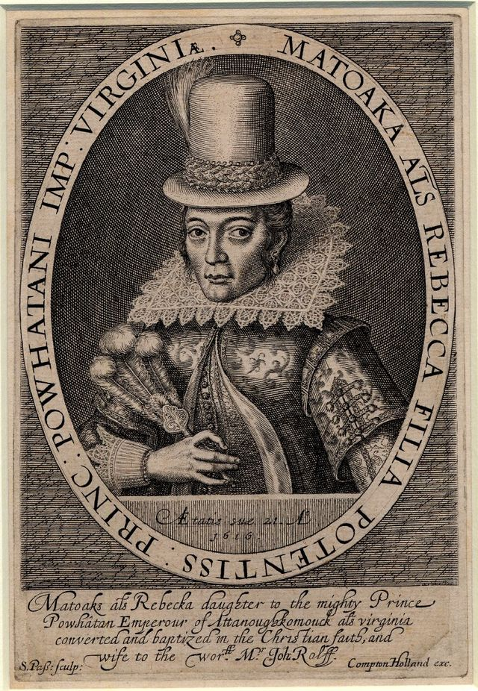
Document #9

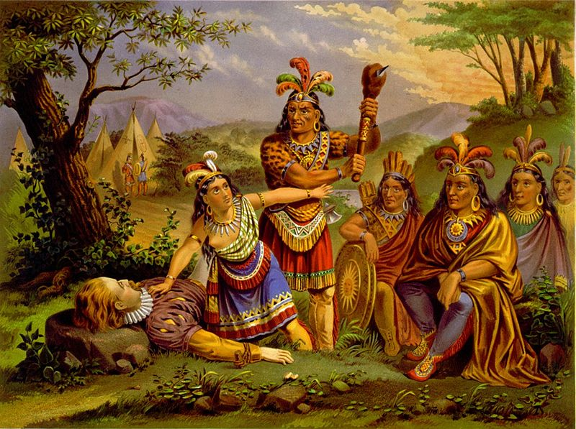
New England Chromo. Lith. Co. - Library of Congress, Prints & Photographs Division 1870

