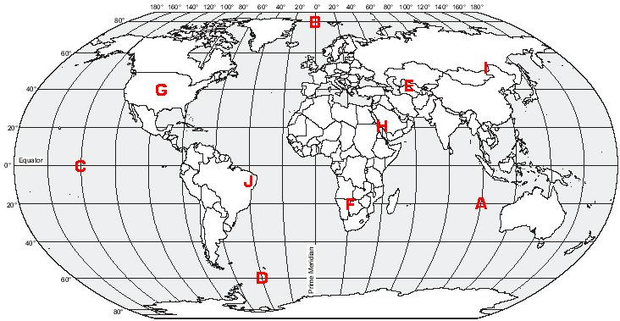

A = ___________________________________ F = ___________________________________

B = ___________________________________ G = ___________________________________

C = ___________________________________ H = ___________________________________

D = ___________________________________ I = ___________________________________

E = ___________________________________ J = ___________________________________

