Name______________________________

Analyzing Primary Source: The Red Scare and the 1920’s

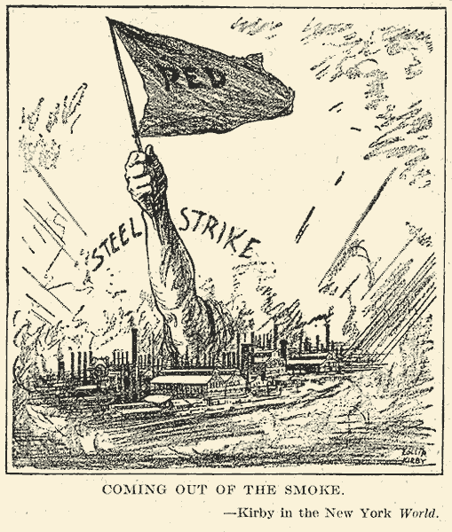
- What do you see?

- What does it mean?

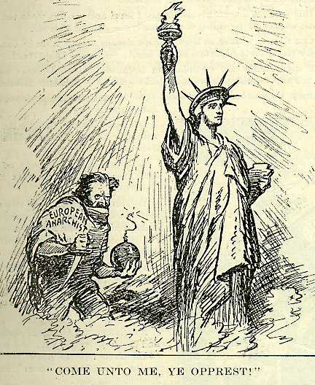

- What do you see?

- What does it mean?

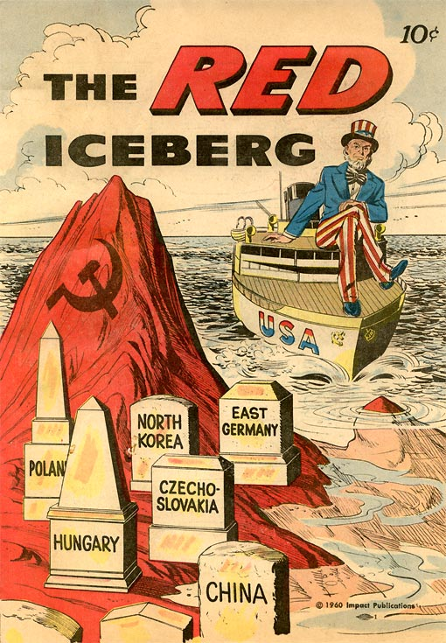
- What do you see?

- What does it mean?

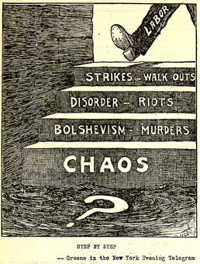

- What do you see?

- What does it mean?

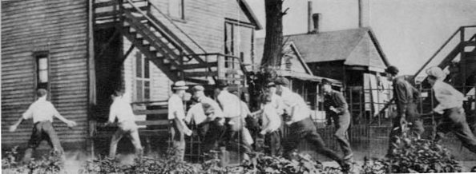
- What do you see?

- What does it mean?

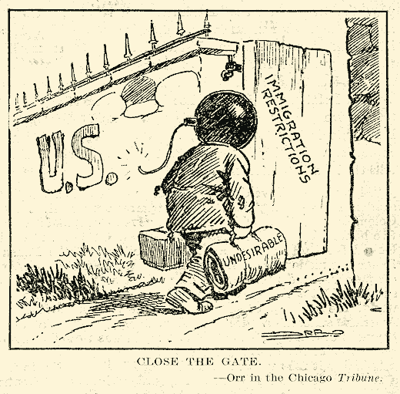

- What do you see?

- What does it mean?

