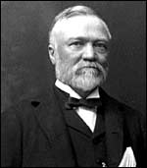
Andrew Carnegie
One of the captains of industry of 19th century America, Andrew Carnegie helped build the formidable American steel industry, a process that turned a poor young man into one of the richest entrepreneurs of his age. Later in his life, Carnegie sold his steel business and systematically gave his collected fortune away to cultural, educational and scientific institutions for "the improvement of mankind."
Carnegie was born in Dunfermline, the medieval capital of Scotland, in 1835. The town was a center of the linen industry, and Andrew's father was a weaver, a profession the young Carnegie was expected to follow. But the industrial revolution that would later make Carnegie the richest man in the world, destroyed the weavers' craft. When the steam-powered looms came to Dunfermline in 1847 hundreds of hand loom weavers became expendable. Andrew's mother went to work to support the family, opening a small grocery shop and mending shoes.
"I began to learn what poverty meant," Andrew would later write. "It was burnt into my heart then that my father had to beg for work. And then and there came the resolve that I would cure that when I got to be a man."
An ambition for riches would mark Carnegie's path in life. However, a belief in political egalitarianism was another ambition he inherited from his family. Andrew's father, his grandfather Tom Morrison and his uncle Tom Jr. were all Scottish radicals who fought to do away with inherited privilege and to bring about the rights of common workers. But Andrew's mother, fearing for the survival of her family, pushed the family to leave the poverty of Scotland for the possibilities in America. She borrowed 20 pounds she needed to pay the fare for the Atlantic passage and in 1848 the Carnegies joined two of Margaret's sisters in Pittsburgh, then a sooty city that was the iron-manufacturing center of the country.
William Carnegie secured work in a cotton factory and his son Andrew took work in the same building as a bobbin boy for $1.20 a week. Later, Carnegie worked as a messenger boy in the city's telegraph office. He did each job to the best of his ability and seized every opportunity to take on new responsibilities. For example, he memorized Pittsburgh's street lay-out as well as the important names and addresses of those he delivered to.
Carnegie often was asked to deliver messages to the theater. He arranged to make these deliveries at night--and stayed on to watch plays by Shakespeare and other great playwrights. In what would be a life-long pursuit of knowledge, Carnegie also took advantage of a small library that a local benefactor made available to working boys. One of the men Carnegie met at the telegraph office was Thomas A. Scott, then beginning his impressive career at Pennsylvania Railroad. Scott was taken by the young worker and referred to him as "my boy Andy," hiring him as his private secretary and personal telegrapher at $35 a month.
"I couldn't imagine," Carnegie said many years later. "what I could ever do with so much money." Ever eager to take on new responsibilities, Carnegie worked his way up the ladder in Pennsylvania Railroad and succeeded Scott as superintendent of the Pittsburgh Division. At the outbreak of the Civil War, Scott was hired to supervise military transportation for the North and Carnegie worked as his right hand man.
The Civil War fueled the iron industry, and by the time the war was over, Carnegie saw the potential in the field and resigned from Pennsylvania Railroad. It was one of many bold moves that would typify Carnegie's life in industry and earn him his fortune. He then turned his attention to the Keystone Bridge Company, which worked to replace wooden bridges with stronger iron ones. In three years he had an annual income of $50,000.
However, Andrew expressed his uneasiness with the businessman's life. In a letter to himself at age 33, he wrote: "To continue much longer overwhelmed by business cares and with most of my thoughts wholly upon the way to make more money in the shortest time, must degrade me beyond hope of permanent recovery. I will resign business at thirty-five, but during the ensuing two years I wish to spend the afternoons in receiving instruction and in reading systematically."
Carnegie would continue making unparalleled amounts of money for the next 30 years. Two years after he wrote that letter Carnegie would embrace a new steel refining process being used by Englishman Henry Bessemer to convert huge batches of iron into steel, which was much more flexible than brittle iron. Carnegie threw his own money into the process and even borrowed heavily to build a new steel plant near Pittsburgh. Carnegie was ruthless in keeping down costs and managed by the motto "watch costs and the profits take care of themselves."
"I think Carnegie's genius was first of all, an ability to foresee how things were going to change," says historian John Ingram. "Once he saw that something was of potential benefit to him, he was willing to invest enormously in it."
Carnegie was unusual among the industrial captains of his day because he preached for the rights of laborers to unionize and to protect their jobs. However, Carnegie's actions did not always match his rhetoric. Carnegie's steel workers were often pushed to long hours and low wages. In the Homestead Strike of 1892, Carnegie threw his support behind plant manager Henry Frick, who locked out workers and hired Pinkerton thugs to intimidate strikers. Many were killed in the conflict, and it was an episode that would forever hurt Carnegie's reputation and haunt the man.
Still, Carnegie's steel juggernaut was unstoppable, and by 1900 Carnegie Steel produced more of the metal than all of Great Britain. That was also the year that financier J. P. Morgan mounted a major challenge to Carnegie's steel empire. While Carnegie believed he could beat Morgan in a battle lasting five, 10 or 15 years, the fight did not appeal to the 64-year old man eager to spend more time with his wife Louise, whom he had married in 1886, and their daughter, Margaret.
Carnegie wrote the asking price for his steel business on a piece of paper and had one of his managers deliver the offer to Morgan. Morgan accepted without hesitation, buying the company for $480 million. "Congratulations, Mr. Carnegie," Morgan said to Carnegie when they finalized the deal. "you are now the richest man in the world."
Fond of saying that "the man who dies rich dies disgraced," Carnegie then turned his attention to giving away his fortune. He abhorred charity, and instead put his money to use helping others help themselves. That was the reason he spent much of his collected fortune on establishing over 2,500 public libraries as well as supporting institutions of higher learning. By the time Carnegie's life was over, he gave away 350 million dollars. Carnegie also was one of the first to call for a "league of nations" and he built a "a palace of peace" that would later evolve into the World Court. His hopes for a civilized world of peace were destroyed, though, with the onset of World War I in 1914. Louise said that with these hostilities her husband's "heart was broken." Carnegie lived for another five years, but the last entry in his autobiography was the day World War I began.

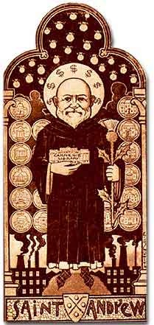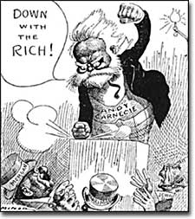

John D. Rockefeller
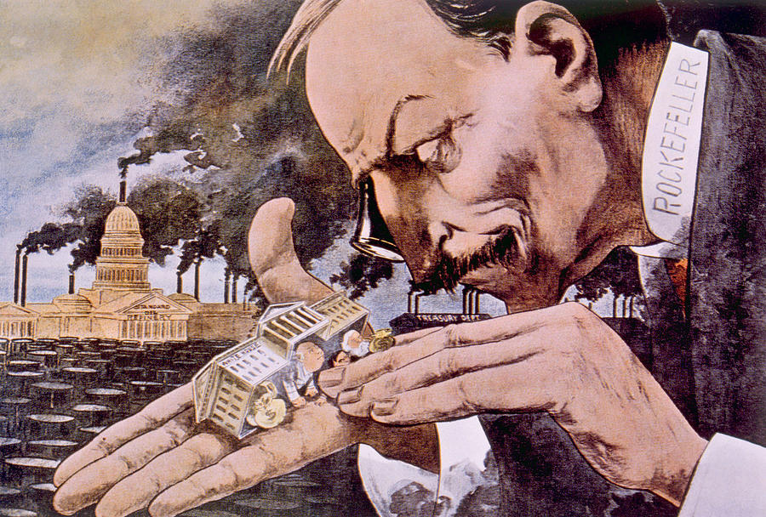
"What a Funny Little Government!" Cartoonist Horace Taylor pokes fun at John D. Rockefeller in this cartoon which appeared in The Verdict, a partisan magazine of the day.
He was America's first billionaire.
In a pure sense, the goal of any capitalist is to make money. And John D. Rockefeller could serve as the poster child for capitalism. Overcoming humble beginnings, Rockefeller had the vision and the drive to become the richest person in America.
At the turn of the century, when the average worker earned $8 to $10 per week, Rockefeller was worth millions.

Robber Baron or Captain of Industry?
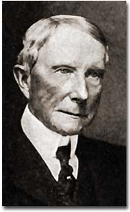
John D. Rockefeller (1839-1937)
What was his secret? Is he to be placed on a pedestal for others as a "captain of industry?" Or should he be demonized as a "robber baron." A robber baron, by definition, was an American capitalist at the turn of the 19th century who enriched himself upon the sweat of others, exploited natural resources, or possessed unfair government influence.
Whatever conclusions can be drawn, Rockefeller's impact on the American economy demands recognition.
Rockefeller was born in 1839 in Moravia, a small town in western New York. His father practiced herbal medicine, professing to cure patients with remedies he had created from plants in the area. John's mother instilled a devout Baptist faith in the boy, a belief system he took to his grave. After being graduated from high school in 1855, the family sent him to a Cleveland business school.
Young John Rockefeller entered the workforce on the bottom rung of the ladder as a clerk in a Cleveland shipping firm. Always thrifty, he saved enough money to start his own business in produce sales. When the Civil War came, the demand for his goods increased dramatically, and Rockefeller found himself amassing a small fortune.
He took advantage of the loophole in the Union draft law by purchasing a substitute to avoid military service. When Edwin Drake discovered oil in 1859 in Titusville, Pennsylvania, Rockefeller saw the future. He slowly sold off his other interests and became convinced that refining oil would bring him great wealth.

Waste Not...
Rockefeller introduced techniques that totally reshaped the oil industry. In the mid-19th century, the chief demand was for kerosene. In the refining process, there are many by-products when crude oil is converted to kerosene. What others saw as waste, Rockefeller saw as gold. He sold one byproduct paraffin to candlemakers and another byproduct petroleum jelly to medical supply companies. He even sold off other "waste" as paving materials for roads. He shipped so many goods that railroad companies drooled over the prospect of getting his business.
Rockefeller demanded rebates, or discounted rates, from the railroads. He used all these methods to reduce the price of oil to his consumers. His profits soared and his competitors were crushed one by one. Rockefeller forced smaller companies to surrender their stock to his control.

Standard Oil — a Trust-worthy Company?
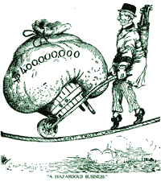
John D. Rockefeller had to perform a delicate balancing act to maintain his reputation as a philanthropist while living the live of a wealthy businessman.
This sort of arrangement is called a trust. A trust is a combination of firms formed by legal agreement. Trusts often reduce fair business competition. As a result of Rockefeller's shrewd business practices, his large corporation, the Standard Oil Company, became the largest business in the land.
As the new century dawned, Rockefeller's investments mushroomed. With the advent of the automobile, gasoline replaced kerosene as the number one petroleum product. Rockefeller was a bona fide billionaire. Critics charged that his labor practices were unfair. Employees pointed out that he could have paid his workers a fairer wage and settled for being a half-billionaire.
Before his death in 1937, Rockefeller gave away nearly half of his fortune. Churches, medical foundations, universities, and centers for the arts received hefty sums of oil money. Whether he was driven by good will, conscience, or his devout faith in God is unknown. Regardless, he became a hero to many enterprising Americans.

J. Pierpont Morgan
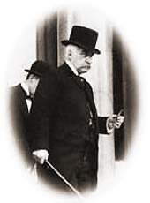
J.P. Morgan invested in everything from Thomas Edison's electric company to railroads and steel companies to insurance firms.

Child of Privilege
Not all of the tycoons of the Gilded Age were rags-to-riches stories. J. Pierpont Morgan was born into a family of great wealth. His father had already made a name for himself in the banking industry. With Morgan's family resources, he enjoyed the finest business education money could buy.
He did not scratch and claw his way to the top of any corporate ladder. His father arranged for an executive track position at one of New York's finest banks. Regardless of his family's advantages, Morgan had a great mind of his own. He set out to conquer the financial world, and conquer it he did.

Morgan the Banker
Morgan's first business ventures were in banking. By 1860, he had already established his own foreign exchange office. He knew the power of investment. Not content to control just the banking industry, he bought many smaller ventures to make money.
During the Civil War, he paid the legally allowed fee to purchase a substitute soldier and evaded military service. Morgan made handsome profits by providing war materials. One of his enterprises sold defective rifles to the Union army. Upon later investigations, he was declared ignorant of the poor quality of his guns and was cleared of all charges.
After the war, he set out to corner the nation's financial markets. When the Panic of 1873 rocked the nation's economy, Morgan protected himself wisely and emerged in the aftermath as the king of American finance.
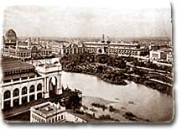
J.P. Morgan was one of the organizers of the World Fair held in Chicago in 1893.
Despite his label as a robber baron, Morgan felt his investments benefited America. His railroad dealings helped consolidate many smaller, mismanaged firms, resulting in shorter trips and more dependable service. Two times during financial panics he allowed the federal government to purchase his vast gold supplies to stop the spiral of deflation.
He owned a bridge company and a tubing company. His most renowned purchase was in 1901, when he bought the Carnegie Steel Company for $500 million to create U.S. Steel. Within ten years U.S. Steel was worth over a billion dollars.
Morgan's actions marked a shift in thinking among American industrialists. He proved that it was not necessary to be a builder to be successful. Smart investment and efficient consolidation could yield massive profits. Young entrepreneurs shifted their goals to banking in the hopes of mirroring Morgan's success.

Trouble with the Government
For all his accomplishments, he was harshly criticized. The first decade of the twentieth century brought challenges to Morgan from the government. His Northern Securities railroad company was deemed illegal under federal antitrust law, the first such action by the national government. He was investigated by Congress for his control of the financial markets. Even U.S. Steel was forced to relinquish its monopoly.
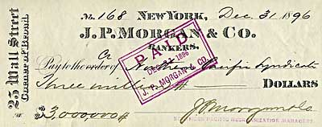
Things you don't see everyday: A cancelled check for three million dollars from J.P. Morgan to the Northern Pacific Syndicate.
Jaded by the criticism, Morgan moved to Europe, where he lived his final days. He was a favorite target of intellectuals who claimed that such tycoons robbed the poor of their deserved wealth. He was a hero to enterprising financiers across the land who dreamed of following his example. That is, of course, unless they were destroyed by his shrewd, fierce tactics.

Cornelius Vanderbilt, The Commodore
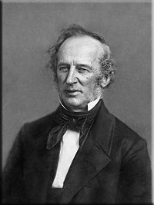

Cornelius Vanderbilt, who is also widely remembered by his nickname as the Commodore because of his early successes in the marine/ship trade, is the first of the great railroad tycoons. Vanderbilt is perhaps the best definition of the term entrepreneur, as he built a massive fortune on sheer determination, will, and belief (doing so with little education). However, due to his ruthless business nature, to an extent early railroad executives like Vanderbilt built the public perception that railroad barons were heartless profiteers caring for little more than expanding their own portfolios (and it was true that Vanderbilt loved to make money). Interestingly, while the Commodore is forever remembered by the railroad empire he created this career did not begin for him until very late in life, as for years he had worked in the steamboat business. Today, much of the New York Central System which he created remains an important transportation artery.
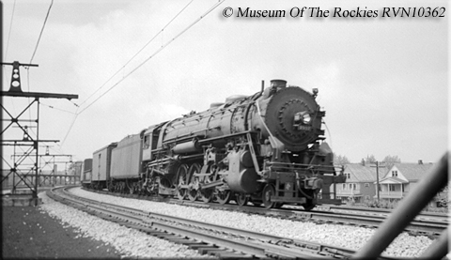
An NYC Class L-2b 4-8-2 Mountain, #2937, is at speed with a freight near Cleveland, Ohio on May 27, 1940.
Cornelius Vanderbilt was born in 1794 to a rather poor family who lived at Port Richmond on New York's Staten Island. Perhaps most interesting, in comparison to his amazing success as a businessman later on life was the fact that he only had formal schooling through the age of 11. At that point he quit school and began helping his father who worked in the boating trade where Vanderbilt first learned about the business he would make a career for more than 50 years. At the age of 16 Vanderbilt began his own ferry service between Staten Island and New York City, with the help of a $100 loan from his mother. Understanding that offering cheap, affordable prices in the service industry could gain a lot of customers Vanderbilt's little ferry operation earned quite a tidy sum, as he quickly repaid his mother the loan along with an additional $1,000! Two years later during the War of 1812 Vanderbilt was able to secure a government contract to move supplies to military forts based in New York.
This enabled Vanderbilt to truly enter the maritime industry as he now had enough funds to build a few of his own ships, in particular schooners. It was at this time that he earned the title of Commodore due to the fact that he operated the largest schooner on the Hudson River. Around the age of 24 he left the ferry business and began working for Thomas Gibbons in the steamboat trade. Through virtually everything Vanderbilt attempted he was quite successful and the steamboat business was no different. In 1829 he went out on his own operating a service between New York City and Peekskill.
As usual he looked to cut rates as low as possible, often putting his competitors out of business or winning in court when they claimed he held an unfair competitive advantage (such as in the Supreme Court case of Robert Fulton and Robert Livingston in 1824, Gibbons vs. Ogden). He was worth a half-million dollars by 1834 and during the rush for gold in California in 1849 Vanderbilt made even more money in the steamboat business by offering a trip that traveled through Nicaragua, saved hundreds of miles, and cost far less. He later briefly tapped into the transatlantic steamship market but this venture was rather unsuccessful and gave up the idea around the start of the Civil War.
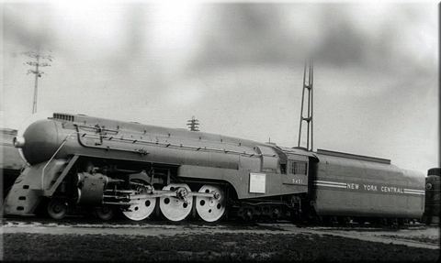
One of the NYC's famed 4-6-4 Hudsons, #5451, with streamlining designed by Henry Dreyfuss for the legendary 20th Century Limited is on display at the Chicago Railroad Fair of 1949 during June of that year (note the plaque on the side of the locomotive).
Around this same time Vanderbilt's legacy in the railroad industry began in 1863, near the age of 70, when he took control of the New York & Harlem Railroad in 1863, much to the chagrin of Daniel Drew. By the time Vanderbilt took over the railroad it operated between New York City and Chatham Four Corners (what is now Chatham). Overall the NY&H was a rather rundown operation although it did provide service directly to downtown Manhattan, a point not lost on the Commodore. A year later he took control of the Hudson River Railroad in 1864, which operated parallel to the NY&H between Albany and New York City.
Vanderbilt, of course, had already established himself as a no-nonsense businessman who could be ruthless in getting what he wanted. He oversaw significant growth of the NY&H and laid its future foundations as a world-class carrier. He immediately changed the railroad's name to the New York Central & Hudson River Railroad when he merged the original New York Central Railroad with the Hudson River Railroad. Later including the New York & Harlem as well, the NYC&HR held a commanding presence in New York City and after gaining control of the Lake Shore & Michigan Southern it reached Chicago on a northern route that was virtually flat (late known as the Water Level Route), in comparison to PRR's main line through the Alleghenies. The NYC&HR would go on to become the legendary New York Central System.
The NYC&HR was again renamed as the New York Central Railroad when it merged with the LS&MS in 1914. Throughout the early 20th century the New York Central System continued to expand reaching Boston; Pittsburgh, PA; Wheeling, WV; the coalfields of southern West Virginia via the Toledo & Ohio Central; Columbus, OH; Cincinnati, Cleveland, and St. Louis via the Big Four Route (the Cincinnati, Cleveland, Chicago & St. Louis Railroad), Columbus, OH; Detroit (and virtually the rest of Michigan via the Michigan Central); and even Montreal, Quebec and Ontario, Canada. Through the years the railroad gained control of notable railroads to reach these markets including the Pittsburgh & Lake Erie, Indiana Harbor Belt, and the aforementioned Big Four.
In 1867 he sparked the "Erie War" with Jim (James) Fisk, Jay Gould, and Daniel Drew when he attempted to gain control of the Erie Railroad to include with his NYC&HR system. This would be the only time Gould ever bested Vanderbilt. During this time the Erie Railroad was one of the most successful systems in the country and what essentially started as an argument between the two turned into a battle of wills as Vanderbilt attempted to corner Erie's stock. In response, Gould and his associates attempted to artificially inflate the Erie's stock value (also known as "watered stock"), which is fraud and against the law. However, Gould only defeated Vanderbilt by bribing the New York state legislature, which allowed the stock to be legalized.

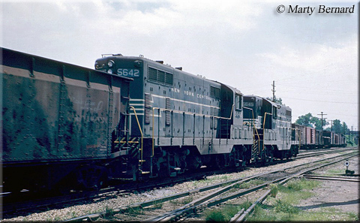
New York Central GP7s #5645 and #5642 roll along subsidiary Indiana Harbor Belt through La Grange, Illinois with a short freight train during early June of 1962.

Over the years Cornelius Vanderbilt had come into dispute with many in the business world such as Drew, Fisk, and others. However, nearly all of these associates he became friends with later on in life, except Gould who often tried to smear Vanderbilt in the public after the Erie incident. The Commodore passed away in January of 1877 at the age of 82 amassing a fortune of nearly $100 million, which would be worth more than $143 billion in today's dollars making him one of the richest Americans in history. In his will Vanderbilt left $95 million of his fortune directly to his son William with his eight daughters receiving between $250,000 and $500,000 each. Unlike James Hill and a number of the other famed railroad tycoons Vanderbilt was not much of a philanthropist, endowing only $1 million of his fortune to the greater good, which went to the Central University in Nashville, Tennessee that became Vanderbilt University.

