Name_____________________________

Sequence of Events: The Genocide in Rwanda
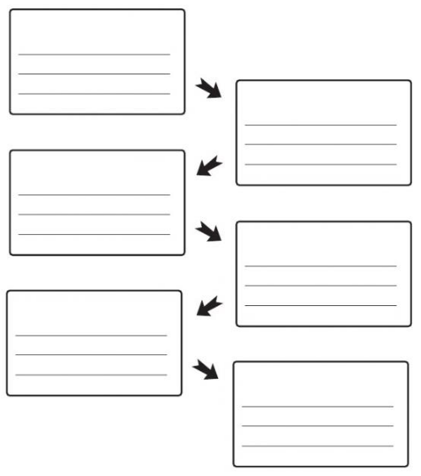

“Before…” | Prior to  Initially  For the past  Previously  Since
“After…” | Following  Soon After
“Next…”  “Then…” | First, Second  Next  Later  Immediately
“While…” | During  When  Simultaneously  Meanwhile
“Finally…” | Subsequently  Eventually  In the end  As a result

__________________________________________________________________________________________
__________________________________________________________________________________________
__________________________________________________________________________________________
__________________________________________________________________________________________
__________________________________________________________________________________________
__________________________________________________________________________________________
__________________________________________________________________________________________
__________________________________________________________________________________________
__________________________________________________________________________________________
__________________________________________________________________________________________
__________________________________________________________________________________________
__________________________________________________________________________________________
__________________________________________________________________________________________
__________________________________________________________________________________________
__________________________________________________________________________________________
__________________________________________________________________________________________
__________________________________________________________________________________________
__________________________________________________________________________________________
__________________________________________________________________________________________
__________________________________________________________________________________________

