Name____________________
Deposition Sheet
Summary of the Bridgewater Hold-up and the Braintree Murders:

Summary of the Arrest of Sacco and Vanzetti:

Category #1: The Backgrounds of Sacco and Vanzetti
Sacco’s Background:

Vanzetti’s Background:

Category #2: Eyewitness Testimony
Mary Splaine- Eyewitness #1 for the Prosecution

Louis Pelser- Eyewitness #2 for the Prosecution

Lola Andrews- Eyewitness #3 for the Prosecution

Witnesses for the Defense:

Category #3: Ballistics Evidence
Evidence against Sacco:

Evidence against Vanzetti:

Category #4: Consciousness of Guilt Evidence
Packing Heat:

Government Attacks against Anarchists:

The Death of Salesdo:

Juror’s Ruling: Are Sacco and Vanzetti both guilty, beyond reasonable doubt, of the Bridgewater holdup and the Braintree murders? On a separate sheet of paper, write your conclusion (5-7 sentences) as to whether or not you believe they are guilty in the American court of law. Make sure that your first sentence is the form of an XYZ thesis statement and that your following sentences provide specific evidence and examples that have been presented in the case. (The evidence/examples that you choose will also be previewed in your XYZ thesis statement).

XYZ Thesis Statement: An XYZ thesis is a thesis statement that answers a question and gives three specific reasons that support the answer.

Sample XYQ Thesis:
Sample Question: Was the Treaty of Versailles that ended World War I, a fair and just treaty?
Sample XYQ Thesis: The Treaty of Versailles was not a fair and just treaty because it made Germany take blame for the war, charged Germany with reparations payments, and did not allow colonialism to end.

YOUR Question: Are Sacco and Vanzetti both guilty, beyond reasonable doubt, of the Bridgewater holdup and the Braintree murders?

Map showing key locations concerning the Sacco and Vanzetti Case
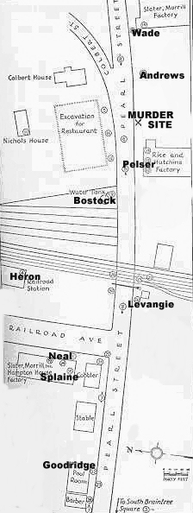
Braintree crime scene with names showing the locations of key prosecution witnesses

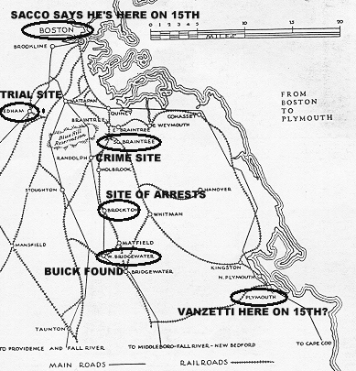

The Crime: District Attonrey Katzman is prosecuting Sacco and Vanzetti in court for two crimes. They include: (1) the Bridgewater holdup and (2) the Braintree murders.

The Evidence: District Attorney Katzman built his case around four categories of evidence: (1) eyewitness identification of Sacco and Vanzetti (2) ballistics testimony (3) the defendant’s sketchy behavior in what is legally referred to as the “consciousness of guilt” (4) the backgrounds of Sacco and Vanzetti.

Your Role: You will be acting as a juror to determine whether or not Sacco and Vanzetti are guilty beyond reasonable doubt.

Directions:
Step 1: Read the Crime Report under this paper and write a summary of the crimes and the arrest on the Deposition Sheet.

Step 2: Read about the four categories of evidence and complete the rest of the deposition sheet.

Step 3: Once you have recorded information on the evidence, write a response as if you were a member of the jury. In your response explain w hether or not you believe Sacco and Vanzetti are guilty, beyond a reasonable doubt, of the Bridgewater holdup and the Braintree murders. No matter what you choose, you need to include an XYZ thesis statement that lists 3 ideas that support your conclusion.

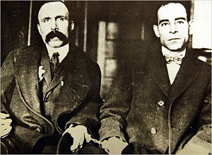
Bartolomeo Vanzetti and Nicola Sacco (Dedham Ccourthouse, 1923)

