Station 1: First Turnpike- 1790 Lancaster, PA
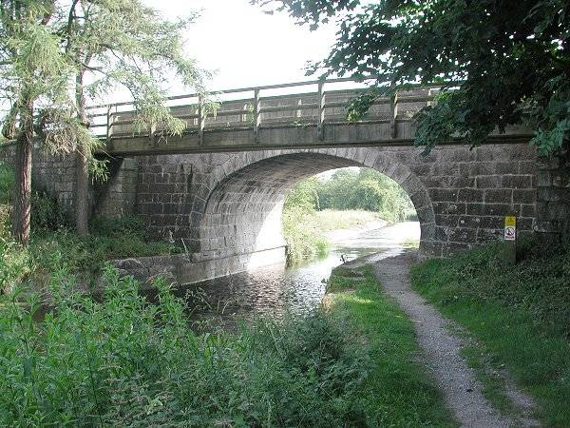
By 1832, nearly 2400 mi. of road connected most major cities.
In the late 18th and early 19th centuries, travel in the White Mountain region was difficult, to say the least. The settlements were spread out and the mountains were a major obstacle to traffic. Attempts to improve the roads were frequent and usually ineffective. The state insisted that roads be built and paid for by the individual towns. The towns had little money and little expertise in road building. There were many petitions to the legislature for assistance in improving the roads. The legislature adopted a solution that was in use at the time in England. They chartered private corporations to build turnpikes and allowed those corporations to collect tolls.
Early toll roads were constructed between some commercial centers and were owned by joint-stock companies that sold stock to raise construction capital, like Pennsylvania's 1795 Lancaster Turnpike Company. While transportation needs were universally recognized, in 1808 Secretary of the Treasury Albert Gallatin's Report on the Subject of Public Roads and Canals suggested that the federal government should fund the construction of interstate turnpikes and canals, but many Anti-Federalists opposed the federal government assuming such a role. The British coastal blockade in the War of 1812 and an inadequate internal capability to respond, demonstrated the United States' reliance upon such overland roads for military operations as well as for general commerce.^{[4]} Construction on the westward National Road began in 1815 at Cumberland, Maryland and it reached Wheeling, Virginia by 1818; by 1824 private tollways connected Cumberland eastward with commercial and port cities. Further westward extensions were constructed to Vandalia, Illinois, but financial crisis ultimately prevented its planned western extension to the Mississippi and Missouri Rivers. Nevertheless, the road became a primary overland route over the Appalachian Mountains and the gateway for the surge of westward-bound settlers and immigrants, which followed these continental wars.
Essential Questions:
- What is a turnpike?
- Who often paid for construction of turnpikes?
- Do we still have turnpikes today?
Cumberland (National Road), 1811
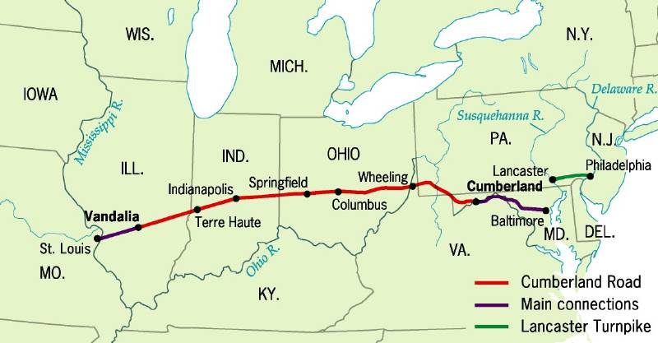
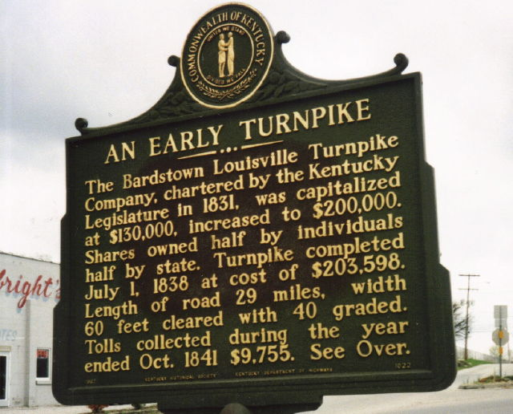

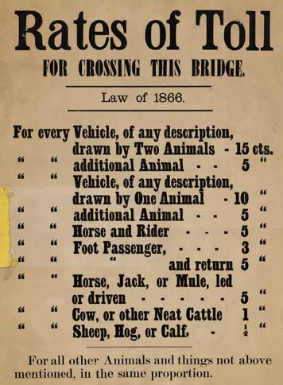
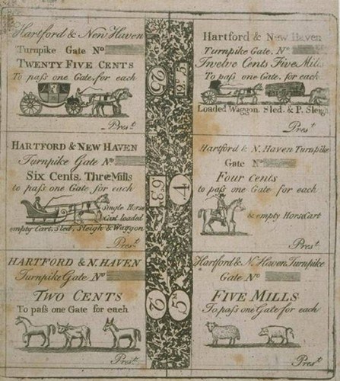

Conestoga Covered Wagons
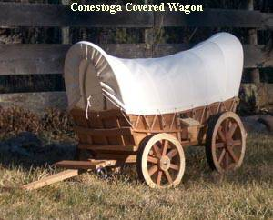

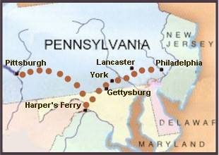
Conestoga Trail, 1820s

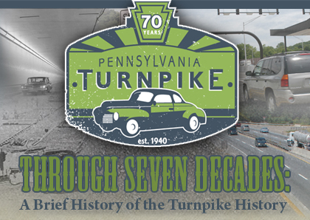

Station 2: The Erie Canal

"Monument of Progress"
Yet it is not that wealth now enriches the scene
Where treasures of Art and of Nature convene;
It is not that this Union our coffers may fill:
Oh! No! It is something more exquisite still.
‘Tis that Genius had triumphed and Science prevailed
Where prejudice flouted and envy assailed
It is that the Vassels of Europe may see
The Progress of Mind in a Land that is free.
-- from The Meeting of the Waters of Hudson and Erie, by Samuel Woodworth, 1825; sung by Mr. Keene at the Grand Canal Celebration, respectfully dedicated to His Excellency, DeWitt Clinton.

The Erie Canal, begun in 1817, was a triumph of early engineering in the United States and one of the most ambitious construction projects of nineteenth-century America. It was longer by far than any other canal previously built in Europe or America, crossing rivers and valleys, cutting through deep rock, and passing through marshes and forests in its 363-mile course across New York State.
The driving force behind the canal project was DeWitt Clinton, former mayor of New York City and Governor of New York State. Completed in 1825, the original Erie Canal is often referred to as "Clinton's Ditch." It was forty feet wide and four feet deep. Ten years after its opening, the Erie Enlargement was begun, built in response to the immediate overcrowding of the original canal. The Enlargement expanded the canal to seventy feet wide and seven feet deep
From the opening days of the canal in 1825, thousands of people from America and Europe took advantage of the new inland waterway and its faster, smoother mode of travel. Thousands more were employed on the canal operating cargo boats that transported goods such as salt, flour, or textiles between Buffalo and New York City

Essential Questions:
- Why was DeWitt Clinton so willing to spend an astronomical amount of money on the creation of the Erie Canal?
- Can you think of any similar infrastructure projects in your community?
http://www.eriecanal.org/UnionCollege/175th.html
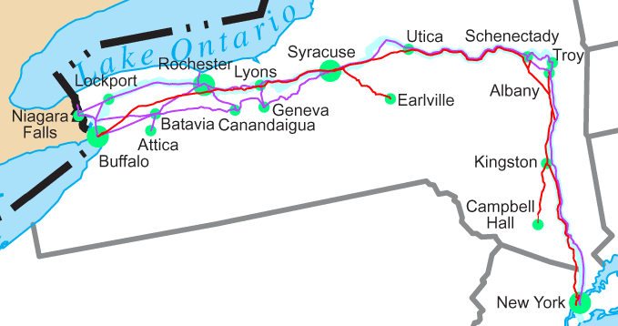
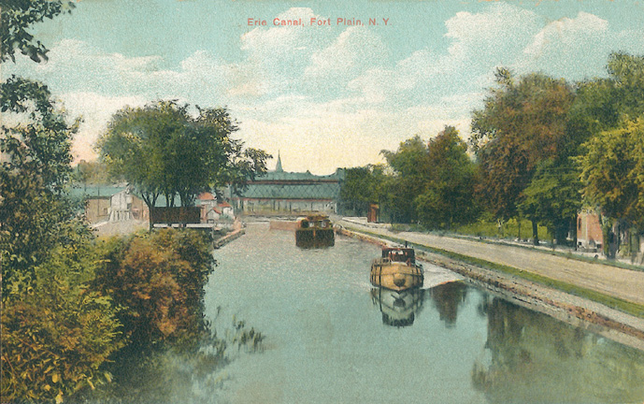
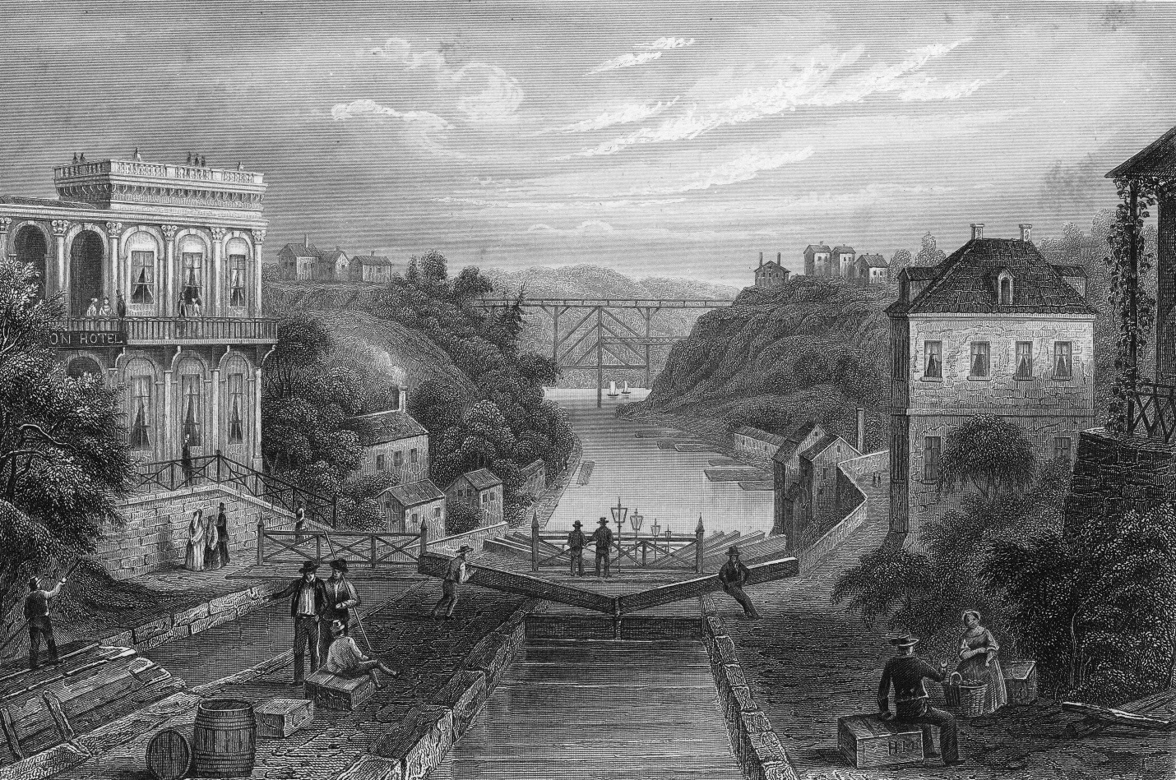
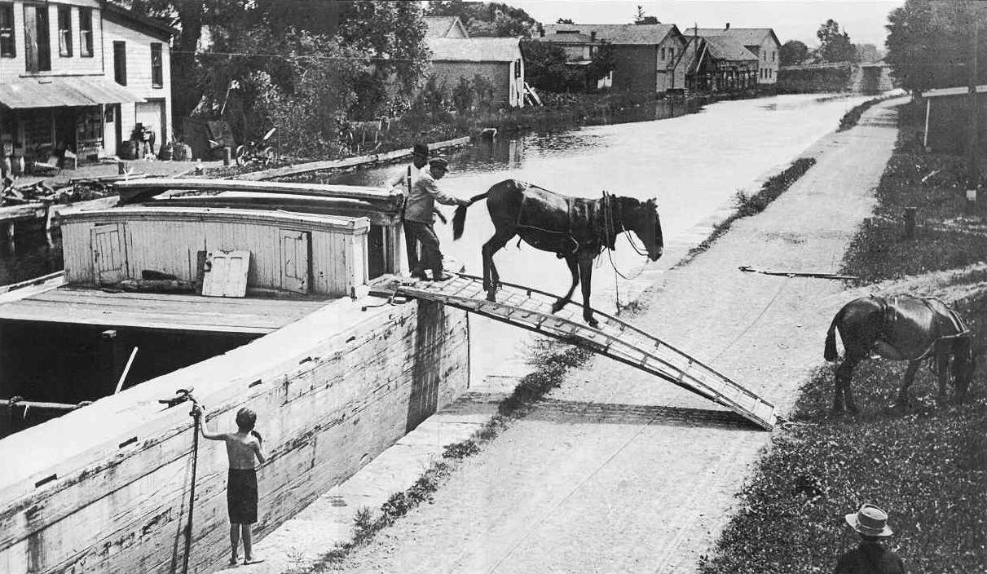
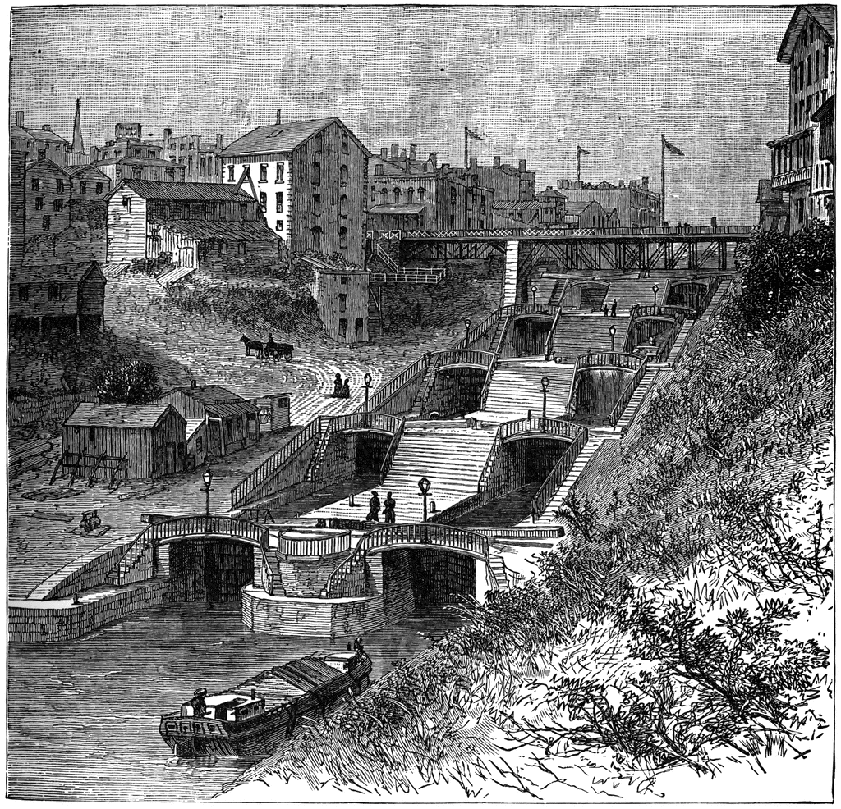
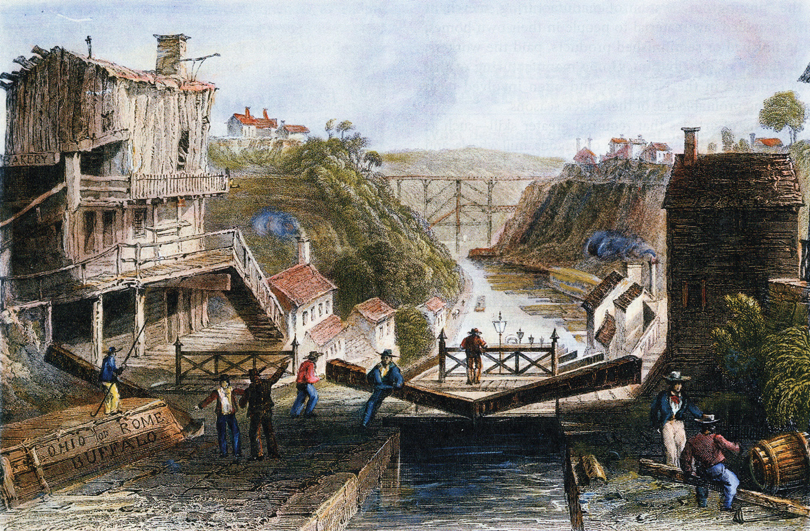
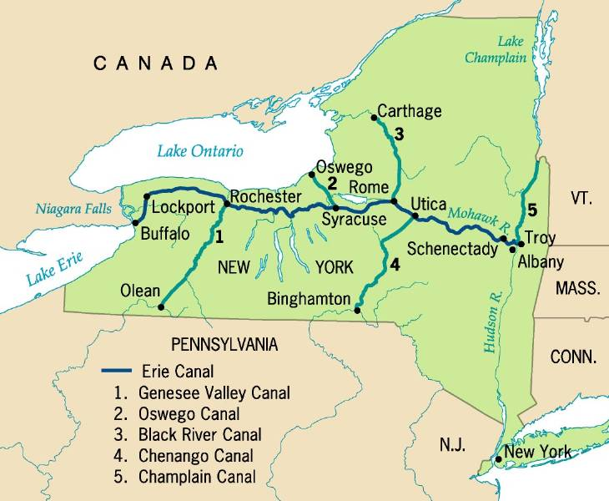

Station 3: Robert Fulton & the Steamboat
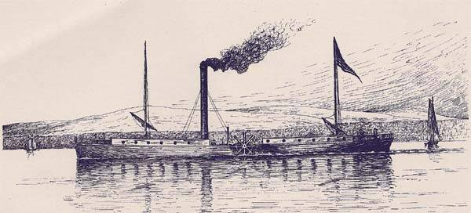
1807: The Clermont
Although Robert Fulton did not invent the steamboat, as is commonly believed, he was instrumental in making steamboat travel a reality. Fulton ventured into London society after he painted Benjamin Franklin's portrait. While abroad, Fulton left the arts for a career in canal and shipbuilding. He was interested in the recently-invented steam engine, and thought it could be used to power ships. Fulton's vision was not original; many others had entered the field, and the unfortunate inventor John Fitch had built a working steamship already. But like Henry Ford, Fulton's genius lay not in invention but in adaptation for the marketplace. To build an efficient, reliable steamboat, Fulton used a special English steam engine. The ship's bottom was flat and its stern was square. Clermont made its debut on August 17, 1807, steaming upriver from New York to Albany, and it soon entered into commercial service. The hilly terrain of New York made water travel faster than land travel, and Fulton's boat -- formerly known as "Fulton's Folly" -- was a hit. Within five years, Fulton would be running services on six major rivers plus the Chesapeake Bay, and raking in the profits.
Essential Question:
- In your opinion, who is often more likely to get rich from an invention: the inventor or the entrepreneur?
- What made the steamboat such an economically and socially transforming invention? HINT: Think about how water and rivers work.
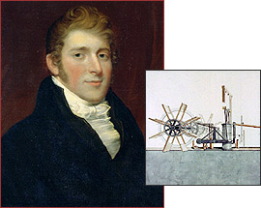

Inland Freight Rates:
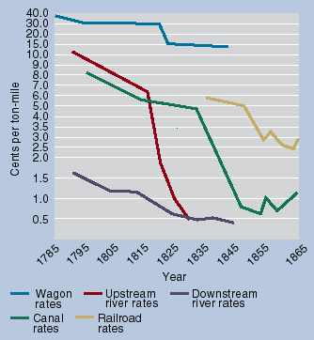

Station 4: America’s First Steam Locomotive, 1830
In the 1820s the port of Baltimore was in danger. The threat came from the newly opened Erie Canal (see "Traveling the Erie Canal, 1836") and the proposed construction of the Chesapeake and Ohio Canal that would parallel the Potomac River from Washington, DC to Cumberland, MD. These new water routes promised to provide a commercial gateway to the West that would bypass Baltimore's thriving harbor and potentially hurl the city into an economic abyss. Something had to be done.
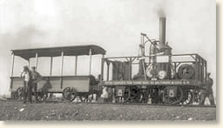
A Modern Reconstruction of
the Tom Thumb
The local entrepreneurs looked across the Atlantic to England and found an answer in the newly developed railroad. In 1828, the Maryland syndicate, led by Charles Carroll - a signer of the Declaration of Independence - broke ground for the Baltimore and Ohio Railroad. The railroad's objective was to connect Baltimore with the Ohio River and the West. Initially, the railroad's power was to be provided by horses. However, it soon became obvious that animal muscle was no match for the long distances and mountainous terrain that would have to be traveled. The solution lay with the steam engine.
By 1830, the B&O Railroad had extended its track from Baltimore to the village of Ellicott's Mills thirteen miles to the west. The railroad was also ready to test its first steam engine - an American-made locomotive engineered by Peter Cooper of New York.
It was a bright summer's day and full of promise. Syndicate members and friends piled into an open car pulled by a diminutive steam locomotive appropriately named the "Tom Thumb" with its inventor at the controls. Passengers thrilled at the heart-pumping sensation of traveling at the then un-heard speed of 18 mph. The outbound journey took less than an hour. On the return trip, an impromptu race with a horse-drawn car developed. The locomotive came out the loser. It was an inauspicious beginning. However, within a few years the railroad would become the dominate form of long-distance transportation and relegate the canals to the dustbin of commercial history.
Essential Question:
- Why was the invention of the railroad so much more revolutionary than some of the other forms of transportation?

The “Iron Horse” Wins! (1830)
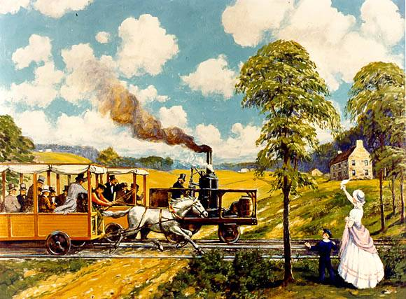

The Railroad Revolution, 1850s
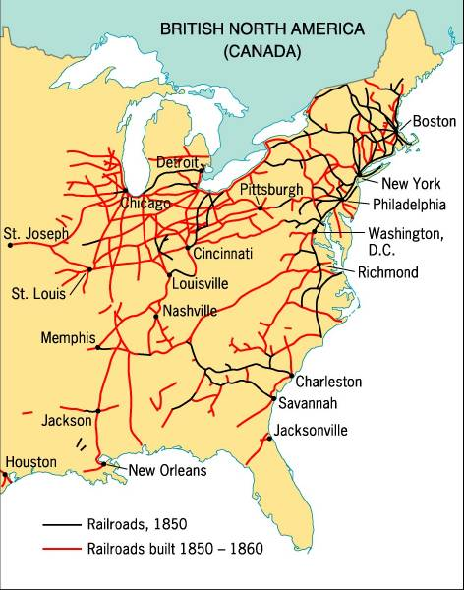

Tom Thumb (1830)
Tom Thumb was the first American-built steam locomotive used on a common-carrier railroad. Designed and built by Peter Cooper in 1830, it was designed to convince owners of the newly formed Baltimore and Ohio Railroad (B&O) to use steam engines. It is especially remembered as a participant in an impromptu race with a horse-drawn car, which the horse won after Tom Thumb suffered a mechanical failure. However, the demonstration was successful; and in the following year, the railroad committed to the use of steam locomotion and held trials for a working engine.

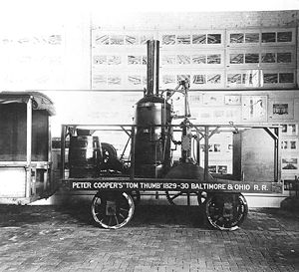

Station 5: John Deere and the Steel Plow (1837)
The Plow That Started it All
In 1837 our founder, John Deere, was a typical blacksmith turning out hayforks, horseshoes, and other essentials for life on the prairie.
Then one day, a broken steel sawmill blade gave him an opportunity. He knew that days in the field were difficult for farmers near his home in Grand Detour, Illinois, because they had to interrupt their work to clean the sticky prairie soil off of their cast-iron plows. He also knew that the soil would slide easily off of a highly polished steel moldboard. Steel was scarce in the area, so Deere fashioned a moldboard out of the second-hand blade.
Now, 175 years later, the company that grew out of the success of this innovative plow continues to manufacture advanced equipment to help those who work with the land accomplish their tasks better and faster.
While the original plow could only do a fraction of the work farmers can tackle with modern tillage equipment, it was high-tech at the time. The revolutionary plow is long gone, but we can draw some conclusions about Deere's plow-making prowess from an 1838 example of his work.
According to "John Deere's Company," a book by Wayne G. Broehl, Jr., the material Deere used wasn't the only unusual thing about the plows. The moldboard was also shaped differently than others of the day. "It is essentially a parallelogram, curved in a concave fashion. Deere must have given a great deal of thought to the shape, to the special curve of his moldboard, for its exact contours would determine just how well the soil would be turned over after the share had made the cut."
Production increased slowly at first, but Deere kept busy. Much of his work was done away from his forge. He constantly tested his products and changed his designs based on suggestions from customers. His research paid off and by 1849 his business was booming – he produced 2,000 plows that year.
Deere continued to expand his operation and he was soon producing several different plows – an 1857 advertisement mentions nine models. Most were similar in design, but different in size or material.
Essential Question:
- How is John Deere’s plow an example of man’s conquering of the West?

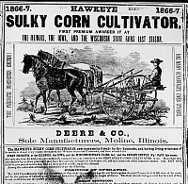
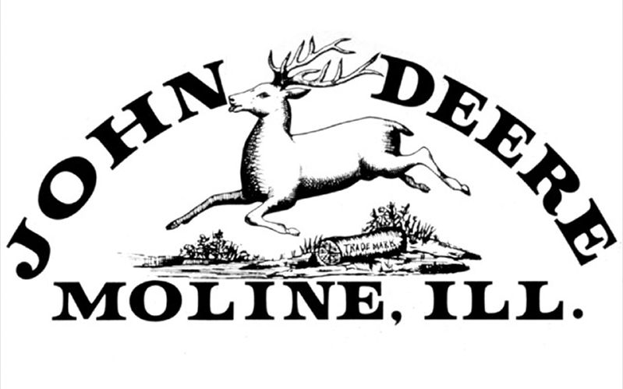

Video:
https://www.youtube.com/watch?v=Gfhrnx6FYv8

Station 6: Cyrus McCormick and the Mechanical Reaper: 1831
Cyrus McCormick of Virginia was responsible for liberating farm workers from hours of back-breaking labor by introducing the farmers to his newly invented mechanical reaper in July, 1831. By 1847, Cyrus McCormick began the mass manufacture of his reaper in a Chicago factory.
The reaper was eventually replaced by the self-propelled combine, operated by one man, which cuts gathers, threshes, and sacks the grain mechanically. The reaper was the first step in a transition from hand labor to the mechanized farming of today. It brought about an industrial revolution, as well as a vast change in agriculture.

Essential Question:
- Describe TWO economic benefits of the mechanical reaper and TWO social benefits of the mechanical reaper

Cyrus McCormick & the Mechanical Reaper: 1831
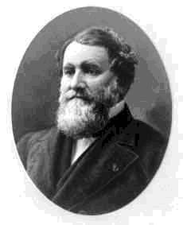
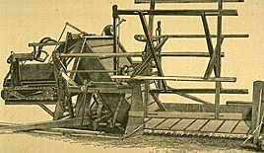

Station 7: Elias Howe and Isaac Singer

Walter Hunt & Elias Howe
In 1834, Walter Hunt built America's first (somewhat) successful sewing machine. He later lost interest in patenting because he believed his invention would cause unemployment. (Hunt's machine could only sew straight steams.) Hunt never patented and in 1846, the first American patent was issued to Elias Howe for "a process that used thread from two different sources."
Elias Howe's machine had a needle with an eye at the point. The needle was pushed through the cloth and created a loop on the other side; a shuttle on a track then slipped the second thread through the loop, creating what is called the lockstitch. However, Elias Howe later encountered problems defending his patent and marketing his invention.
For the next nine years Elias Howe struggled, first to enlist interest in his machine, then to protect his patent from imitators. His lockstitch mechanism was adopted by others who were developing innovations of their own. Isaac Singer invented the up-and-down motion mechanism, and Allen Wilson developed a rotary hook shuttle.

Isaac Singer Vs Elias Howe - Patent Wars
Sewing machines did not go into mass production until the 1850's, when Isaac Singer built the first commercially successful machine. Singer built the first sewing machine where the needle moved up and down rather than the side-to-side and the needle was powered by a foot treadle. Previous machines were all hand-cranked. However, Isaac Singer's machine used the same lockstitch that Howe had patented. Elias Howe sued Isaac Singer for patent infringement and won in 1854. Walter Hunt's sewing machine also used a lockstitch with two spools of thread and an eye-pointed needle; however, the courts upheld Howe's patent since Hunt had abandoned his patent.
If Hunt had patented his invention, Elias Howe would have lost his case and Isaac Singer would have won. Since he lost, Isaac Singer had to pay Elias Howe patent royalties. As a side note: In 1844, Englishmen John Fisher received a patent for a lace making machine that was identical enough to the machines made by Howe and Singer that if Fisher's patent had not been lost in the patent office, John Fisher would also have been part of the patent battle.
After successfully defending his right to a share in the profits of his invention, Elias Howe saw his annual income jump from three hundred to more than two hundred thousand dollars a year. Between 1854 and 1867, Howe earned close to two million dollars from his invention. During the Civil War, he donated a portion of his wealth to equip an infantry regiment for the Union Army and served in the regiment as a private.
Essential Question:
- Why was the mechanical lock-stick design such a “revolutionary” invention? Think about the economic and social ramifications of the Singer sewing machine.

1940s Sewing Machine
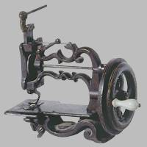

Station 8: Eli Whitney’s Cotton Gin, 1791

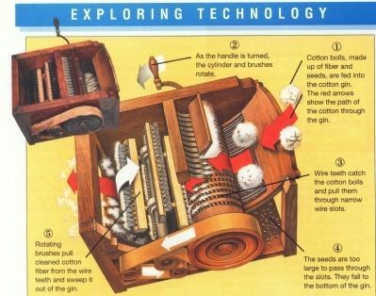

Whitney Moves On
In 1794, U.S.-born inventor Eli Whitney (1765-1825) patented the cotton gin, a machine that revolutionized the production of cotton by greatly speeding up the process of removing seeds from cotton fiber. By the mid-19th century, cotton had become America’s leading export. Despite its success, the gin made little money for Whitney due to patent-infringement issues. Also, his invention offered Southern planters a justification to maintain and expand slavery even as a growing number of Americans supported its abolition. Based in part on his reputation for creating the cotton gin, Whitney later secured a major contract to build muskets for the U.S. government. Through this project, he promoted the idea of interchangeable parts–standardized, identical parts that made for faster assembly and easier repair of various devices. For his work, he is credited as a pioneer of American manufacturing.
Patent-law issues prevented Whitney from ever significantly profiting from the cotton gin; however, in 1798, he secured a contract from the U.S. government to produce 10,000 muskets in two years, an amount that had never been manufactured in such a short period. Whitney promoted the idea of interchangeable parts–standardized, identical parts that would make for faster assembly as well as easier repair of various objects and machines. At the time, guns were typically built individually by skilled craftsmen, so that each finished device was unique. Although it ultimately took Whitney some 10 years, instead of two, to fulfill his contract, he was credited with playing a pioneering role in the development of the American system of mass-production.

Did you know?

Some historians believe Catherine Greene devised the cotton gin and Eli Whitney merely built it and applied for the patent, since at that time women were not allowed to file for patents. Others believe the idea was Whitney's but Greene played an important role as both designer and financier.

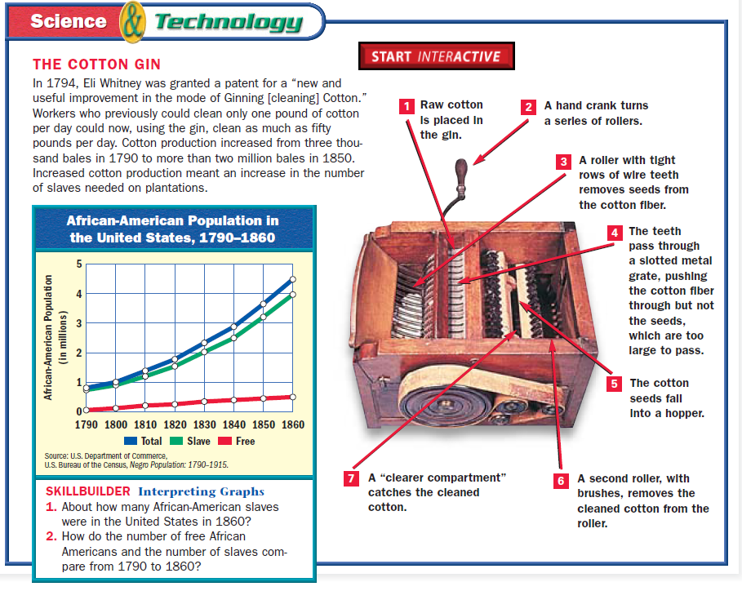

Essential Questions:

- Originally, the cotton gin intended to eliminate the need for slaver labor, yet created monumental and unintended consequences. List TWO social and TWO economic consequences of the cotton gin.
- What was the geographical impact of “King Cotton” on the market revolution?

Station 9: Cyrus Field & the Transatlantic Cable, 1858
The telegraph was first developed by Samuel F. B. Morse, an artist-turned-inventor who conceived of the idea of the electric telegraph in 1832. Several European inventors had proposed such a device, but Morse worked independently and by the mid-1830s had built a working telegraph instrument. In the late 1830s, he perfected Morse Code, a set of signals that could represent language in telegraph messages. In May 1844, Morse inaugurated the world's first commercial telegraph line with the message "What hath God wrought," sent from the U.S. Capitol to a railroad station in Baltimore. Within a decade, more than 20,000 miles of telegraph cable crisscrossed the country. The rapid communication it made possible greatly aided American expansion, making railroad travel safer as it provided a boost to business conducted across the great distances of a growing United States.
In 1854, Cyrus West Field conceived the idea of the telegraph cable and secured a charter to lay a well-insulated line across the floor of the Atlantic Ocean. Obtaining the aid of British and American naval ships, he made four unsuccessful attempts, beginning in 1857. In July 1858, four British and American vessels--the Agamemnon, the Valorous, the Niagara, and the Gorgon--met in mid-ocean for the fifth attempt. On July 29, the Niagara and the Gorgon, with their load of cable, departed for Trinity Bay, Newfoundland, while the Agamemnon and the Valorous embarked for Valentia, Ireland. By August 5, the cable had been successfully laid, stretching nearly 2,000 miles across the Atlantic at a depth often of more than two miles. On August 16, President James Buchanan and Queen Victoria exchanged formal introductory and complimentary messages. Unfortunately, the cable proved weak and the current insufficient and by the beginning of September had ceased functioning.
Field later raised new funds and made new arrangements. In 1866, the British ship Great Eastern succeeded in laying the first permanent telegraph line across the Atlantic Ocean. Cyrus West Field was the object of much praise on both sides of the Atlantic for his persistence in accomplishing what many thought to be an impossible undertaking. He later promoted other oceanic cables, including telegraph lines that stretched from Hawaii to Asia and Australia.

Essential Question:
- Hypothetical thinking: How might the Transatlantic Cable and Morse code have altered the War of 1812 if it would have been invented around the turn of the 19th century?

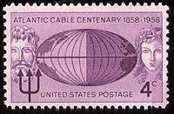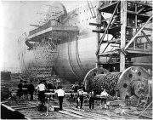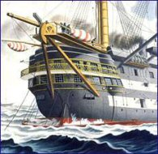
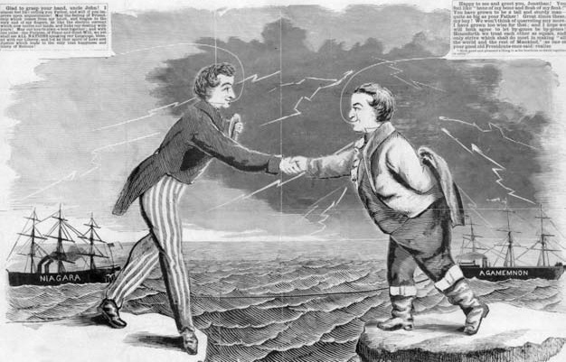
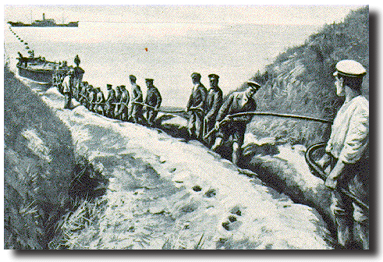

Station 10: Samuel Slater (“The Father of the Factory System”)
Son of a yeoman farmer, Samuel Slater became involved in the textile industry at the age of 14 when he was apprenticed to Jedediah Strutt, a partner of Richard Arkwright and the owner of one of the first cotton mills.
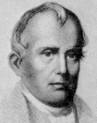
Samuel Slater
Believing that textile industry in England had reached its peak, Slater emigrated secretly to America in 1789 in hopes of making his fortune in America's infant textile industry. While others with textile manufacturing experience had emigrated before him, Slater was the first who knew how to build as well as operate textile machines. Slater, with funding from Providence investors and assistance from skilled local artisans, built the first successful water powered textile mill in Pawtucket in 1793.
By the time other firms entered the industry, Slater's organizational methods had become the model for his successors in the Blackstone River Valley. Later known as the Rhode Island System, it began when Slater enlisted entire families, including children, to work in his mills. These families often lived in company owned housing located near the mills, shopped at the company stores and attended company schools and churches. While not big enough to support the large mills which became common in Massachusetts, the Blackstone River's steep drop and numerous falls provided ideal conditions for the development of small, rural textile mills around which mill villages developed.
One of the earliest of these mill villages was Slatersville. Located on the Branch River in present day North Smithfield, Rhode Island, Slatersville was built by Samuel Slater and his brother John in 1803. By 1807, the village included the Slatersville Mill, the largest and most modern industrial building of its day, two tenement houses for workers, the owner's house and the company store. In the early twentieth century, industrialist and preservationist Henry P. Kendall took a personal interest in the village and initiated many of the improvement projects which give the village its traditional New England Charm.
Essential Questions:
- Why would England keep such tight security on machine patents and knowledge of textile mills?
- On a scale of 1 to 10 (10 being the most), what score would you give the factory system in regards to economic impact? Why?

Station 11: Lowell Mills, Massachusetts
The "Mill Girls" (or "Factory Girls," as they called themselves) were female workers who came to work for the textile corporations in Lowell, Massachusetts, during the early industrial era in the United States. The women initially recruited by the corporations were daughters of propertied New England farmers, between the ages of 15 and 30. (There also could be "little girls" who worked there about the age of 13.) By 1840, at the height of the Market Revolution, the textile mills had recruited over 8,000 women, who came to make up nearly seventy-five percent of the mill workforce.
Essential Questions
- List TWO possible social consequences of young women working in the textile mills?
- What might be attractive to young girls about working in the textile mills?
- What might be negative about working in the textile mills?

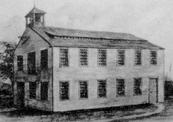
New England Dominance in Textiles
