Dear Parents and Guardians,
Ms. Hite has made the following changes to the Social Studies syllabus. Please review these new policies below and sign the bottom to be returned by Monday, January 28th. Please email or call if you have any questions: alhite@aps.k12.co.us and 303-326-2427. Please keep the top portion for your records.

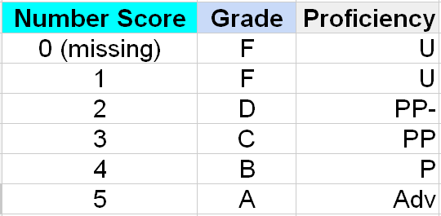
The chart demonstrates the approximate translation of the numbers that you will see in the new grading system and Mastery Tracker. This and more information can be found on the “settings” page of the Mastery Tracker. The pages can be changed at the bottom of the document.

Mastery Tracker and Accessing Grades
The Social Studies Department is running a pilot evaluation on a new form of progress monitoring for parents and students. Rather than Infinite Campus which has many limitations on what we can communicate, we will be using a mastery tracker that will be constantly updated and available for students and parents to view. All you will need is your students ID number and access to the school website via the internet or a Smartphone. Once there, access your Social Studies teachers page and click on your class period. You will then see your progress by student ID number. Standards and work habits will be listed and we will be working on defining the standards so they are 100% clear to students and parents/guardians. We would really appreciate your feedback on this new system as we launch the pilot and appreciate your support. You may also access the Mastery Track by going to the class website www.hitesocialstudies.weebly.com and clicking on the “Mastery Tracker-Grades” link.
Summative
Summative assessments (assessment of learning) provide information to be used in making judgments about a student’s achievement at the end of a sequence of instruction, e.g. final drafts, tests, assignments, projects, performances, etc. These assessments are located under the Summative section and are worth 40% of the student’s grade.
Formative
Formative assessments (assessments for learning) provide direction for improvement for the student and adjustment of instruction for the teacher e.g. observation, quizzes, homework, discussion, drafts, etc. These assignments are located under the state standard that they address and are worth 40% of the student’s grade.
Work Habits
Classroom participation and consistent attendance are crucial for students to be successful in learning the material and scoring well on assessments. It is the student’s responsibility to be accountable for their learning in class. Therefore, if a student misses class it is also their responsibility to ensure that they make up missed work or learning. Work habits count for 20% of the students’ grades.
Late Work Policies
Late work will no longer be accepted for full credit. Students can turn in their work for partial credit within one week. After one week has passed, they can no longer make up the assignment.
Responsible Technology Use
Students are NOT allowed to have technology in the classroom unless they are given explicit permission to do so. The first offense requires that their technology is confiscated and returned at the end of the day. The second offense requires that their technology is confiscated and turned in to the dean for parents or guardians to pick up. Anymore offenses beyond that may result in a referral.
------------------------------------------------------------------------------------------------------------------------------------------------
Detach and turn in lower portion. Keep the syllabus.

I have carefully read the expectations of this course and agree to support the goals and initiatives of the course. I will show up, speak up, stand up and go further than I ever thought possible.
Student name: _____________________________________________(print) Grade _______ period _________

Parent/Guardian Signature: __________________________________________

