#1

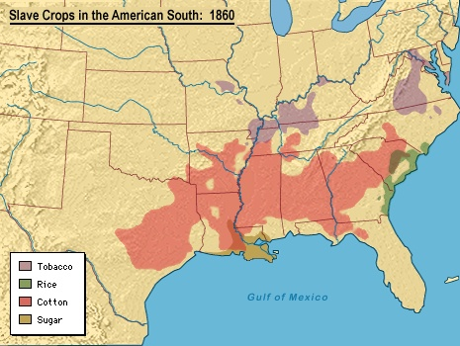

#2

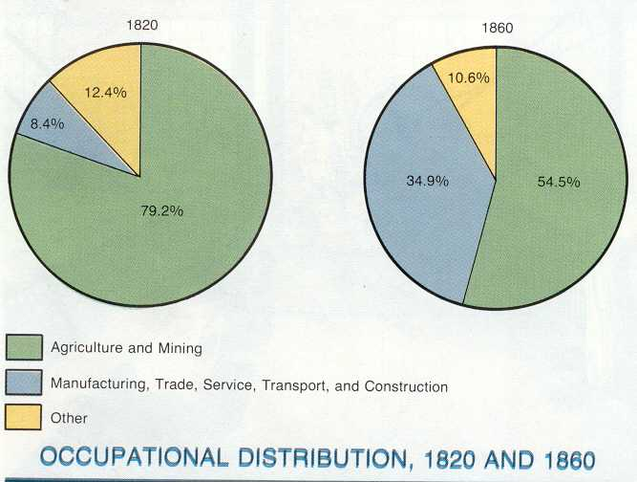

#3

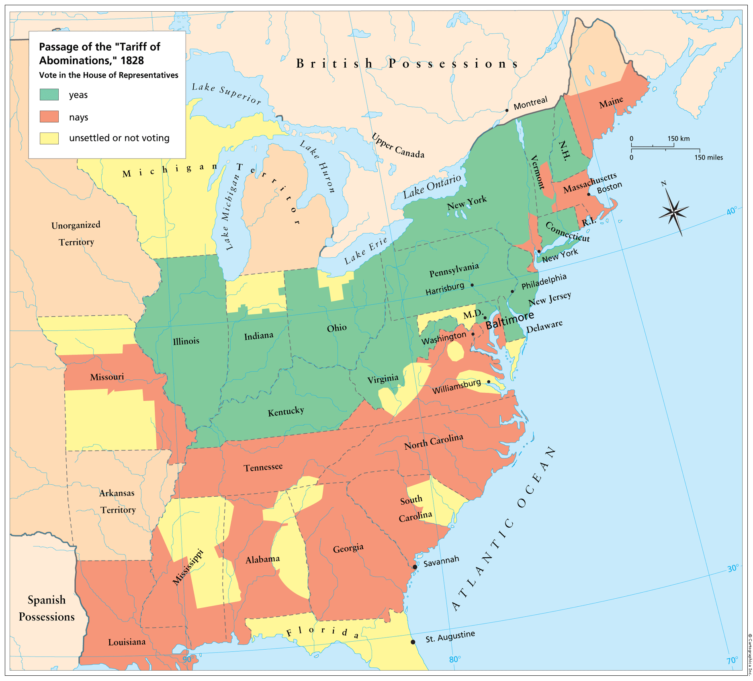

#4
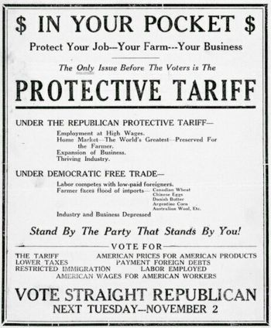

#5

South Carolina Ordinance of Nullification (November 24, 1832)
Whereas the Congress of the United States , by various acts, purporting to be acts laying duties and imposts on foreign imports, but in reality intended for the protection of domestic manufactures, and the giving of bounties to classes and individuals engaged in particular employments, at the expense and to the injury and oppression of other classes and individuals... hath exceeded its just powers under the Constitution....
We, therefore the people of the state of South Carolina in Convention assembled, do declare and ordain .... [That the tariff acts of 1828 and 1832] purporting to be laws for the imposing of duties and imposts on the importation of foreign commodities.... are unauthorized by the Constitution of the United States, and violate the true meaning and intent thereof, and are null, void, and no law, nor binding upon this State, its officers or citizens....
And it is further Ordained, That it shall not be lawful for any of the constituted authorities, whether of this State or of the United States, to enforce payment of the duties imposed by said acts.... [and] it shall be the duty of the [South Carolina] Legislature to adopt such measures and pass such acts as may be necessary to give full effect to this Ordinance....
And we, the people of South Carolina, to the end that it may be fully understood by the Government of the United States, and the people of the co-States, that we are determined to maintain this, our Ordinance and Declaration, at every hazard, Do further Declare that we will not submit to the application of force, on the part of the Federal Government, to reduce this State to obedience; but that we will consider the passage by Congress, of any act... to coerce the State, shut up her ports, destroy or harass her commerce, or to enforce the acts hereby declared null and void, otherwise than through the civil tribunals of the country, as inconsistent with the longer continuance of South Carolina in the Union: and that the people of this state will thenceforth hold themselves absolved from all further obligation to maintain or preserve their political connection with the people of the other States, and will forthwith proceed to organize a separate Government, and do all other acts and things which sovereign and independent States may of right do....

#6

Excerpt from Andrew Jackson’s Nullification Proclamation (1832)

For what do you throw away these inestimable blessings-for what would you exchange your share in the advantages and honor of the Union? For the dream of a separate independence-a dream interrupted by bloody conflicts with your neighbors, and a vile dependence on a foreign power. If your leaders could succeed in establishing a separation, what would be your situation? Are you united at home-are you free from the apprehension of civil discord, with all its fearful consequences? Do our neighboring republics, every day suffering some new revolution or contending with some new insurrection- do they excite your envy? But the dictates of a high duty oblige me solemnly to announce that you cannot succeed.

The laws of the United States must be executed. I have no discretionary power on the subject, my duty is emphatically pronounced in the Constitution. Those who told you that you might peaceably prevent their execution, deceived you-they could not have been deceived themselves. They know that a forcible opposition could alone prevent the execution of the laws, and they know that such opposition must be repelled. Their object is disunion, but be not deceived by names; disunion, by armed force, is TREASON. Are you really ready to incur its guilt? If you are, on the head of the instigators of the act be the dreadful consequences-on their heads be the dishonor, but on yours may fall the punishment-on your unhappy State will inevitably fall all the evils of the conflict you force upon the government of your country….the consequence must be fearful for you, distressing to your fellow-citizens here, and to the friends of good government throughout the world.

Its enemies have beheld our prosperity with a vexation they could not conceal--it was a standing refutation of their slavish doctrines, and they will point to our discord with the triumph of malignant joy. It is yet in your power to disappoint them. There is yet time to show that the descendants of the Pinckneys, the Sumpters, the Rutledges, and of the thousand other names which adorn the pages of your Revolutionary history, will not abandon that Union to support which so many of them fought and bled and died. I adjure you, as you honor their memory--as you love the cause of freedom, to which they dedicated their lives--as you prize the peace of your country, the lives of its best citizens, and your own fair fame, to retrace your steps. Snatch from the archives of your State the disorganizing edict of its convention-bid its members to re-assemble and promulgate the decided expressions of your will to remain in the path which alone can conduct you to safety, prosperity, and honor….

