The Spanish-American War

Section 1 - Introduction
In the late 1800s, one of the best-known New Yorkers was not a person at all. He was the Yellow Kid, a character in a wildly popular newspaper comic. For a time, the Yellow Kid appeared in two newspapers at once, the New York World and the New York Journal, which competed to own the comic.
The struggle over the Yellow Kid was part of a larger "newspaper war" in New York City during the 1890s. Joseph Pulitzer, the publisher of the World, faced off against William Randolph Hearst, the publisher of the Journal, in a battle to dominate the city's newspaper market. Their struggle over newspaper sales helped to provoke a real war, the Spanish-American War.
The artist who created the Yellow Kid, R. F. Outcalt, first sold his comic in 1895 to Pulitzer's World. The comic was set in New York's poor, rough-and-tumble ethnic neighborhoods and featured a bald-headed street urchin dressed in a bright yellow nightshirt. The Yellow Kid was an instant success. Newspaper comics were new at the time, and Pulitzer's World enjoyed a huge jump in sales.
Not to be outdone, Hearst lured Outcalt to the Journal by promising him more money. In response, Pulitzer hired another cartoonist to draw his own version of the cartoon. Before long, the two newspapers were flooded with images of the Yellow Kid and became known as the "Yellow Kid Papers" or "Yellow Papers."
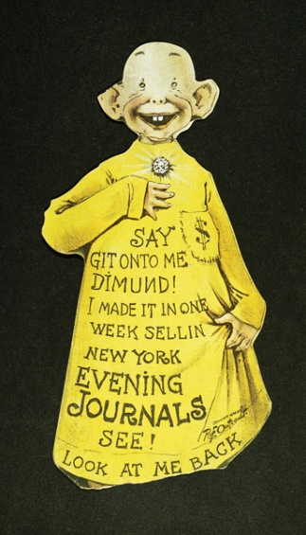
The rivalry between the World and the Journal extended beyond the Yellow Kid cartoons. In their struggle to attract readers, the two "Yellow Papers" developed an exaggerated style of reporting. Their sensational news stories soon became known as yellow journalism. Among these stories were news reports about other countries. One favorite subject was the brutal suppression of a rebellion in Cuba against Spanish rule. Yellow journalism helped inflame public support for going to war against Spain. In this chapter, you will learn why the United States went to war against Spain and why this conflict was a significant event in American foreign relations.

Section 2 - Trouble Brewing in Cuba
The island of Cuba lies just 90 miles off the coast of Florida, in the Caribbean Sea. It was founded as a Spanish colony by Christopher Columbus in 1492 and later became one of the world's leading sugar producers. Hundreds of thousands of slaves worked on its plantations. For over three centuries, Cuba was part of Spain's vast empire. But by the late 1800s, there were just two Spanish colonies in the Americas: the islands of Puerto Rico and Cuba. A growing independence movement was threatening Spanish rule in Cuba.
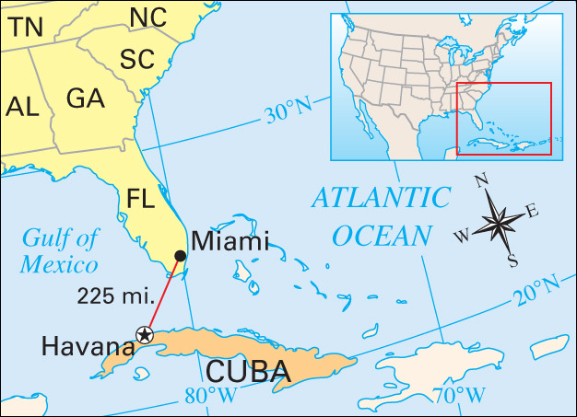
Cubans Struggle for Independence During the 1800s, many Cubans had voiced a desire for self-rule. In 1868, a revolutionary group largely made up of poor whites, free blacks, and slaves demanded independence from Spain, the establishment of a republic, and the end of slavery. When Spain rejected these demands, bitter fighting followed. Spain eventually crushed the revolt but then tried to ease tensions by agreeing to limited reforms. It gave Cubans some representation in the government, and it abolished slavery in 1886.
Meanwhile, Cuba was coming under the economic influence of the United States. American business interests saw it as a good place to trade and invest. By the mid-1890s, American investment in Cuba's sugar plantations had reached many millions of dollars. American investors were therefore nervous about the island's political instability.
Despite some reforms, the political situation did not improve significantly. In 1895, Cubans again rebelled. This second struggle for independence was led by José Martí, a Cuban poet, journalist, and statesman. Forced to leave Cuba because of his revolutionary activities, Martí lived in the United States from 1881 to 1895. Even while he was living abroad, Martí inspired his fellow Cubans with calls for liberty. He wrote, "Like bones to the human body . . . so is liberty the essence of life. Whatever is done without it is imperfect." Martí sailed to Cuba in 1895 to lead the revolt but was soon killed in combat. Nevertheless, the rebellion continued.
The Cuban rebels engaged in guerrilla warfare, launching surprise attacks against Spanish forces and fading back into the countryside. In 1896, Spain sent a new commander, General Valeriano Weyler, to put down the uprising. To eliminate support for the rebels, Weyler forced tens of thousands of Cubans into reconcentration camps. These overcrowded, unsanitary prison camps provided little food or shelter, causing thousands of deaths from disease and starvation.
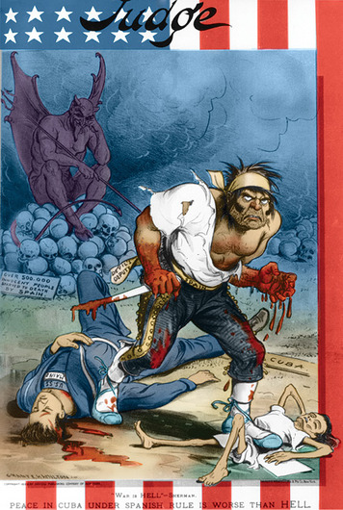
Political cartoons helped shape public opinion about events in Cuba. This cartoon from 1898 depicts the island suffering from Spanish misrule. The fearsome figure in the center is labeled "Spain," and he is shown stepping over a dead American sailor and a starving Cuban.
Many Americans sympathized with the rebellion, seeing it as a struggle for freedom, like the American Revolution. Meanwhile, American investors feared that the political unrest was putting their Cuban investments and property at risk. Despite public calls for the United States to intervene in Cuba, President Grover Cleveland followed a policy of strict neutrality. When William McKinley was elected president in 1896, he hoped to maintain neutrality. But that would become more difficult as the public increasingly called for the United States to help the rebels.
American Newspapers React Most Americans learned about the events in Cuba through newspapers and magazines. At that time, these were the only forms of mass media—methods of communicating to a mass audience.
Newspapers were very popular in the late 1800s. With the yellow journalism of the time, however, many papers were not as careful in their reporting as they are today. To sell newspapers, publishers like Joseph Pulitzer and William Randolph Hearst sensationalized the news. Both the New York World and the New York Journal saw reporting on the Cuban rebellion as a good way to gain new readers. Reporters and artists were encouraged to stretch the truth about the bravery of Cuban rebels and the horrors of Spanish rule, especially "Butcher" Weyler's brutality. Many readers were shocked by these reports. Some demanded that the United States help Cuba win independence. In this way, yellow journalism helped stir public support for U.S. intervention to aid the rebels.

Section 3 - Americans Call for War with Spain
In 1897, the Spanish government promised greater self-rule in Cuba. It also removed General Weyler from his post and ordered him to return to Spain. As a result, the Cuban crisis cooled down. In February 1898, however, two events aroused American anger and led to increasing calls for war.
The de Lôme Letter Incites the Public On February 9, 1898, Hearst's New York Journal published a letter written by Enrique Dupuy de Lôme, the Spanish ambassador to Washington. The de Lôme letter was addressed to a friend in Cuba but was somehow stolen from the mail and sent to the Journal for publication.
In the letter, de Lôme called President McKinley "weak and catering to the rabble and, besides, a low politician." Americans were offended by this criticism of their president. De Lôme offered his resignation, but the damage was done. The publishing of this letter intensified anti-Spanish feelings in the United States and underscored the power of the press to inflame public opinion.
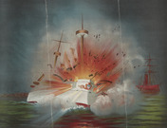
Inflammatory articles and illustrations about the sinking of the USS Maine helped rouse public support for war with Spain. The New York Journal offered a reward for evidence in the sinking. To this day, however, historians are not sure what caused the blast.
Newspapers Decry the Maine Incident Not long after the de Lôme affair, a much more alarming incident occurred: the sinking of the battleship USS Maine in Havana harbor. Newspapers around the country responded with calls for vengeance.
The Maine had sailed to Cuba in January after riots broke out in the streets of Havana. Spaniards who opposed government reforms in Cuba led the riots. Fearing harm to American citizens and property, President McKinley had sent the Maine to Cuba to protect American interests.
For two weeks, the Maine sat in Havana harbor. Then, on the night of February 15, a tremendous explosion rocked the battleship. The captain reported hearing "a bursting, rending, and crashing roar of immense volume." Then the ship began to sink. More than 260 sailors died from the blast.
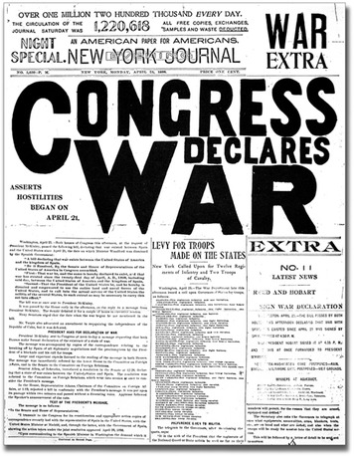
On April 25, 1898, Congress declared war on Spain after the Spanish government rejected American demands for Cuban independence. Newspapers trumpeted the news and called for a quick victory over Spanish forces.
An official navy investigation began immediately, but the Journal and other newspapers immediately blamed Spain. The Hearst paper published bellicose articles under such headlines as "The Maine Was Destroyed by Treachery" and "The Whole Country Thrills with War Fever!" Across the country, "Remember the Maine" became a rallying cry for war.
The United States Responds In March, the navy issued its report on the sinking of the Maine. Though the evidence was sketchy, navy investigators concluded that the explosion was caused by an underwater mine. Their report did not suggest who was responsible. In 1976, navy researchers who studied the incident again concluded that heat from a fire in a coal bin exploded a nearby supply of ammunition.
Four days before the report was completed, Senator Redfield Proctor of Vermont gave a compelling speech on the Senate floor. Proctor had just returned from Cuba and described the appalling conditions there. Although General Weyler was no longer in charge, the reconcentration camps were still in operation, and the Cuban people were still suffering. Proctor concluded,
To me the strongest appeal is not the barbarity practiced by Weyler nor the loss of the Maine . . . but the spectacle of a million and a half of people, the entire native population of Cuba, struggling for freedom and deliverance from the worst misgovernment of which I ever had knowledge.
—Redfield Proctor, speech before the Senate, March 17, 1898
The Maine report and Proctor's speech helped turn opinion in Congress and the public toward war. But President McKinley, still hoping to avoid conflict, gave Spain one last chance. He called for an armistice, a cessation of hostilities, until a permanent peace could be discussed. He also called on Spain to close the reconcentration camps and to take steps to grant Cuba its independence. Spain agreed to an armistice and to closing the camps, but was unwilling to give up control of Cuba.
Under great public pressure, McKinley asked Congress to declare war on Spain. Congress passed a resolution, a formal statement about a course of action, recognizing Cuban independence and authorizing military force, if necessary, to liberate Cuba. Congress also passed the Teller Amendment, which said that after Cuba was liberated and peace was restored, the United States would "leave the government and control of the Island to its people." Spain then passed a declaration of war against the United States. On April 25, Congress formally declared war on Spain.

Section 4 - A "Splendid Little War" with Spain
The Spanish-American War lasted only a few months, but it had dramatic results. The United States won the conflict convincingly, demonstrating military power in overseas combat, with few American battle casualties. John Hay, who served as U.S. ambassador to Britain and later as secretary of state, described it as "a splendid little war, begun with the highest motives, carried on with magnificent intelligence and spirit, favored by that Fortune which loves the brave."
Fighting Begins in the Philippines Even though the war was sparked by problems in Cuba, the first battle took place much farther away, in the Philippines. A large group of islands southeast of China, the Philippines were Spain's largest remaining colony. As in Cuba, a revolt against Spain had been brewing. Emilio Aguinaldo, a young Filipino, led this resistance. When the Spanish-American War began, he was living in exile in Hong Kong.
At least two months before war was declared, the United States began preparing for battle in the Philippines. If war broke out, it wanted to strike a quick blow against the Spanish fleet in Manila Bay. Theodore Roosevelt, the assistant secretary of the navy at the time, instructed the commander of the Pacific squadron, Commodore George Dewey, to sail to Hong Kong and await further orders.
On May 1, just days after the declaration of war, Dewey's squadron steamed into Manila Bay and opened fire on the Spanish fleet. Taken by surprise, the fleet was entirely destroyed. Dewey did not lose a single ship and suffered only a few battle casualties.
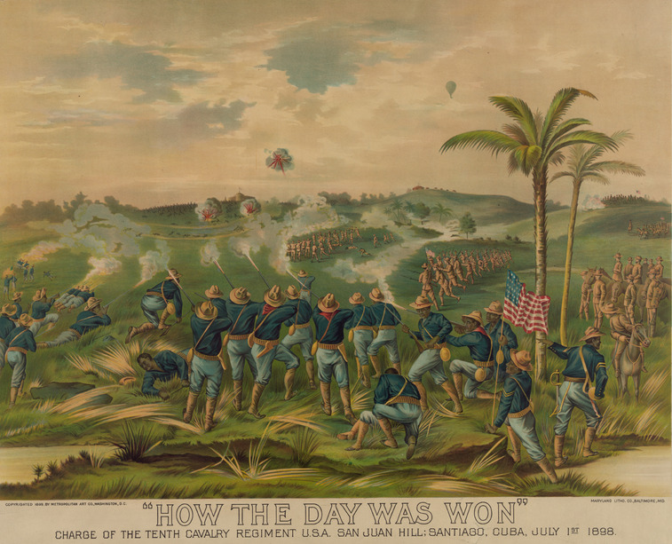
Black and white troops fought together in the assault on San Juan Hill. The 10th Cavalry Regiment, shown here, was an all African American unit. By taking the hill, American forces broke Spain’s main line of defense for the city of Santiago. First Lieuten ant John J. Pershing wrote of that battle: “White regiments, black regiments . . . fought shoulder to shoulder, unmindful of race or color . . . and mindful of only their common duty as Americans."
Dewey had scored a stunning victory but did not have sufficient troops to land in Manila and take the city. In the meantime, Aguinaldo returned to the Philippines with his rebel forces to fight the Spanish on his own. American reinforcements finally arrived near the end of July. On August 13, the Philippines fell to a combined force of American soldiers and Filipino rebels.
Fighting Moves to Cuba Meanwhile, fighting had begun in Cuba. The U.S. Navy quickly set up a blockade of Havana and the north coast of Cuba. At the eastern end of the island, however, a Spanish squadron slipped into the harbor at Santiago de Cuba. President McKinley ordered troops to sail for Santiago. The plan was to join the navy there and engage the Spanish. The American troops, led by General William Shafter, arrived outside Santiago on June 20.
The U.S. Army in Cuba consisted of various forces. Among them were four regiments of African American soldiers, many of whom had fought in the Indian Wars in the American West. The army also relied on volunteer regiments, including one led by Theodore Roosevelt. When the war began, Roosevelt quit his post as assistant secretary of the navy so that he could join the fighting. Together with Colonel Leonard Wood, he helped form the First U.S. Volunteer Cavalry, better known as the Rough Riders. Handpicked by Roosevelt, this regiment was a mix of college athletes and western cowboys.
On July 1, General Shafter launched his assault on Santiago, moving against Spanish troops dug in along a ridge. Roosevelt and the Rough Riders charged up Kettle Hill, while other U.S. forces fought the even tougher battle for San Juan Hill. By nightfall, the U.S. Army had taken the ridge.
The rest of the war went quickly. The American navy destroyed the Spanish squadron as it tried to leave Santiago harbor, and on July 17, Santiago surrendered. The following week, the United States captured Puerto Rico. With no prospect of success, Spain agreed to a peace settlement on August 12. Four months after the start of the conflict, the war was over.
Despite their quick victory, not everything went well for the U.S. forces. About 5,500 Americans died in the war, mostly from tropical diseases like malaria and yellow fever. As regiments were formed on short notice, many soldiers lacked proper equipment and supplies. Most had heavy wool uniforms, a severe liability in Cuba's tropical heat, and food was often of poor quality. Despite these difficulties, the United States had won a major victory in its first overseas war.

Section 5 - A New Power on the World Stage
With its victory in the Spanish-American War, the United States emerged as a new world power. It had defeated a European nation and won control of overseas territories. In the peace treaty, the United States solidified its new position in world affairs.
The Treaty of Paris The war ended on August 12, 1898, with the signing of a peace protocol, a first draft of a treaty to be submitted for ratification. In October, Spanish and American officials met in Paris to finalize the terms.
On December 10, the United States and Spain signed the Treaty of Paris. Spain agreed to three main points. First, it granted independence to Cuba. Second, it ceded Puerto Rico and the Pacific island of Guam to the United States. And third, it ceded the Philippines to the United States in exchange for a payment of $20 million. Under the treaty, Puerto Rico, Guam, and the Philippines became American possessions. The United States was now a colonial empire.
The Senate Debate over the Treaty For the treaty to take effect, the Senate would have to ratify it by a two-thirds vote. This vote prompted a fierce debate over imperialism. While some Americans supported creating an American empire, others were strongly opposed. The debate over the treaty raged not only in the Senate but also across the entire country.
Leading opponents were the members of the Anti-Imperialist League, an organization formed during the war to oppose the establishment of U.S. colonies. Its membership was diverse, ranging from union leader Samuel Gompers to millionaire industrialist Andrew Carnegie. Social worker Jane Addams joined, as did author Mark Twain. Although the motives and political views of league members varied widely, they all believed that imperialism violated the country's founding principles of freedom and democracy. As the league's platform stated, "We hold that the policy known as imperialism is hostile to liberty . . . We insist that the subjugation of any people is 'criminal aggression' and open disloyalty to the distinctive principles of our Government."
Supporters of the treaty included many prominent political leaders, such as President William McKinley, Theodore Roosevelt, and Senator Henry Cabot Lodge. During the Senate debate, Lodge argued that forming an empire was critical to the nation's future. He declared that the United States needed to compete equally with other great nations. In a letter to Theodore Roosevelt, Lodge wrote that rejection of the treaty would be a "humiliation of the whole country in the eyes of the world" and would "show we are unfit to enter into great questions of foreign policy."
The Senate debate raged for a month. In the end, the supporters of empire won out. By a vote of 57 to 27, a two-thirds majority by the narrow margin of two votes, the Senate ratified the Treaty of Paris on February 6, 1899. The United States now had its empire. But the debate over imperialism would continue into the 20th century.
The United States Stays in Cuba Cuba also remained an issue in American foreign policy. Although the Treaty of Paris granted Cuba independence, the island was in ruins. President McKinley decided that the United States should remain in Cuba to restore order and assist in the island's recovery.
For four years, the United States ruled Cuba under a military government. This government improved sanitation and built schools and roads. But many Cubans resented American control. They believed that the occupation violated the spirit of the Treaty of Paris and the Teller Amendment, which had pledged that the United States would leave the island after the war was over.
The United States finally withdrew its troops in 1902, but only after Cuba added provisions to its constitution to protect American interests. These provisions, called the Platt Amendment, allowed the United States to intervene in Cuban affairs and to buy or lease land for naval bases. In the years to come, U.S. troops reoccupied Cuba on several occasions. The United States finally agreed in 1934 to repeal the Platt Amendment. However, a U.S. naval base at Guantánamo Bay, on Cuba's southeastern coast, still operates under a permanent lease.
American companies also gained significant control over the Cuban economy. By 1913, American investment on the island had quadrupled from prewar levels to $220 million. U.S. business interests owned 60 percent of Cuba's rural lands and controlled many of the island's industries.

Yellow Journalism Activity:

For each section (2-5) you will create a newspaper cover story that represents yellow journalism. Make sure that you overexaggerate in order to get your audience riled up.

Include the following in each of your cover stories:
-Headlines (catchy title)
-One paragraph
-Underline the topics that you must include

Section 2:
- Cuba's history
- American investments in sugar plantations
- Cubans' struggle for independence
- Jose Marti
- General Valeriano Weyler
- American Revolution

Section 3:
- The de Lome letter
- The sinking of the USS Maine
- Senator Redfield Proctor
- Armistice
- Declaration of War
- Teller Amendment

Section 4:
- Dewey's success in the Philippines
- Surrender of Santiago, Cuba
- Capture of Puerto Rico
- Winning the war

Section 5:
- The Treaty of Paris
- Anti-Imperialist League
- Supporters of the Treaty
- The Platt Amendment
- US involvement in Cuban economy

