Station 1

The 14th and 15th Amendments
1870s-1890s

- On page 280, refresh your memory about the 14th amendment by reading the section on that amendment. On page 282, do the same thing for the 15th amendment.

- Now, read the heading “Women’s Rights” on pages 282-283.

- Write a letter from the perspective of Elizabeth Cady Canton. Address the letter to another women’s rights activist. In your letter, explain how you feel about the following issues:
- The passage of the 14th and 15th amendment.
- Explain your stance on marriage laws, inheritance laws, and voting.

Example:

Dear Henrietta Jones,

Hello Henrietta. I hope that you are doing well. As you know, I have been fighting for women’s rights for years. The news of the passage of the 14th and 15th amendment has been…
...................................................................
...................................................................
...................................................................
...................................................................
...................................................................
...................................................................
Love always,
Elizabeth Cady Canton
Station 2

The Progressive Era
1880s-1920

- Read pages 337-339. Start from the heading “The Reformers” on page 337.

- Answer the following questions on a separate sheet of paper. Title the paper “The Progressive Era: 1880s-1920.” Write down the questions and the answers.

Questions:
- What kind of occupations did many women have during this time?
- How did progressive women help reform the cities? (Include descriptions of settlement houses and Hull House).
- What successes did Jane Addams have with the establishment of the Hull House?

Station 3

Women’s Progressivism and the 19th Amendment
1920

- Read pages 341-242. Start from the heading “Women’s Progressivism” and end at the heading “Progressivism in National Politics.”

- Examine the political cartoon at the bottom of page 341, and examine the political cartoon provided at the station.

- On a blank sheet of paper, answer the following questions. Write the questions and the answers:
- Which political cartoon is anti-suffrage? What evidence from the cartoon supports your answer?
- Which political cartoon is pro-suffrage? What evidence from the cartoon supports your answer?

- On the other side of the paper, draw your own political cartoon regarding suffrage. At the top, write whether it is a “pro-suffrage” cartoon or “anti-suffrage” cartoon.

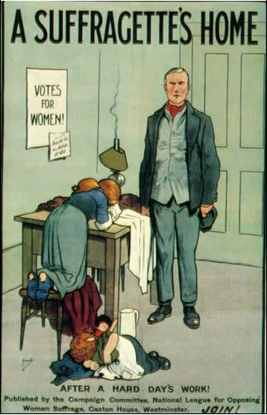
Station 4

The Roaring ‘20s
1920’s

- Read pages 379-380. Start from the heading “Changing Roles for Women” and end at the heading “Disillusioned Writers, Liberalizing Mores.”

- Draw a picture of a flapper girl from the 1920’s. Make sure to label the different characteristics that make her a flapper girl.

Station 5
Women in WWII
1942-1945
- Read the section titled “Women” on page 420.

- Draw a poster that advertises jobs needed to be filled by women during WWII. Include the following:
- Rosie the Riveter (see page 406 for an example)
- Mention at least 3 different job opportunities
- At least 4 sentences that help promote the jobs.
- Poster should be persuasive for women seeking jobs.

Example of persuasive poster advertising for young men to join the war:
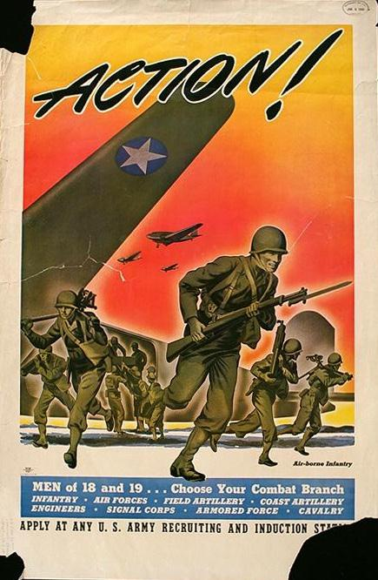
Station 6
Civil Rights Movement of the ‘60s

- Read the section titled “The Women’s Movement” on page 465.

- Write a biography on Betty Friedan. In the biography describe the following successes that she had:
- The Feminine Mystique
- Civil Rights Act
- National Organization of Women (NOW)

Station 7
The Women’s Movement of the ‘70s

- Read pages 480-481. Begin at the heading “The Women’s Movement” and end at the heading “The Gay Liberation Movement.”

- On a separate sheet of paper, write down the following terms and explain what each one was:

- Equal Rights Amendment
- Title IX of the Higher Education Act
- Roe v. Wade
- “glass ceiling”
- Gender-neutral terms
- The new “ideal man”

Station 8
Opposition to the Women’s Movement

- Read the section titled “Family Values” on page 483.

- Write a letter from the perspective of Phyllis Schlafly explaining your reasons for supporting the STOP-ERA organization. Cite at least 3 reasons to support your/her opinion.

Dear ______________,

Sincerely,
Phyllis Schlafly

