Women’s Rights

**D**ocument **B**ased **Q**uestion

Use the following documents to answer the essential question:

**EQ:** Compare and contrast the arguments for and against women's suffrage. Include in your analysis evidence from the primary source documents that support each side.

You will be graded on the content and quality of your response as well as completely answering the questions pertaining to the individual documents. Be sure to keep the EQ in mind as you analyze the sources!

Pro-Suffrage Anti-Suffrage

**Document 1**

|  |  |
| --- | --- |
|  | What is the document about?    _________________________________  _________________________________  _________________________________  _________________________________  _________________________________  _________________________________  How might the document support or hinder women’s rights?  _________________________________  _________________________________  _________________________________  _________________________________  _________________________________  _________________________________ |
| What do you believe was the outcome of the trial?­­­­­­­­­­­­­­ ________________________________________________  __________________________________________________________________________________________  __________________________________________________________________________________________  What can we get from this source to help answer the EQ? __________________________________________  __________________________________________________________________________________________  __________________________________________________________________________________________  __________________________________________________________________________________________  __________________________________________________________________________________________  **Document 2**   |  |  | | --- | --- | | Who do you believe wrote this document—men or women?  _______________________________  What do the authors believe is the role of women? ___________  _______________________________  _______________________________  _______________________________  _______________________________  _______________________________  _______________________________ | http://memory.loc.gov/rbc/rbpe/rbpe13/rbpe130/1300130c/001dr.jpg | | What can we get from this source to help answer the EQ? ______________________________  ________________________________________________________________________________________  ________________________________________________________________________________________  ________________________________________________________________________________________  ________________________________________________________________________________________ | | | |

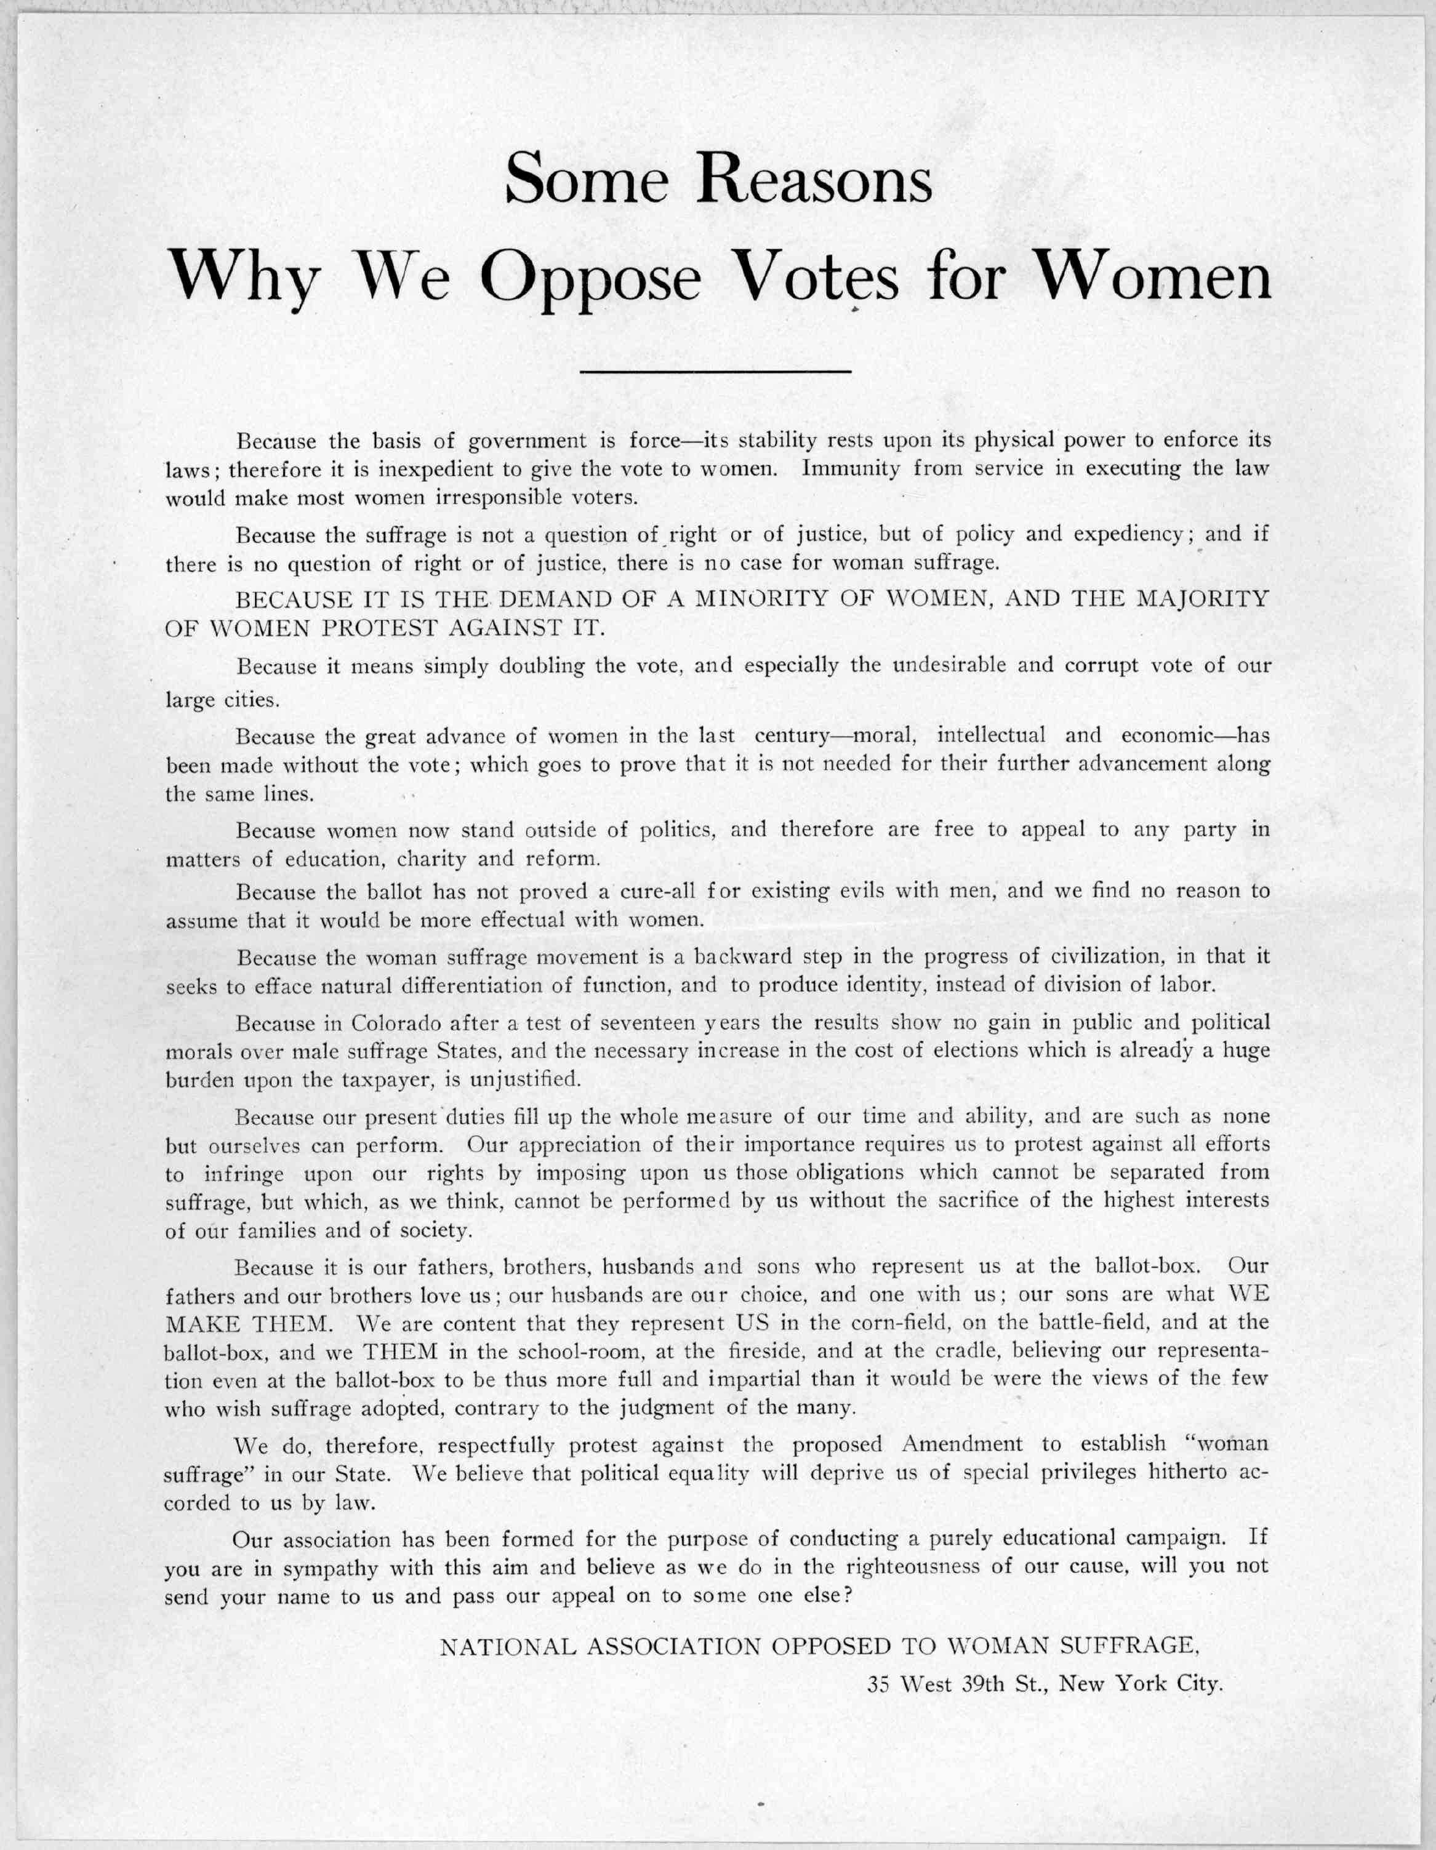

**Document 3**

|  |  |
| --- | --- |
|  | What do you notice about the cartoon? What stands out to you?  ___________________________________  ___________________________________  ___________________________________  ___________________________________  ___________________________________  ___________________________________  ___________________________________  How does the cartoon portray the shift in society as a result of women’s suffrage? _______________  ___________________________________  ___________________________________  ___________________________________  ___________________________________  ___________________________________ |
| What can we get from this source to help answer the EQ? ______________________________  ________________________________________________________________________________________  ________________________________________________________________________________________  ________________________________________________________________________________________  ________________________________________________________________________________________ | |

**Document 4**

|  |  |
| --- | --- |
| Who is standing outside of the Headquarters? ________  ___________________________  ___________________________  ___________________________  ___________________________  ___________________________  ___________________________  What do these people demonstrate about society?  ___________________________  ___________________________  ___________________________  ___________________________  ___________________________  ___________________________  ___________________________ |  |
| What can we get from this source to help answer the EQ? ______________________________  ________________________________________________________________________________________  ________________________________________________________________________________________  ________________________________________________________________________________________  ________________________________________________________________________________________ | |

**Document 5**

|  |  |
| --- | --- |
| http://memory.loc.gov/rbc/rbpe/rbpe13/rbpe132/13200400/001dr.jpg | Why are the women requesting the right to vote? Provide at least 3 reasons.  1. _________________________  ____________________________  ____________________________  ____________________________  2. _________________________  ____________________________  ____________________________  ____________________________  3. _________________________  ____________________________  ____________________________  ____________________________  Does their argument seem reasonable? _______________  ____________________________  ____________________________  ____________________________  ____________________________ |
| What can we get from this source to help answer the EQ? ______________________________  ________________________________________________________________________________________  ________________________________________________________________________________________  ________________________________________________________________________________________  ________________________________________________________________________________________ | |

**Document 6**

|  |
| --- |
|  |
| Based on what you can tell from the picture and picket signs, where are the women located? ________________________________________________________________________________  What words are the women wearing on their sashes? Are these words significant?  Why or why not? ________________________________________________________________________  __________________________________________________________________________________________  What can we get from this source to help answer the EQ? ______________________________  ________________________________________________________________________________________  ________________________________________________________________________________________ |