Causes of World War One
Although it was the assassination of the Austrian archduke, Franz Ferdinand that led to the outbreak of world war one in August 1914, the actual causes of the war were more complicated and not confined to a single cause.
Militarism  Militarism means that the army and military forces are given a high profile by the government. The growing European divide had led to an arms race between the main countries. The armies of both France and Germany had more than doubled between 1870 and 1914 and there was fierce competition between Britain and Germany for mastery of the seas. The British had introduced the 'Dreadnought', an effective battleship, in 1906. The Germans soon followed suit introducing their own battleships. The German, Von Schlieffen also drew up a plan of action that involved attacking France through Belgium if Russia made an attack on Germany. | 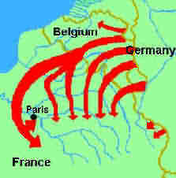

Alliances
An alliance is an agreement made between two or more countries to give each other help if it is needed. When an alliance is signed, those countries become known as Allies. A number of alliances had been signed by countries between the years 1879 and 1914. These were important because they meant that some countries had no option but to declare war if one of their allies declared war first. The Triple Alliance (Central Powers) included Germany, Austria-Hungary, and Italy. These countries signed the Triple Alliance so that Italy would not take sides with Russia. The Triple Entente (Allied Powers) included Russia, France and Britain to counter the increasing threat from Germany.
Imperialism  Imperialism is when a country takes over new lands or countries and makes them subject to their rule. By 1900 the British Empire extended over five continents and France had control of large areas of Africa. The amount of lands 'owned' by Britain and France increased the rivalry with Germany who had entered the scramble to acquire colonies late and only had small areas of Africa. Germany was annoyed because they didn’t have control of as many colonies/countries as Britain and France. |  | 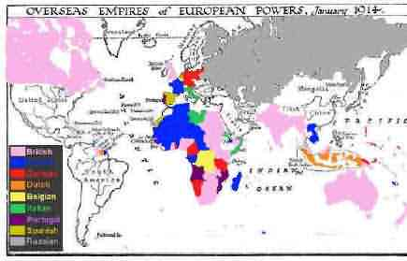Pink = British Blue = French  Red = German

Nationalism
Nationalism means being a strong supporter of the rights and interests of one's country. The Congress of Vienna, held after the Napoleonic wars left both Germany and Italy as divided states. It was nationalism that caused the re-unification of Italy in 1861 and Germany in 1871. France was angry because the settlement at the end of the Franco-Prussian war had given a French land to Germany. Large areas of both Austria-Hungary and Serbia were home to people from different countries, all of whom wanted to go back to their homeland.

Crises
The Moroccan Crisis - In 1904 Morocco had been given to France by Britain, but the Moroccans wanted independence and were supported by Germany. War was avoided, but in 1911, the Germans were again protesting against French possession of Morocco. Britain supported France and Germany was persuaded to back down for part of French Congo.

The Bosnian Crisis - In 1908, Austria-Hungary took over Bosnia. This angered Serbians who felt the province should be theirs. Serbia threatened Austria-Hungary with war, Russia, allied to Serbia, mobilised its forces. Germany, allied to Austria-Hungary mobilised its forces and prepared to threaten Russia. War was avoided when Russia backed down. In 1911 and 1912 there was war in the Balkans when the Balkan states drove Turkey out of the area. The states then fought each other over which area should belong to which state. Austria-Hungary intervened and forced Serbia to give up land. Tension between Serbia and Austria-Hungary was high.
Causes of World War One
Militarism  - Explain the term militarism in your own words. Then, use it correctly in a sentence.  - Describe the part played by Germany in increasing European militarism.  - Which armies had increased in size between 1870 and 1914?  - Describe the Schlieffen Plan. | Alliance  - Explain the term alliance in your own words. Then, use it correctly in a sentence.  - Which countries were allied by the Triple Alliance (Central Powers)? Why were they allies?  - Which countries were allied by the Triple Entente (Allied Powers)? Why were they allies?
Imperialism  - Explain the term imperialism in your own words. Then, use it correctly in a sentence.  - Why was Germany annoyed by Imperialism? | Nationalism  - Explain the term nationalism in your own words. Then, use it correctly in a sentence.  - Why was France angry after the Franco-Prussian War? What did they want?
Crises
Moroccan Crisis  - What links were there between the Moroccan Crisis in 1904 and:  - Militarism  - Alliances  - Imperialism  - Nationalism | Bosnian Crisis  - What links were there between the Bosnian Crisis in 1904 and:  - Militarism  - Alliances  - Imperialism  - Nationalism

