Station 1: The Battles of WWI pre-American involvement
Directions: Go to www.pbs.org/greatwar/maps/ and click on the following events/topics on the menu. Read the about the event and use the interactive map to help gain an understanding of what happened.

Event | Summary of what happened | Results (casualties, land gained/lost, etc.)
The Outbreak of War
Gallipoli 1915
The Battle of Verdun 1916
The Battle of the Somme 1916
The Third Battle of Ypres 1917

Station 2: The Trenches: Symbol of the Stalemate
Directions: Watch the 3 videos on trenches and read the article about trenches. Then you will draw what a scene would like look in a system of trenches. Label the parts of the system. Make sure you include the following in your drawing:
- The four different kinds of trenches
- Items that might be found in or around the trenches
- The human experience of what it would be like to be in the trenches

Station 3: The Deadlock
Directions: Read the article about the deadlock between the Allied powers and the Central powers. Complete the table below by explaining how each of the factors below contributed to a deadlock.

Factor | How it contributed to a stalemate
Trenches
Germany’s occupation of Belgium and Northern France
Russia’s strategy in the eastern front

Station 4: The Lusitania: America Joins the War
Directions: Read the article about the sinking of the Lusitania. Then answer the questions below and draw on the map.

- Why were ocean voyages dangerous during this time?

- Use the map below to draw an arrow representing the passage of the Lusitania.

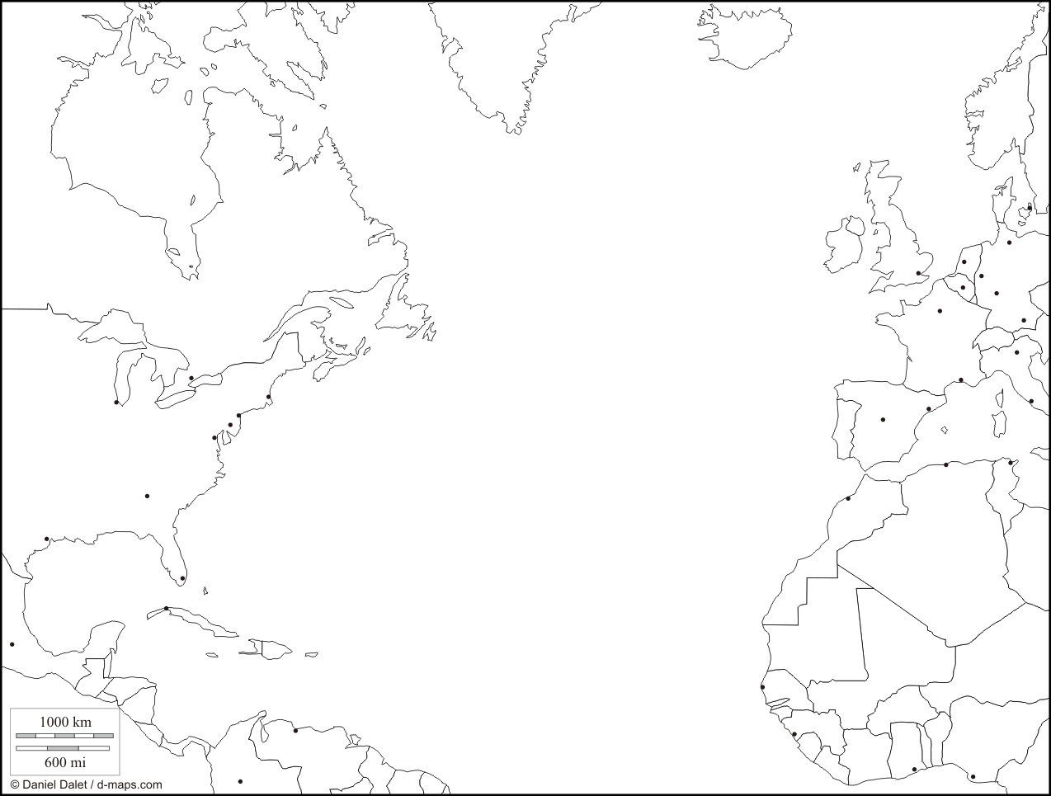

- What was the captain of the ship instructed (told) to do in order to avoid being targeted by a German U-Boat? Why didn’t William Thomas Turner follow those directions?

- How did the sinking of the Lusitania affect the war? (Who joined the war because of this tragic event?)

By the war's end, each side had dug at least 12,000 miles of trenches.
The first major trench lines were completed in late November 1914. At their peak, the trenches built by both sides extended nearly 400 miles from Nieuport, on the Belgian coast, to the Swiss border. Among the Allies, the Belgians occupied 40 miles, the British occupied 90 miles and the French occupied the rest. Experts calculate that along the western front, the Allies and Central Powers dug nearly 6,2500 miles of trenches by the end of 1914.
"[the bodies] we could not get from the German wire continued to swell ... the color of the dead faces changed from white to yellow-gray, to red, to purple, to green to black." Robert Graves, poet, novelist, critic
Organization of the trenches
The Allies used four "types" of trenches. The first, the front-line trench (or firing-and-attack trench), was located from 50 yards to 1 mile from the German's front trench. Several hundred yards behind the front-line trench was the support trench, with men and supplies that could immediately assist those on the front line. The reserve trench was dug several hundred yards further back and contained men and supplies that were available in emergencies should the first trenches be overrun.
Diagram of trench system
Connecting these trenches were communication trenches, which allowed movement of messages, supplies, and men among the trenches. Some underground networks connected gun emplacements and bunkers with the communication trenches.
German trench life was much different. They constructed elaborate and sophisticated tunnel and trench structures, sometimes with living quarters more than 50 feet below the surface. These trenches had electricity, beds, toilets and other niceties of life that contrasted sharply with the open-air trenches of the Allies.
Morale Booster
French soldiers drying feet
On average, daily losses for the British soldiers were nearly 7,000 men killed, disabled or wounded. This figure remained fairly constant throughout the war. To keep morale as high as possible and to keep the soldiers on the front as fresh as possible, the British established a three-week rotation schedule. A week in the front trench was followed by a week in the support trench, which was followed by a week in the reserve trenches. During this third week, the men could relax with sports, concerts and plays, keeping their minds away from life on the front.
No man's land: The Territory Between the Trenches
By mid-November 1914, the territory between the opposing front trenches was marked with huge craters caused by the shelling; nearly all vegetation was destroyed. Whenever possible, both sides filled this land with barbed wire to slow down any rapid advances by the enemy. The machine gun and the new long-range rifles made movement in this area almost impossible.
Timing of Movements at the Front
American doughboys
Both sides quickly recognized that assaults against the enemy trenches were suicide if begun in broad daylight, so attacks tended to take place just before dawn or right at dawn. Poison gases tended to be more effective in the mornings, as the colder air and absence of wind allowed the gases to stay closer to the ground for longer periods of time.
Except for artillery shelling, daytime was relatively safe for the soldiers on the front line. Once the sun went down, men crawled out of their trenches to conduct raids, investigate the layout of the terrain, and eavesdrop near the enemy lines to pick up information on their strengths, weakness and strategies.

THE GREAT WAR and the Shaping of the 20th Century
Trenches: Symbols of the Stalemate
© 2004 PBS www.pbs.org/greatwar Lesson Plan Two: Handout page 1 of 2
By the end of 1914, the two sides settled into trenches and faced each other across no
man’s land, the area between the trenches on the western and eastern fronts. A war of
attrition was underway, with each side trying to wear down the other. This harsh reality
had a devastating effect on the morale of the soldiers on both sides. At the beginning,
most people expected that the war would be over by Christmas 1914. This expectation
prompted an outburst of patriotic enthusiasm on the part of the soldiers headed to the
front as well as on the part of the civilians left behind. Young men eagerly signed up to
achieve the type of glory that was associated with fighting for one's country.
However, when the early offensives failed and the casualties mounted, a widespread
sense of despair developed in the trenches. The public did not know the extent of the
despair because governments concealed it from them by imposing rigid censorship.
Governments prevented news reporting of the slaughter at the front and intercepted mail
from soldiers that contained messages of gloom and doom.
The Prussian military theorist Karl von Clausewitz once defined war as an extension of
politics. But the political purposes of World War I had been lost amid the enormous death
and destruction. The assassination of Archduke Francis Ferdinand and the rivalry
between Austria-Hungary and Serbia in the Balkans were but distant memories with no
relevance to the traumatic experience of soldiers on the battlefield. As the two sides
confronted each other in trenches and periodically engaged in suicidal attempts to break
the deadlock, the soldiers lost their original enthusiasm for the war effort. By 1917 the
growing sense of despair and lack of purpose resulted in widespread discontent in the
French and Russian armies.

Causes of the Deadlock
For three years of continuous warfare, neither side succeeded in gaining a decisive
success on either of the main European fronts, in spite of the millions of lives sacrificed.
By the end of 1914, the western front had solidified into two deeply entrenched systems
of fortifications running west to east from the English Channel to the border of
Switzerland. The fortifications consisted of numerous parallel lines of interconnected
trenches protected by lines of barbed wire. The leaders on both sides thought that the way
to achieve a breakthrough was to penetrate enemy lines and gain access to open country.
In the open country, they believed that they could regain the ability to maneuver. They
also thought that the only way to penetrate enemy lines was to start a massive artillery
bombardment of a chosen sector and to follow it up with a massive infantry assault.
However, both sides had equal forces, so they could repel enemy attempts to overwhelm
entrenched defensive positions. The tragic equilibrium, as it has been called, caused
continued assaults. With each assault, both sides attempted to improve upon the
preceding one, chiefly by adding more artillery shells to the bombardment and more men
to the attack. As more soldiers were killed in futile efforts to overrun enemy positions,
leaders continued the same pattern because they felt that they had to prove that it would
succeed, thus justifying the slaughter of their troops.
The reason that the leaders continued using this suicidal strategy for the remainder of the
war was that no alternative appeared to exist. Maintaining fixed positions in the trenches
was no solution, since it produced only boredom and eventually despair. In addition, as
each army appointed new leaders, they resumed the deadly offensives to try to earn a
place in history by masterminding a breakthrough that would end the war.
Another factor in the deadlock on the western front was that Germany had occupied
almost all of Belgium and parts of northern France since the beginning of the war. The
French people and their government did not want to entertain any war aim other than
recovering the occupied territory and its inhabitants. France's preoccupation with this
goal hampered British-French strategy.
The French commander in chief on the northeastern front in France considered that area
the only front worthy of French resources, and he also felt that the British should loyally
accept the same viewpoint. The British, however, had developed other war aims to break
the stalemate that did not always coincide with those of their French allies. For example,
officials in London wanted to concentrate on the British war effort against the Ottoman
Empire. To the French, the war in the Middle East was much less important than the
struggle to liberate the occupied portions of northeastern France. As a result, the two
allies continually disputed military priorities.
On the eastern front, there was also stalemate, although geographically the armies had
plenty of room to maneuver. The Russians followed a strategy that had brought them
success against previous invasions from the west in other wars. Russian armies would
withdraw eastward deep into Russia's interior, fighting bloody defensive battles as
opportunity offered. Then, as the invading armies wasted away, Russia's vast reservoirs
of manpower would refill the Russian ranks.
In World War I, however, the strategy did not work. Russian industry could not furnish
enough weapons or ammunition to supply the reserve of manpower. On the other hand,
the periodic British and French offensives in the west prevented Germany from
transferring sufficient forces to the eastern front. Without these troops, the Germans
could not shatter the Russian armies and achieve victory. Thus, the exchange of fighting
continued, and neither side gained a decisive edge on the eastern front until the Russian
Revolutions of 1917.

Source: Encarta
http://encarta.msn.com/text_761569981___31/World_War_I.html

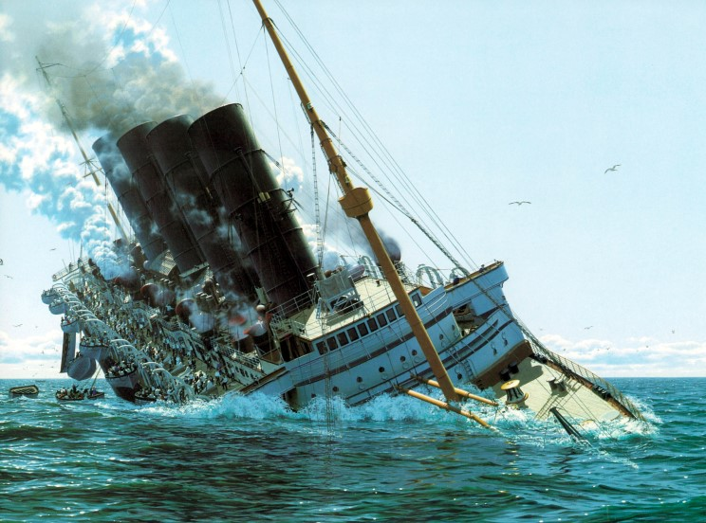Date: May 7, 1915

Sinking of the Lusitania

The British ocean liner RMS Lusitania, famous for its luxurious accommodations and high-speed capability, primarily ferried people and goods across the Atlantic Ocean between the United States and Great Britain (England).

On May 1, 1915, the Lusitania left port in New York for Liverpool, England to make her 202nd trip across the Atlantic. On board were 1,959 people, 159 of whom were Americans.

Since the outbreak of World War I, ocean voyages had become dangerous. Each side hoped to blockade the other, thus prevent any war materials getting through. German U-boats (submarines) stalked British waters, continually looking for enemy vessels (ships) to sink. All ships headed to Great Britain were instructed to be on the lookout for U-boats and take precautionary measures such as travel at full speed and make zigzag movements.

Unfortunately, on May 7, 1915, Captain William Thomas Turner slowed the Lusitania down because of fog and traveled in a predictable, straight line.
Approximately 14 miles off the coast of Southern Ireland at Old Head of Kinsale, neither the captain nor any of his crew realized that the German U-boat, U-20, had already spotted and targeted them. At 1:40 p.m., the U-boat launched a torpedo. The torpedo hit the starboard (right) side of the Lusitania. Almost immediately, another explosion rocked the ship.
At the time, the Allies thought the Germans had launched two or three torpedoes to sink the Lusitania. However, the Germans say their U-boat only fired one torpedo. Many believe the second explosion was caused by the ignition of ammunition hidden in the cargo hold. Others say that coal dust, kicked up when the torpedo hit, exploded. No matter what the exact cause, it was the damage from the second explosion that made the ship sink.
The Lusitania sunk within 18 minutes. Though there had been enough lifeboats for all passengers, the damage to the ship prevented most from being launched properly. Of the 1,959 people on board, 1,198 (over 60%) died. The toll of civilians killed in this disaster shocked the world.
Americans were outraged to learn 128 U.S. civilians were killed in a war in which they were officially neutral. Destroying ships not known to be carrying war materials countered generally accepted international war protocols (rules). The sinking of the Lusitania heightened tensions between the U.S. and Germany and helped sway American opinion in favor of joining the war.
In 2008, divers explored the wreck of the Lusitania, situated eight miles off the coast of Ireland. On board, the divers found approximately four million U.S.-made Remington .303 bullets. The discovery supports the German's long-held belief that the Lusitania was being used to transport war materials. The find also supports the theory that it was the explosion of munitions on board that caused the second explosion on the Lusitania.

